Mosquito Science
Inspired by Bill Reitz, AAPT Physics Teaching Resource Agent
and The Physics Teacher’s:
“Classroom Materials from the Acoustical Society of America”
by W. K. Adams, A. Clark, and K. Schneider

Description: Students will read a popular children’s storybook about mosquitos, then design their own physical mosquito buzzer.

Purpose: Students will modify a buzzer to explore how elements of the design change the function and pitch of the buzzer. Students will describe the qualities of sound.

NGSS Connections:
Disciplinary Core Ideas:
- PS4.A: Wave Properties
Cross Cutting Concepts:
- Cause and Effect
- Structure and Function
Science and Engineering Practices:
- Planning and Carrying Out Investigations
Performance Expectations:
- 1-PS4-1. Plan and conduct investigations to provide evidence that vibrating materials can make sound and that sound can make materials vibrate.
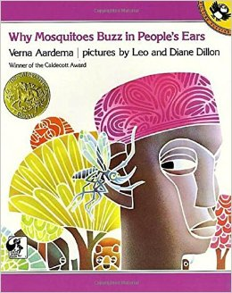
- MS-PS4-1 Use mathematical representations to describe a simple model for waves that includes how the amplitude of a wave is related to the energy in a wave.

Materials:
- Why Mosquitoes Buzz in People’s Ears by Verna Aardema
- Craft sticks
- 4x6in index cards
- Rubber bands of various thickness
- Foam board or card board
- String
- Stapler
- Safety goggles
- YouTube video: “Slow Motion Mosquito Flight” https://www.youtube.com/watch?v=9uBuKDkyZVY
- YouTube video: “The Mystery of Mosquito Flight” https://www.youtube.com/watch?v=JQl4OP2XdYA

Modifications:
- Students can redesign their buzzers more than three times.
- The teacher can encourage students to change only one variable as they experiment
- Teacher can provide a guiding question such as “How can we make our buzzers higher pitched?” or “How can we make our buzzers louder?”

Mosquito Science

Student Worksheet
Note to teacher: Italicized commentary are notes for teachers. Red statements show sample correct student responses. Highlighted yellow items are areas where students are likely to get “stumped.

Description: Students will design their own mosquito buzzer to observe and describe differences in sound.

Purpose: Students will modify a buzzer to explore how elements of the design change the function/pitch of the buzzer. Students will describe the qualities of sound.

Guiding questions:
- Close your eyes and imagine a situation in which you might have a mosquito buzzing around you. How do you feel when a mosquito buzzes in your ear?

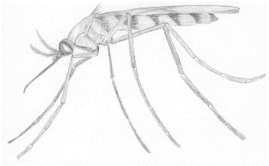

- Read the book Why Mosquitoes Buzz in People’s Ears by Verna Aardema

This is a place for a discussion about the differences and similarities between cultural and scientific explanations and beliefs. It is important to note that while Western scientific tradition seeks empirical evidence for explanations, there is also great value in cultural explanations, especially when their purpose is to convey a moral and not a scientific explanation.

How did this West African story explain why mosquitoes buzzed around people?
What do you think is the purpose of the story?
Does this story provide a scientific explanation for why mosquitos buzz? Explain why or why not.
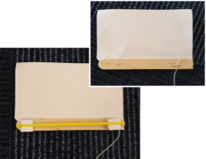

- To develop a scientific explanation for why mosquitos buzz, construct a “mosquito buzzer” using the instructions below.

Have students wear safety goggles while spinning. If the buzzer is not buzzing, the student may not be spinning it fast enough.

  - Staple a craft stick along the bottom of a note card.
  - On top of the stick staple the end of a string about 2 feet long.
  - Wrap a rubber band around the popsicle stick.
  - Slide two square pieces of foam or cardboard between the rubber band and the popsicle stick one at each end.
  - Put on safety goggles.
  - Hold firmly onto the string and spin the buzzer over your head in a circle quickly.

- Spin your buzzer and listen to how it sounds. Describe how your buzzer and another student’s buzzer sounds below:
My buzzer sounded...
Another student’s buzzer sounded...

- What are all the words you can use to describe different types of sounds? List them in the word bank to the right:

Introduce the term pitch to your students as they reflect on these questions. Pitch is the perception of how frequently sound waves get to your ear. In this case, pitch is fairly equivalent to how high a note is perceived. A high note is caused by a high pitch.

- How do you think the sound is created as you spin the buzzer? (Make sure you say where you think the sound is coming from. Use the picture of the buzzer to help you).

- How do you think you could change your buzzer sound? Make a plan in the space below how you would modify the basic design.
The base model looks like this....
Our new buzzer will look like this...
I think the sound will be different from the original because...

- Build and test your new design.
When we tested our new buzzer it sounded...

I think it changed because...
Next time I would like to do this differently...

- Try to make your buzzer sound really different from before. Make changes and try your buzzer again.
When we tested our new buzzer it sounded...
I think it changed because...
Next time I would like to do this differently...

- Again, try to make your buzzer sound really different from before. Make changes and try your buzzer again.
When we tested our new buzzer it sounded...
I think it changed because...
Next time I would like to do this differently...

10. Reflect on your designs and tests.
In which test did you get the highest pitch sound? Why do you think that was the highest?
In which test did you get the lowest pitch sound? Why do you think that was the lowest?
Which test sounded the most like a real mosquito? Why?

Play the following videos which show a mosquito’s wings vibrating to create a buzzing sound.
- “Slow Motion Mosquito Flight” https://www.youtube.com/watch?v=9uBuKDkyZVY
- “The Mystery of Mosquito Flight” https://www.youtube.com/watch?v=JQl4OP2XdYA

Based on the video and your exploration, how do you think mosquitos and other insects make a buzzing sound?

How is what you learned in the videos similar to your buzzer?

