Sound Vibration Science
Inspired by The Physics Teacher’s:
“Classroom Materials from the Acoustical Society of America”
by W. K. Adams, A. Clark, and K. Schneider

Description: Students will use tuning forks, pasta resonators, straw trombones, and resonating bottles and looking for patterns relating frequency and length.

Purpose: Students will determine that sound is caused by vibration passing through a medium. Students will describe how length, frequency, and pitch of a sound are interrelated.

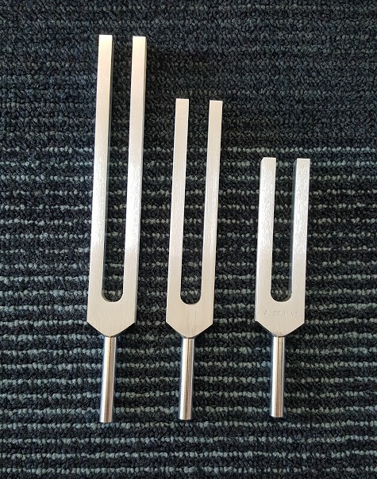
NGSS:
Disciplinary Core Ideas:
- PS4.A: Wave Properties
Cross Cutting Concepts:
- Cause and Effect
- Structure and Function
- Scale, Proportion, and Quantity
- Patterns

Science and Engineering Practices:
- Planning and Carrying Out Investigations
- Analyzing and Interpreting Data
- Constructing Explanations and Design Solutions

Performance Expectations: Waves and Their Applications in Technologies for Information Transfer
- 1-PS4-1-Plan and conduct investigations to provide evidence that vibrating materials can make sound and that sound can make materials vibrate.

Materials:
Part I
- Tuning forks
- Cup filled with water
- Ping pong ball on a string
- Paper towels
Part II
- Spaghetti pasta
- Mini marshmallows
- Ruler
Part III
- Straws of two thicknesses
  - One must fit smoothly inside the other
- Scissors
Part IV
- Bottles
- Water
Part V
- Plastic cups
- String
- Paperclips

Advanced Preparation:
- Fill cup half full with water
- Tape a piece of string (at least 6 in long) onto a ping pong ball

Sound Vibration Science

Student Worksheet
Note to teacher: Italicized commentary are notes for teachers. Red statements show sample correct student responses. Highlighted yellow items are areas where students are likely to get “stumped.

Description: Students will use tuning forks, pasta resonators, straw trombones, and resonating bottles and looking for patterns relating frequency and length.

Purpose: Students will determine that sound is caused by vibration passing through a medium. Students will describe how length, frequency, and pitch of a sound are interrelated.

Guiding questions:

Part I: Tuning Fork Exploration

In a discussion reflect on the following questions: Consider the purpose of a tuning fork. It is used to generate, or create, a specific frequency of sound. What are the differences from one tuning fork to another? How do you initiate the tuning fork’s sound? How is the sound of your buzzer connected to the sound of your tuning forks?

Safety Note: Students should never hold a vibrating tuning fork up to their eyes or teeth.
To strike a tuning fork, firmly strike the bottom of a rubber shoe. Never strike a tuning fork on something hard as this will bend the fork and alter the sound. See the following website for more information: http://adailydoseofsoundtherapy.com/product-recommendation/how-to-use-tuning-forks/

- Strike one of the tuning forks and touch it with your fingers.
When I touched my fingers, it felt like….
This reminds me of...
I think it felt that way because...

- Strike the tuning fork and touch the tip to your nose.
When I touched my nose, it felt like….
This reminds me of...
I think it felt that way because...

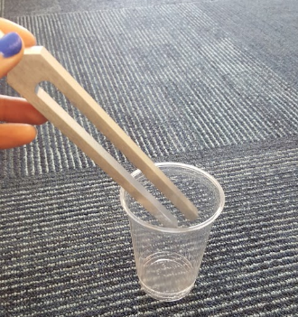
- Strike the tuning fork and hold the tip in a cup of water.
When I put it in water, it did this….
This reminds me of...
I think this happened because...

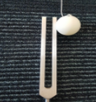
- Strike a tuning fork and have hold it next to a hanging ping pong ball on a string.

When I touched the ping pong ball, it did this….
This reminds me of...
I think this happened because...

- What other tests can you do to explore how a tuning fork creates sound? Explain your plans to your teacher before you try it. Then, try your test!
I tried this with my tuning fork...
This happened...
I think this happened because...

Using evidence from the moving ping pong ball and the water explorations, guide students to the conclusion that a movement creates sound and define the term vibration.

- Based on your exploration of tuning forks, what can you conclude about how tuning forks create sound?

- How is the tuning fork creating sound similar to how your mosquito buzzer creates sound?

- How does the length of the tuning fork affect the sound that it makes?

The short tuning fork sounds… | The medium tuning fork sounds… | The long tuning fork sounds…  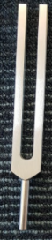

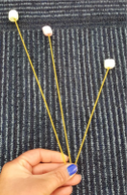
Part II: Pasta Resonance

- Remove three pieces of spaghetti from the pile
  - Leave one piece the full length between 10in and 11in
  - Break the second piece to a length between 8in and 9in
  - Break the third piece of past to a length between 7in and 8in
- Place a mini marshmallow at one end of each of the three pieces of pasta
- Hold the other end of all three pieces of past between your forefinger and thumb and shake your fingers back and forth. Begin at a rate, or frequency, of 2 shakes per second.
- Slowly shake at a higher and higher rate. Record observations below.

It is natural to start shaking with a greater amplitude or larger back and forth movements. However, you want to move more frequently back and forth. Frequency is how often something occurs. In a higher frequency sound wave, the waves are hitting your ear more often. We perceive that higher frequency sound wave as a higher pitch sound.

Low
Pasta Movement
Describe what happens to each of the pasta lengths below at the different frequencies.
Medium
High
Frequency of Movement

- Reflect on your findings below.
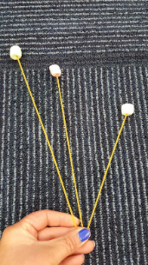

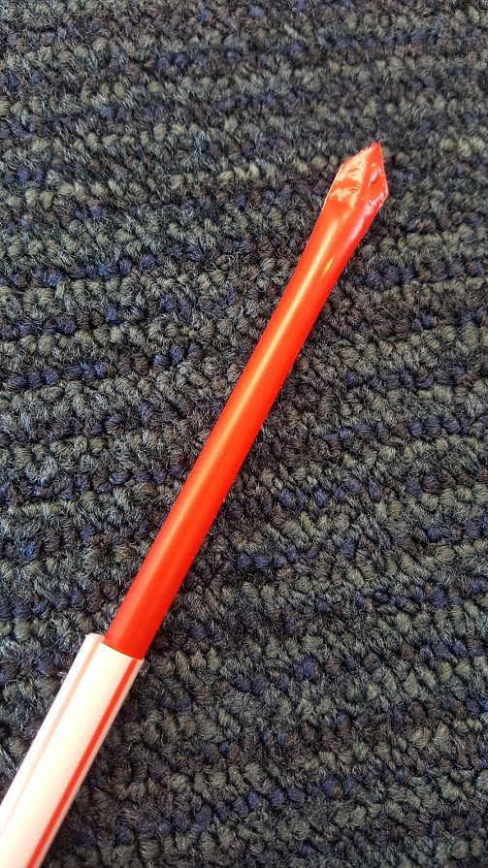
Part III: Straw Trombones
- Build a straw trombone:
  - Take a thinner straw out from the wrapper, and bite the end down so it is flat.
  - Cut the corners of the straw to form a small triangle.
  - Open the thicker straw and slide the thinner straw inside.
  - Put the triangle end in your mouth and blow. Move the thicker straw along the thinner so your instrument is playing at different lengths.

- Describe the sound produced in each case.

The short trombone… | The medium trombone… | The long trombone…

3. Think about the words “pitch” and “frequency” as you now compare the straw trombone and the pasta.
The highest pitch occurred when...
The lowest pitch occurred when...

The pasta was similar to and different from the straw trombone because…
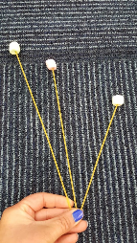
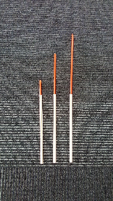

The longer the straw, the smaller the frequency, or rate of vibration. When the straw trombone is completely extended, the frequency is low. When the trombone is short, the frequency is high.
High frequency is heard as a high pitch, while low frequency is heard as a low pitch.

4. The pasta activity revealed that the longer the pasta, the lower the frequency necessary to make it vibrate. The shorter the pasta, the higher the frequency. Connecting the longer object to a lower frequency, consider the following ideas:
When the frequency was highest, the pitch was….
When the frequency was lowest, the pitch was...
As the frequency of sound vibration increases the pitch we hear...

Part IV: Resonance Bottles

- Blow over the top of an empty bottle.
When I blew over the bottle, it sounded like...
This reminds me of...
I think it happened because...

- How can you change the pitch of the bottle’s sound? You may use the water provided to you by your teacher.
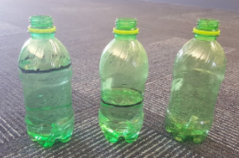
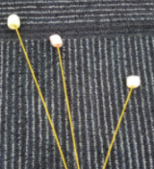
The pitch and frequency was the highest when...
The pitch and frequency was the lowest when...

The higher the water level, the ________ the frequency

and the ______________ the pitch.
I changed the pitch by...
The longer the trombone, the _____________ the
Frequency and the _________________ the pitch.
I know that the _________________ (water or air) is vibrating
in the bottle because…
The longer the pasta, the
________ the frequency.
Note that with the bottles, it is not the water that is vibrating, but the air inside the bottles that vibrates. This is why the rule appears opposite of the other two examples when considering the height of the water (as opposed to the length of the air inside the bottle).

