Candy Science: Color and Reflection
Inspired by The Physics Teacher’s
“A Student-Centered Interactive Color Quiz” by Edward P. Wyrembeck

Description: Students learn about how we perceive color by shining pure, colored light on candies and observing how their appearances change.

Purpose: Students will describe how pigments are similar to filters (and work by subtraction of light). They will be able to predict the perceived color of an object under different colors of light. They will better understand why things look a specific color.
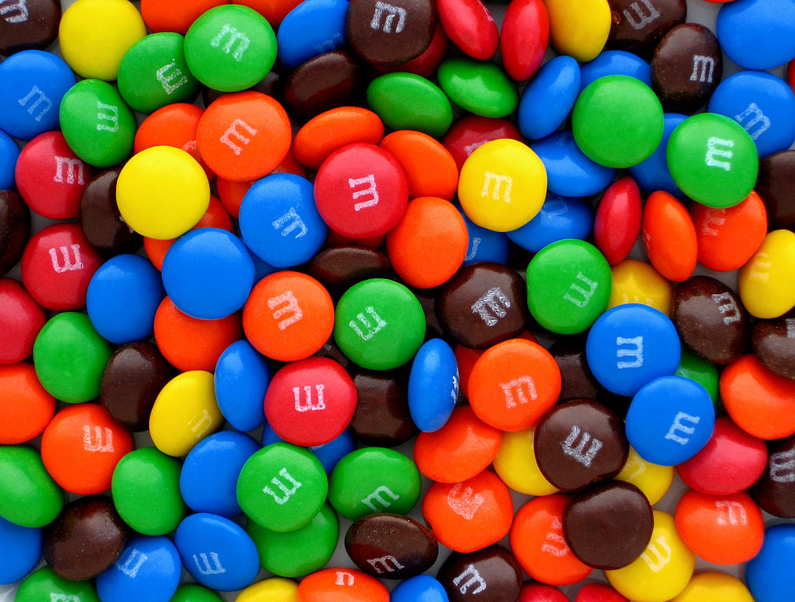
NGSS Connections: See Page 7 for full listing
Of NGSS correlations to this lesson
Disciplinary Core Ideas:
- PS4.B: Electromagnetic Radiation
Crosscutting Concepts:
- Structure and Function
- Cause and Effect
Science and Engineering Practices:
- Planning and Carrying Out Investigations
- Constructing Explanations
- Developing and Using Models
Performance Expectations: Waves
- 1-PS4-2, 1-PS4-3
- 4-PS4-2
- MS-PS4-2

Materials:
- 3 x monochromatic light source(s) – any of the following:
  - Variable-color LED lamp and controller (red, green, blue, yellow, magenta, cyan, white) (ideal)
  - Smartphone “flashlight-type” app that produces monochromatic screen colors
  - Monochromatic LED flashlights (red, green, blue, can add yellow, magenta, cyan, white)
  - Flashlights covered with filters (less ideal)
- M&M’s (or other candies that have primary colors: red, green, and blue)
- Gummy Bears (or translucent candies that are red, green, yellow, and clear – Haribo brand gummy bears have the necessary colors)
- Yellow, magenta, and cyan highlighters
- Colored Pencils

Advanced Preparation:
- Prepare small quantities of about 30-50 M&M’s per group.
- Ensure that students do not have allergies to chocolate if using candy-coated chocolate candies.
- Darken the room completely so that no extra white light makes it through – otherwise the sorting activity will not be effective!
Modifications:
- Avoid using edible foods in laboratory settings where contamination might occur.
- Alternative, colored small objects could include pieces of construction paper or buttons
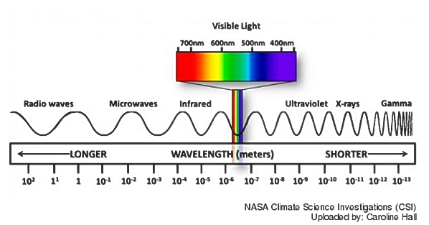
Prior Knowledge Required:
- The Electromagnetic Spectrum: The human eye is sensitive to a very narrow band of frequencies that lie between the wavelength range of ~400 to ~700 nanometers within the electromagnetic spectrum (see diagram above). Specific wavelengths within this narrow band are perceived by humans as color, with red occupying the longer-wavelength end and violet the shorter. The rich variety of colors we see result from the varying wavelengths of light emitted or reflected by objects into our eyes.

- Light Reflection and Light Absorption: Depending upon the properties of an object, light of different wavelengths may be reflected from it, absorbed into it, or transmitted through it. Some objects reflect light, but some absorb one or more frequencies. If a sample of matter appears red, that means it is absorbing light in the frequencies of blue and green and reflecting the color red (i.e., the color red is the only one that will reach our eyes).

- RGB Color: The Additive Primaries -- RGB is short for “Red, Green, Blue”, the primary colors of light. In human eyes, our retinas contain light receptors called cones, which are sensitive to the red, blue, and green wavelengths of light on the electromagnetic spectrum. The RGB primary colors of light are not a fundamental property of light, but are related to the color vision system in humans and mammals. Red, green, and blue are called the Additive Primary Colors because the addition of all these colors yields white light. Mixing primary colors of light produces the following:
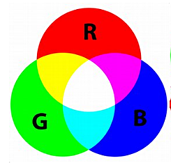
Red + Green = Yellow
Red + Blue = Magenta
Blue + Green = Cyan
Red + Blue + Green = White

- Pigment Color: The Subtractive Primaries -- Pigments are substances such as paint, ink, or dyes. Unlike RGB color, the primary colors of pigment are yellow, magenta, and cyan. They are called Subtractive Primary colors because each can be formed by subtracting one of the primary additives (red, green, or blue) from white light. Teachers: For excellent content support on color subtraction, see this free digital resource: Color Subtraction Tutorial: Eastern Illinois University

Misconceptions
- Students in the secondary grades often have difficulty believing that color is not an intrinsic property of an object, but rather is an interpretation of the reflective and absorptive properties of an object’s surface and the wavelengths of light emitted or reflected by the object. Humans see the wavelength range of 600-700 nanometers as orange or red; dogs see it as brown or goldish-brown. So you and Rover may both be looking at a “red” ball, but it’s brown to Rover! The color isn’t innate to the ball; it’s the result of wavelength perception in human vs. canine eyeballs.
- Another area of documented difficulty is in understanding what happens at the molecular level when light and matter interact. Matter is composed of atoms that are capable of selectively absorbing or reflecting one or more frequencies of light. When visible light strikes an object and a specific frequency becomes absorbed, that frequency of light will never make it to our eyes. So, if the object is absorbing all the green and red frequencies of light, it will appear blue to our eyes.
Lab Activities for Students: Color and Reflection

PART 1: Pigment and Light Mixing

- Use highlighters to mix the following colors of pigment: magenta, cyan, and yellow. These are called the Primary Subtractive Colors because each can be formed by subtracting one of the Primary Additives Colors (red, green, or blue) from white light. Do yellow first! Record what each combination gives you.
Note: Expect students to be surprised by the results! Pigment mixes should yield:
Yellow + Magenta = Red; Yellow + Cyan = Green; and Cyan + Magenta = Blue. All pigments mixed together give black/brown. If highlighter pens are unavailable, this can be best observed by mixing cups of water tinted with color from an ink printer refill. See diagram below showing overlaps of the primary subtractive colors.
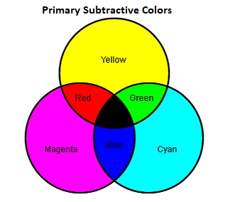

- Use the LED lamps to mix the primary colors of light (red, blue, green). Write down what each combination gives you. What is the difference between mixing light and color?
Light should mix to give: red + blue = magenta, red + green = yellow, and blue + green = cyan. This can be easily observed by shining the LED lamps on the ceiling or desk. Teachers: Anticipate that the mixing of red and green to produce yellow will be counterintuitive to many students. Some may not believe their eyes! This is the perfect time to reinforce the difference between the primary colors of light and the primary colors of pigment. The LED lamps are a light emitter; paint pigment reflects light (does not emit light).

Pigment Light
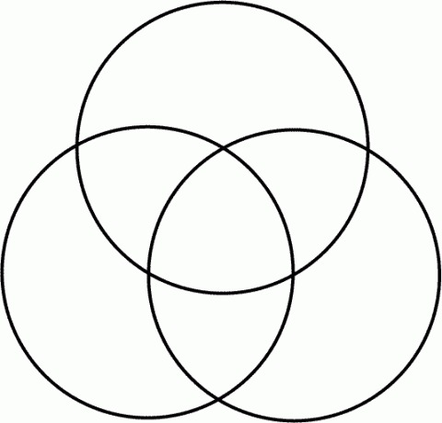

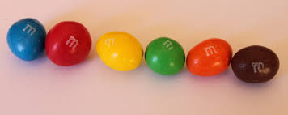

PART 2: M&M’s Color Sorting
- Turn out the lights, and turn on your LED lamp to only red, green, or blue.
Make sure that all students are using the same color at the same time.
Source: Bribri2B. Licensed under CreativeCommons
- Sort your M&M’s into groups based on their observed color. You might not be able to make 6 groups; that is fine.
Allow students about 90 seconds to sort 30-50 candies. Some students will have greater perception of color variations, so the groupings will be mixed.
- On your table space, circle the groups and label them with the color they appear under the light.
- Turn the lights back on, and observe the color of M&M’s in each sorted group. Why would they be grouped that way? (Hint: think about what color light was shining on them.)
Ex: Under red light, students will most likely make the following groups: (1) red/yellow/orange candies, and (2) blue, green, and brown candies. This is because the red/yellow/orange candies contain red pigment, and therefore reflect the color and appear “bright.” The blue, green, and brown candies absorb the color and appear “dark.”
- Label each group with the number and color of M&M’s in each group on the student worksheet.
- Redo steps 2-6 with each different color light (red, green, blue). Note how the M&M’s look different under different colored lights!

PART 3: White Light

- Try to draw what colors a white and black M&M would reflect to our eyes under white light. (Hint: What colors make up white light? If we see the M&M as white, what color(s) are entering our eyes?) See solutions below. The white M&M will reflect all colors of light, whereas the black M&M won’t reflect any colors (it absorbs them, as indicated by the X).

- Try to draw how red and green M&M’s will appear to our eyes under white light (composed of red, green, and blue), as well as under pure red light and under pure blue light. Again, the solutions are all of the lines coming off of the M&Ms. Note that students may try to solve this by saying that red light reflects off of a green M&M as green light, or that blue light reflects off of a red M&M as red light. If students are having trouble with this, offer them the opportunity to try the practical experiment again with the specific color light and M&M they are struggling with. This should allow them to see that the green M&M doesn’t reflect any red light.

White Light Red Light Blue Light

Big Idea: When we see colors of an object that does not produce its own light, we are simply seeing light that reflects off of the object coming back to our eye.

PART 4: Light Blockers

- Use the LED lamps to find out what colors of light get through (transmit) each color of gummy bear. You can do this by checking if the bear casts a shadow, or if some color of light gets through. What colors get blocked? Why? Below each color bear, draw which color of light gets transmitted through the bear!

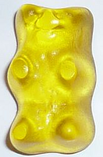
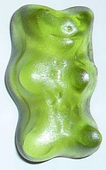
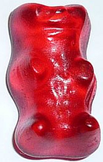

Big Idea: When light goes into an object, some of the light gets absorbed and some of it gets transmitted based on the medium.

PART 5: Color Filter Ball Game
Assign three students to be red, green, and blue “color filters” – much like the gummy bears. Ask them to think about what colors they will and will not allow through. Assign one student to be a “photoemitter,” who sends out different colored light towards the “filters.” Line up the filters in some order. Have the photoemitter throw one ball to the first filter. If the filter should allow the light to pass, have them throw it to the next filter, and so on. If the filter should stop the light, they should set the ball down at their feet. Allow the filters to rearrange periodically, so that the same color light does not always stop at the same place.

Scroll down for NGSS Correlations

NGSS: Next Generation Science Standards
Performance Expectations
Middle School Physical Science: Waves
- MS-PS4-2: Develop and use a model to describe that waves are reflected, absorbed, or transmitted through various materials. (Strong correlation)

Disciplinary Core Ideas
Middle School Physical Science: Electromagnetic Radiation
- MS-PS4.B.1: When light shines on an object, it is reflected, absorbed, or transmitted through the object, depending on the object’s material and the frequency (color) of the light.
- MS-PS4.B.3: A wave model of light is useful for explaining brightness, color, and the frequency-dependent bending of light at a surface between media.
- HS-PS4.B.4: Atoms of each element emit and absorb characteristic frequencies of light. These characteristics allow identification of the presence of an element, even in microscopic quantities.

Crosscutting Concepts:
Structure and Function
- Investigating or designing new systems or structures requires a detailed examination of the properties of different materials, the structures of different components, and connections of components to reveal its function and/or solve a problem.
Cause and Effect
- Cause and effect relationships can be suggested and predicted for complex natural and human-designed systems by examining what is known about smaller scale mechanisms within the system.

Science and Engineering Practices
Constructing Explanations
- Apply scientific principles and evidence to provide an explanation of phenomena, taking into account possible unanticipated effects.
Analyzing and Interpreting Data
- Analyze data using tools, technologies, and/or models in order to make valid and reliable scientific claims.
Planning and Carrying Out Investigations
- Conduct an investigation to produce data to serve as the basis to answer scientific questions under a range of conditions.

