DNA Science: Modeling Rosalind Franklin’s Discovery
with a Pen Spring
Inspired by The Physics Teacher’s:
“How Rosalind Franklin Discovered the Helical Structure of DNA: Experiments in Diffraction”
by Gregory Braun, Dennis Tierney, and Heidrun Schmitzer
and

“Wavetank in a Glass”
by Dave Van Domelen
“Simulate Interference…With Supplies that Last”
By David Kagan

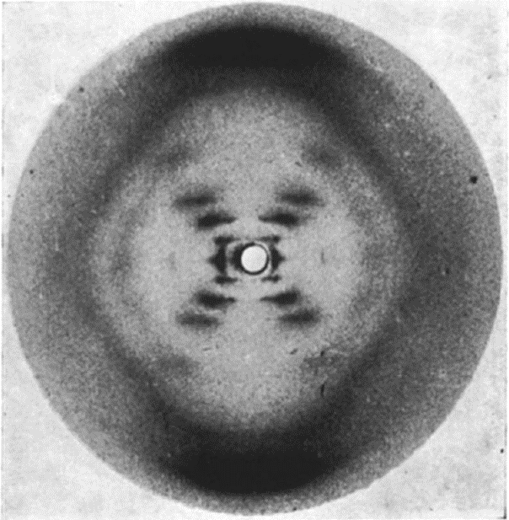
Description: In this exploration lab, students observe the light patterns produced by a laser beam as it passes through a helical pen spring. Students observe changes in the pattern as a result of differences in pitch (spacing between the coils), and make inferences about the structure of DNA using Rosalind Franklin’s original image.

Purpose: Determine the information that can be inferred from a light pattern produced by an object.
© Raymond Gosling / King’s College London

NGSS Connections:
Disciplinary Core Ideas:
- Waves and Their Applications in Technologies for Information Transfer: HS-PS4-3
Crosscutting Concepts:
- Patterns
- Cause and Effect
- Scale, Proportion, and Quantity
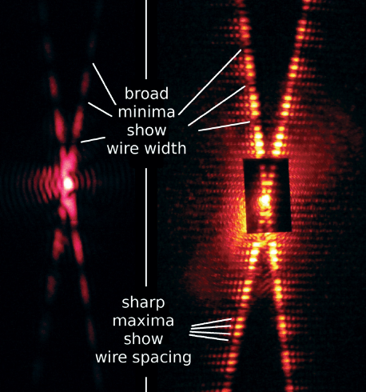
Science and Engineering Practices:
- Developing and Using Models
- Analyzing and Interpreting Data
- Constructing Explanations
- Engaging in Argument from Evidence

Materials:
- Laser
- Spring pen (small, compressible spring)
- Ruler/Vernier caliper
- Protractor
- Print-out of Rosalind Franklin’s X-ray pattern
- Wide-mouthed glass or petri dish filled with water (optional)
- Mechanical/vibrating toothbrush (optional)
- Prepared overhead transparencies of waves
- Scissors
- Single hole-punch
- Tack
- Cardboard (at least the size of a regular sheet of paper)

Prior Conceptual Understandings Required
- Wave model of light
- Superposition and interference (qualitative understandings)
- Diffraction (qualitative understandings) with single and double slits

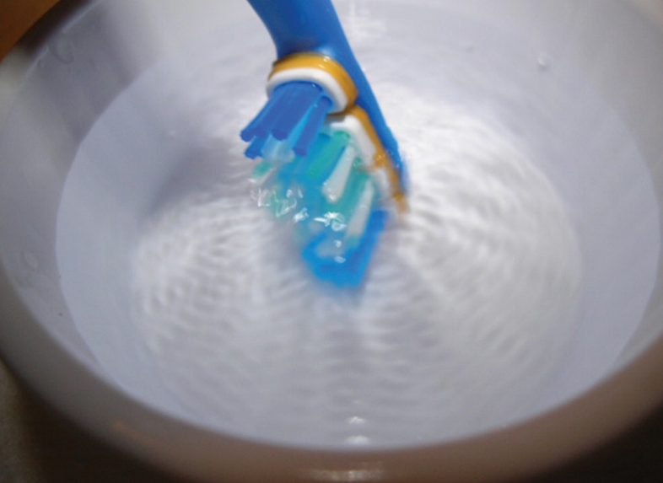
Lab Activities (in brief):
- Suggested pre-lab activity: Investigate single and double-slit diffraction.
- Suggested pre-lab activity: “Wavetank in a Glass” If wave tanks are unavailable to help students to visualize the wave nature of light and its properties (such as diffraction and interference), you can easily construct a “mini wave tank” by submerging a vibrating mechanical toothbrush into a shallow cup or petri dish of water. Cut down the brush to two bundles of fibers to observe the interactions of two “point-sources.”
- Suggested pre-lab activity: “Simulate Interference…With Supplies that Last”
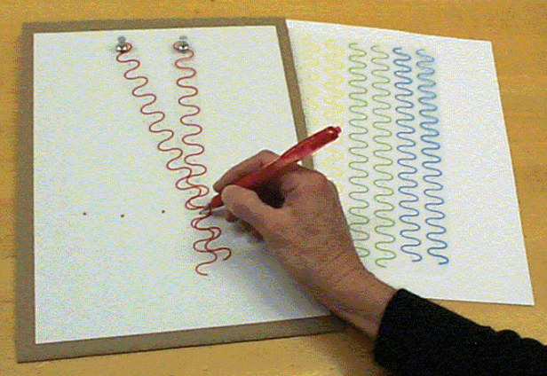
Help students to understand the nature and cause of interference patterns by noting points of constructive interference by two point-sources of light using the overhead transparencies, and referencing
- Have students observe diffraction patterns produced by a single laser beam passing through a small spring. Ensure that students note: (1) two bright axes that form an “X,” and (2) bright and dark spots along the arms of the “X.” Encourage students to think about why these two phenomena have occurred.
- Have students model interference patterns with the overhead transparencies of waves of different frequency.
- Again observe the interference pattern caused by the spring. Encourage students to provide a deeper explanation for what is occurring. Determine what variables can be measured from the produced patterns, using a variety of springs. Draw relationships between spring pitch and the angle formed by the axes of the “X” and the spring wire thickness and the distance between the dark spots along the axes of the “X.”

DNA Science: Modeling Rosalind Franklin’s Discovery
with a Pen Spring

Student Worksheet
Note to teacher: Italicized commentary are notes for teachers. Red statements show sample correct student responses. Highlighted yellow items are areas where students are likely to get “stumped.

Purpose: Determine the information that can be inferred from a light pattern produced by an object.

Background (from “How Rosalind Franklin Discovered the Helican Structure of DNA: Experiments in Diffraction” by Gregory Braun, Dennis Tierney, and Heidrun Schmitzer.)

Rosalind Franklin, a chemical physicist (1920-1958), used x-ray diffraction to determine the structure of DNA. What exactly should she read out from her x-ray pattern? In lecture notes dated November 1951, R. Franklin wrote the following: “The results suggest a helical structure (which must be very closely packed), containing 2, 3, or 4 co-axial nucleic acid chains per helical unit, and having the phosphate groups near the outside.” This was 16 months before J.D. Watson and Fr. Crick published their description of DNA, which was based on R. Franklin’s x-ray photos. How they gained access to her x-ray photos is a fascinating tale of clashing personalities and male chauvinism.

Guiding questions:
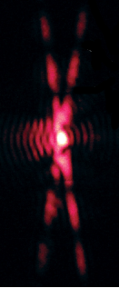
  - Rosalind Franklin attempted to learn more about DNA by shining a beam of X-rays through it and observing the pattern that resulted. To do this, she suspended a bundle of about 20 strands of DNA (about the width of a human hair) vertically.

Perform a similar investigation by holding a pen spring vertically and shining a laser beam through it. Make the projection as big as possible, and observe everything you can. Draw a sketch below. (You might need to have someone else hold the laser and spring at a distance so that you can see it up close).

Remind students to NEVER look into a laser beam, and to always keep lasers below eye-level and to avoid shining it onto highly reflective surfaces.

The most obvious pattern is a vertically-stretched “X.” The axes of the “X” are made of up bright and dark spots that get progressively dimmer as they move away from the center of the projection.

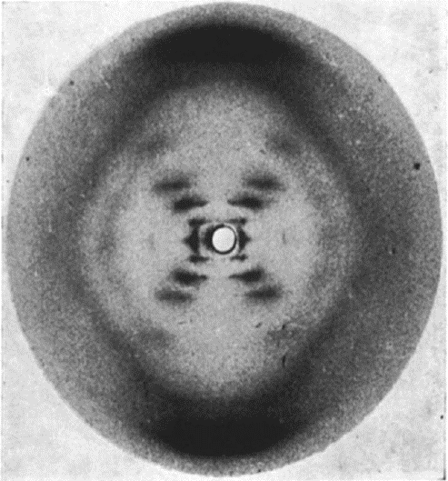

  - How is your project above different from or similar to Rosalind’s famous Photo 51 of DNA?

The projected image from the spring is much more vertically-stretched than Rosalind’s and is projected in color. Rosalind’s picture also seems to be blocked out near the center and limited at the edges. There’s also some irregularity in the bands that make up the “X,” as there is a gap after the first few bands and before the last one.
© Raymond Gosling / King’s College London

The projected image by the students is also much more likely to be very large (especially if projected a number of meters away).

  - What are some questions that you have about the meaning of your projection? (What kinds of questions do you think that Rosalind had about the meaning of her picture?) List at least three.

- Why does the pattern make an X?
- Do all helical springs make an X? (Is DNA, therefore, like a helical spring?)
- Why is my projection’s X more vertical?
- What do the dark and bright spots mean? (Why aren’t they just solid lines?)
- How can I use what I know about single and double-slit interference to make sense of these images?

  - To start making some sense of what is happening, hold the spring near your eye and look through it. Draw a picture of what you see – this is what the laser beam “sees” when it passes through it. Provide an explanation for where you think the “X” in the projection might come from.

Students might have some ideas, such as that the “front and back” coils overlap and cause an “X” (but they do not cross one another), so this is not a possible explanation. (Rather, the laser beam “sees” a zig-zag pattern, similar to what is drawn to the right). Students are also likely to be confused by the fact that light is going “around” an object, not through a slit. Students might recognize the fact that the front and back coils are angled with respect to one another, and that this might have something to do with what could be two angled diffraction patterns that appear to crisscross.

  - One thing that can provide some help in understanding is “Babinet’s Principle.” Just like light diffracts as it leaves a slit (which have internal edges), it diffracts as it goes around objects (which have external edges). Babinet’s Principle states that light will produce a pattern that is almost exactly the same whether it is going around an object, or going through a hole that has the same outline as the object.

Using Babinet’s Principle, explain how shining a laser beam through a spring is similar to what you have observed when shining lasers through slits.
Spring
“Cut-out” of a spring

Shining through a spring is like shining through multiple angled slits.

  - Let’s focus on TWO individual slits – one at a time.

What kind of pattern would be produced from the TOP slit, on the image below? Draw a simple sketch showing the correct type of pattern and angle of the pattern for the white, top slit. Explain your reasoning.

A simple single-slit diffraction pattern would be observed from the top slit, with a pattern that extends along an axis that is 90 degrees to the angle of the top slit.

The dotted line below represents the axis of the pattern, but does not accurately represent the diffraction pattern itself.

What kind of pattern would be produced from the BOTTOM slit, on the image below? Draw a simple sketch showing the correct type of pattern and angle of the pattern for the white, bottom slit. Explain your reasoning.

A simple single-slit diffraction pattern would be observed from the bottom slit, with a pattern that extends along an axis that is 90 degrees to the angle of the bottom slit.

The dotted line below represents the axis of the pattern, but does not accurately represent the diffraction pattern itself.

  - Given your answer to #5 above, what do you predict will happen to your projection if you squeeze the coils closer together? Draw a sketch, and explain why.

The angle of the axes of the X will change, because the angle of the “source slits” will change. It is equivalent to rotating a slit in front of a laser beam.
Many students will predict that the X will get “flatter,” although the opposite is true! (What is produced is a diffraction and interference pattern, not a shadow!)

  - Observe changes in the projection when you squeeze the spring. What happens? Is this different from what you predicted?

When the distance between the coils (pitch) gets smaller, the X becomes more vertical. In order words, as the horizontal angle between the front and back coils gets smaller, the vertical angle between the axes gets smaller as well.

  - Using only the projection on the wall, a protractor, and geometry, predict pitch angle of coils, 2α. Explain how you will accomplish this.

2α
2α

By creating a sketch above of the axes of the diffraction patterns, students can use simple geometry and right angles to determine that the pitch angle is a similar angle to the angle measured between the axes at the “top” or “bottom” of the X.

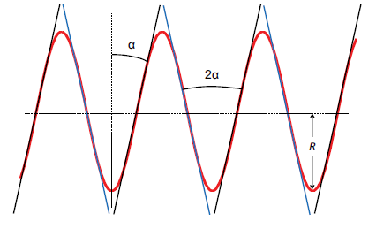
  - Using Photo 51 on the following page, and a protractor, what information can you glean about the geometry of DNA? How is it different from your spring?
DNA is also like a helical spring! The angle, 2α, is 71 degrees, so now the relative pitch can be known. The pitch angle of DNA is much greater than the pitch angle of most pen springs.

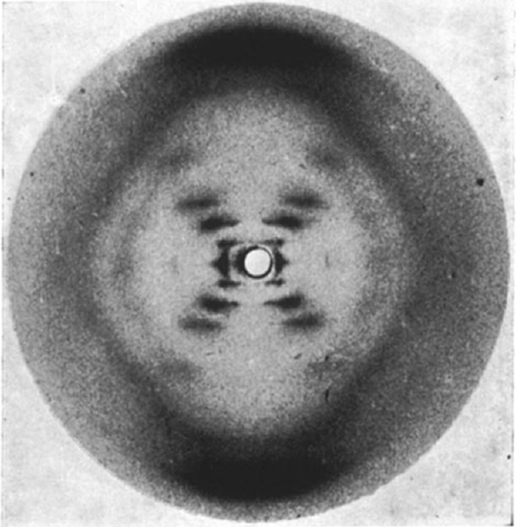

© Raymond Gosling / King’s College London

  - What other geometric properties of DNA might be necessary to get a full sense of what it looks like? What kind of test with your springs could you perform to find out how Rosalind might have gotten that information?
Diameter – test the projections through springs of varying diameter but same pitch and thickness.The above is possible to measure in the classroom, but it requires the use of a collimator, as described in Experiment 2 of the associated article.
Thickness of coil – test the projections through springs of varying coil thickness but same pitch and diameter. The above is possible to measure in the classroom (it corresponds to the relative distance between the “broad minima” along the axes of the X), as described in Experiment 1 of the associated article.

Lastly, one of Franklin’s great insights was that DNA was not a simple helical structure like a single piece of metal bent into a coil. In fact, DNA is composed of two strands wound together, more like a ladder that has been curved into a coil. She concluded this based on the missing spots in the axes of the X on Photo 51, caused by destructive interference of light resulting from the second coil.

