Nerve Science: Using Gelatin Circuits to Understand how Neurons Work through Physics and Biology

Student Worksheet

Purpose: Determine the volume of helium gas in an irregularly-shaped Mylar balloon.

Background (from “Bridging Physics and Biology Using Resistance and Axons” by Joshua M. Dyer):

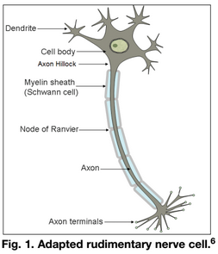
Neurons are nerve cells that are composed of three major sections, as shown in Fig. 1: the dendrites, the cell body, and the axon. These nerves cells transmit electro-chemical signals to cells such as other neurons, muscles, and endocrine cells. This signal transmission is, for example, how the brain tells muscles to contract. Multiple signals enter the neuron through the dendrites. The separate electrical impulses through these dendrites combine at the cell body. This signal then becomes attenuated as it travels through the cell body toward the axon hillock and is known at this point as the graded potential. This signal reduction is natural since the cell body is composed of cytoplasm, which has electrical resistance. An electrical threshold exists at the axon hillock, determining if an action potential will occur and the signal will continue to pass down the neuron. If the graded potential is smaller than the threshold, then an action potential will not occur and the signal will be stopped. Now, as the signal travels through the axon, it will attenuate further.
At each node of Ranvier including the axon hillock, the signal, assuming it stays above threshold, is reconstructed by a sodium ion channel located at the node, thus boosting the signal voltage up and mitigating the natural signal degradation. To aid in transmitting this signal, some animals, including humans, produce a fatty tissue called myelin, which insulates the axon from surrounding materials and minimizes signal leakage from the axon. The myelin also contributes to the capacitive properties of the axon and affects the speed that electrical impulses are transmitted through nerves. In humans, however, certain congenital problems can cause demyelination, allowing the signal to leak out of the axon between the nodes of Ranvier and fall below threshold, resulting in overall loss of the signal. Demyelination is believed to be the underlying cause of the disease multiple sclerosis.
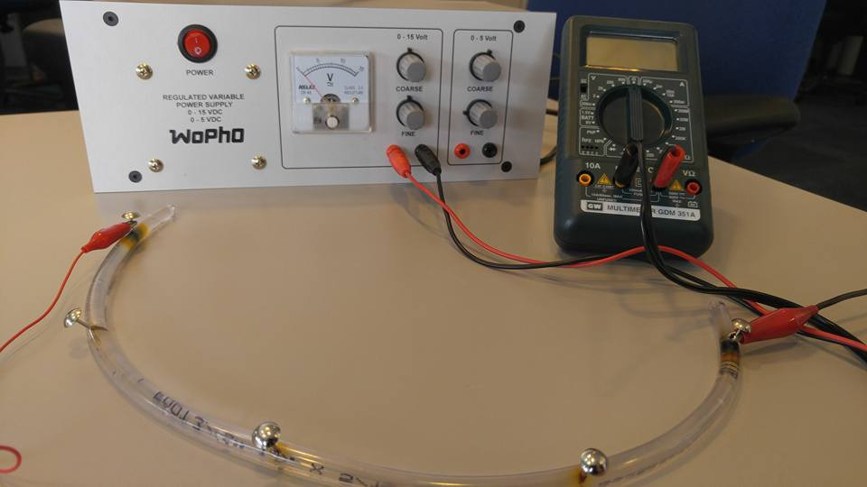

Guiding questions:

Prepare a “neural pathway” that includes a power source, a current meter, and a thin neuron with four segments. See the next page’s diagram, and check with your teacher to ensure that you have the correct setup before turning on the circuit!

Battery
A

  - Explain how the physical components above relate to the biological components of an organism’s nerve cells. How is this model accurate or insufficient?

  - On the diagram above, label the appropriate voltage increase across the battery, the current through the ammeter, and the current through each segment of the axon. Justify how you labeled these values (where did they come from?)

  - Determine the resistance of the full axon. Explain how you did this. If requested, provide a data set and a graph to support your answer.

  - With the assistance of a voltmeter, determine the voltage drops across each individual segment of the axon. What is the relationship of the voltage drop across each segment to the total voltage drop across the model axon? How is this different from / similar to what would actually be observed with a real neuron?

  - Determine the resistance of each segment of the axon, and label it on the diagram on the previous page under the current arrows. What is the relationship of the resistance of each segment to the total resistance of the axon? Explain why you think this is the case.

  - Given your observations of this model, what do you think is the relationship between the length of an axon and its resistance? After making a prediction and recording it below, collect data and produce a graph to determine the actual relationship.

  - Prepare a “neural pathway” with a thick neuron. Make the same observations and recordings on this diagram below as the one you did above for the thin neuron (questions #2, 3, 4, and 5).

Battery
A

  - Generally, what can you say about the electrical properties of a thick neuron compared to a thin neuron? Provide a rationale for your answers.

Resistance and Resistivity

  - You have observed that the resistance in an axon is dependent both upon its length, L, and its cross-sectional area, A (thickness). What other variables might influence the total resistance of the axon?

  - Proposal a possible mathematical expression that might describe this relationship algebraically. Provide a rationale for your thinking.

  - Access the “Resistance in a Wire” simulation (https://phet.colorado.edu/en/simulation/resistance-in-a-wire), and explain how resistivity, ρ, is modeled in the salted gelatin. Provide a possible explanation for how resistivity could be changed. (If time allows, modify the salted gelatin, and perform an experiment to determine if you were able to change the resistivity!)

  - Considering that salt is also the primary mode of conduction in animal cells (specifically, through sodium-potassium pumps), explain what you think might be the effects of the on nerve cell behavior and function if an organism is deprived of salt.

Modeling Signal Transfer

  - Using the thin neuron, acquire a single 47kΩ resistor and place it about halfway down the length of the tube, and between the probe end of the voltmeter and where the probe connects to the axon. Explain how the addition of this resistor models signal transfer from one tissue to another.

  - Assuming that 8V is the required threshold for the axon hillock and each node of Ranvier, what happens to the voltage of the neuron, and what happens to the total current flowing through the neuron when transferring the electrical signal?

Modeling Multiple Sclerosis and Demyelination
  - Demyelination of neurons results in weaker, slower signal transmission in nerves. Explain how the image below, using a set of 12kΩ resistors, models this.

  - What kind of physiological effects might you expect to see from a patient who experiences demyelination of their nerves?

  - Famously, the “giant squid axon” is a huge axon fiber with a diameter of up to half a millimeter. However, the nerve cell does not have any myelination at all. Explain why the axon is so large.

