UPC Science: The Real Prize Inside
Learning about Science and Spectra from Cereal Boxes
Inspired by The Physics Teacher’s:
“The Real Prize Inside: Learning about Science and Spectra from Cereal Boxes”
by Mary Bridget Kustusch, Jon D. H. Gaffney, and Robert Beichner

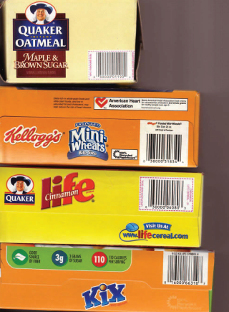
Description: Students use UPC codes from various products to develop hypotheses for the meaning of the barcodes.

Purpose: Model scientific processes through observations, identifying patterns, and making inferences and hypotheses.

NGSS Connections:
Disciplinary Core Ideas:
- Waves and Their Applications in Technologies for Information Transfer: MS-PS4-3, HS-PS4-4
Crosscutting Concepts:
- Patterns
Science and Engineering Practices:
- Asking Questions
- Analyzing and Interpreting Data
- Using Mathematics and Computational Thinking
- Constructing Explanations
- Engaging in Argument from Evidence
- Obtaining, Evaluating, and Communicating Information

Materials:
- Student worksheets with barcodes
- Variety of materials with barcodes (textbooks, cereal boxes, etc.). If possible, provide a variety of items that share the same manufacturer but are different products.

Prior Conceptual Understandings Required
- None

Lab Activities (in brief):
- Provides students with the four UPC bar codes (on their worksheet) corresponding to the four breakfast cereal boxes in the image above.
- Ask students make as many observations of the set of barcodes as possible, and to list those observations with their group. Whenever possible, make inferences about the barcodes.
- As a whole class, discuss what would be necessary to “disprove” their hypotheses about the barcodes (“proof” is not possible in science).
- Use the numeric code key and the unmarked barcodes to decode them, and to see if (1) hypotheses hold true or if they are disproven, and to (2) attempt to determine what corresponds to the unmarked barcodes.
- Encourage a discussion about how this activity relates to the process and content of science.
- Discuss the purpose of UPC codes and the benefits of transmitting information digitally.

UPC Science: The Real Prize Inside
Learning about Science and Spectra from Cereal Boxes
Student Worksheet
Note to teacher: Italicized commentary are notes for teachers. Red statements show sample correct student responses.

Purpose: Model scientific processes through observations, identifying patterns, and making inferences and hypotheses.

Guiding questions:
  - Barcodes on products are used to convey information about the product. A laser scanner at the check-out quickly processes the information so that the customer is charged the correct amount, and so that the store can keep track of inventory.

Using the box to the right, list as many “rules” about UPC codes as you can, using ONLY these UPC codes on the front page of this worksheet.
Rules about UPC Codes:
All the barcodes are black and white.
Every barcode begins and ends with two longer bars.
The codes for identical numbers located to the left and right of the longer middle bars are different.
Each code starts with zero (see article for discussion of this hypothesis).
The first five digits are the same for the same manufacturer.
There was a separate digit at the end (most notice the digit, but no one discerns the underlying checksum algorithm).

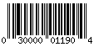
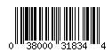
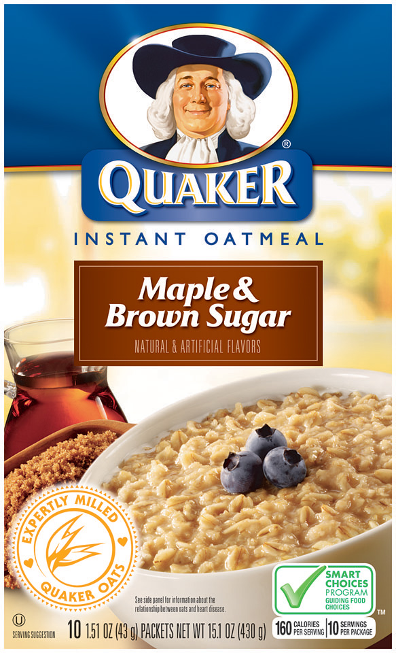

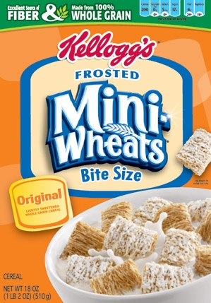


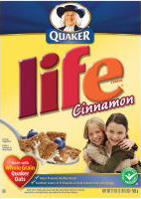

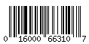
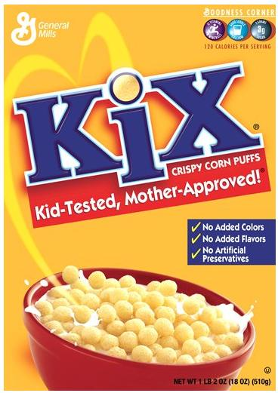
All UPC codes are associated with numerical digits. Combinations of lines of varying thickness represent numbers as shown in the key below:
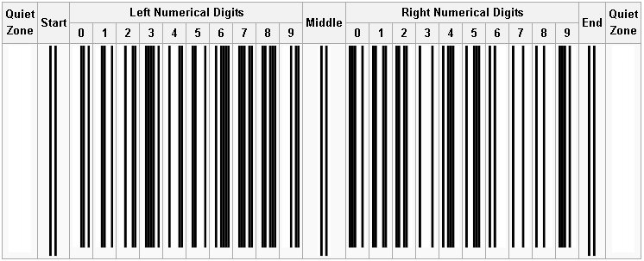
Numeric Code Key

  - Based on the new information above, what information can you glean from the following codes? Do all of the rules you developed earlier still apply? Explain.





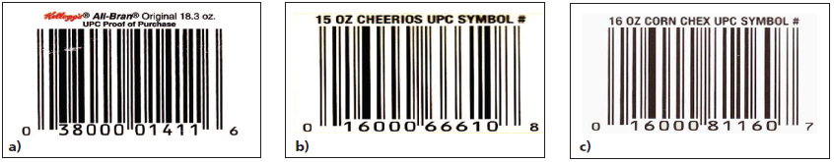
Based on the first five digits, it appears that the first product is from Kellogg’s, and that the last two are from General Mills. These items are also likely to be breakfast products.

See the answer key below:

  - What additional questions would need to be asked, or investigations would need to be done, in order to ensure that the rules you developed were accurate, and that you had identified all of the rules?
We would need to look at more UPC codes, especially from a wide set of products. Other questions to be asked could include, “Why are some lines longer than others?,” “Why are some of the numbers farther out on the ends?,” and “How is data information actually transmitted to the scanner?”

  - Why would someone want to transmit information about a product via UPC code anyway?
Answers will vary…see Teaching the Fundamentals of Cell Phones and Wireless Communications for information about how (1) Digital systems are more efficient, (2) Digital systems are more accurate, and (3) Digital signals can be encrypted for privacy and security.

  - This activity modeled science. If this were a scientific activity, would it be classified as an investigation or an experiment? Why?
This is an investigation, because we are primarily using observation techniques. In experimentation, we would be manipulating the natural world in order to see its effects.

  - How did this activity model science as being empirically-based?

Science is based upon observation evidence. Likewise, this activity required justification by evidence in the actual UPC codes as presented.

  - How did this activity model science as being tentative?

Scientific understanding can change over time. After looking at other UPC codes, it was clear that not all of the initially proposed rules held true!

