Lecture Tutorial: Auroral Currents

Description: This guided inquiry tutorial gives students the opportunity to practice and extend their knowledge of magnetic fields produced by current-carrying wires. They examine perturbations in the Earth’s magnetic field as measured by the International Real-time Magnetic Observatory Network (using data publicly available at www.intermagnet.org) to infer the direction and strength of currents running through the ionosphere. This resource is designed to supplement Lecture-Tutorials for Introductory Astronomy for lecture-style classrooms as well as for use in recitation or tutorial classrooms.

Prerequisite ideas:
● Right-hand rule for relating the current in a long wire and the direction of the resulting magnetic field
● Magnitude of the magnetic field produced a constant line current (as determined by Ampère’s law)

Some instructor notes:
● The side view diagrams are helpful for guiding students’ thinking. Even so, watch for students who may have difficulty recognizing that the B-field vectors are purely in the plane of the page.
● It may help to bring wires or lengths of string to serve as visual aids, especially if students need help with applying the appropriate right-hand rule.
● Watch for students who may struggle with part I.C (bottom of p. 2), as this task will likely be the first opportunity for students to work “backwards” from a known magnetic field to the current producing that field.

Suggested post-test problem:

The magnetic field at the origin of a (right-handed) Cartesian coordinate system is measured to be: B_{x} = + 450 nT, B_{y} = – 600 nT, B_{z} = 0. (Ignore the magnetic field of the Earth itself.) It is known that the source of this magnetic field is a very long wire that runs parallel to the z-axis and that carries a steady current of 2.25 A.

There are TWO (2) possible locations for this wire. For each possibility, (a) determine the exact location where the wire intersects the x-y plane, and (b) deduce the direction of the current. Clearly show all work.

Note: This problem is “near transfer” task that should be adequately handled by the students after the tutorial. The primary differences between this problem and tasks in this tutorial are as follows:
- The problem prompts students to find two possible locations of the current-carrying wire. In the tutorial, since the current had to be running above (not below) the tabletop, the students didn’t have to consider both options.
- The students must find the full distance between the observation point and the wire, rather than be told the “component” of that distance (which in the tutorial was along the z-axis).

In this tutorial we will explore the magnetic effects of auroral currents—currents in Earth’s ionosphere that are associated with the aurora (e.g., the “Northern Lights”). We will find that we can model their behavior using what we know about the magnetic field caused by line currents.

Review: Line currents as sources of magnetic fields
Imagine that you and a friend are studying magnetic fields by straight-line currents in a physics lab. You have started doing this by defining a coordinate system in which the directions of due north and due east—both parallel to your tabletop—are defined to be the +$\hat{i}$ and +$\hat{j}$ directions, respectively. (Note: In this section, ignore the effects of all sources of magnetic fields other than current-carrying wires.)

A. Which direction should you select for +$\hat{k}$, so that your coordinate system is right-handed? Explain.

Note: Your answer here in part A may seem an odd choice, but we will see how this choice will be necessary when we examine real data about Earth’s magnetic field.

B. Now imagine that you begin your experiments by setting up a long, straight wire so that it is oriented horizontally, at a uniform height (say, 6.0 cm) above your lab table, and so that it carries a steady (conventional current) flowing in the –$\hat{j}$ direction (westward). (See the perspective view diagram below left, and the side view diagram below right.)

Long current-carrying wire
Horizontal table
$$\hat{i}$$
$$\hat{j}$$
D
E
C
C
D
$$\hat{j}$$
$$\hat{i}$$
Current

For each of the following locations on the tabletop, determine whether each component of magnetic field (B_{x}, B_{y}, and B_{z}) due to the current-carrying wire are positive, negative, or zero at that location. Discuss your reasoning with your partners. (Hint: You should find one of these components to be equal to zero at all three locations. Which component, and why?)

- Location C: Directly below the wire (and hence, 6.0 cm directly beneath it)
- Location D: 8.0 cm due north of Location C
- Location E: 8.0 cm due east of Location C

Modeling currents associated with aurora
The aurora is created by electric currents from space that flow along the magnetic field into and out of the ionosphere. These charged particles move horizontally through currents called the auroral electrojets.

Imagine now that you and your partners—working as physicists for the U.S. Geological Survey—are reviewing magnetic field data from the College, AK, observatory (near Fairbanks, AK) that were taken on a day (November 3, 2017) of a small magnetic disturbance that produced auroral electrojet activity. The zero level in the plot below refers to the undisturbed magnetic field, so that deviations from zero in the magnetic field are due to the electrojets.

Note: The (right-handed) coordinate system used for these data is defined just as you have been using thus far in this tutorial: +$\hat{i}$ points due north and +$\hat{j}$ points due east. For our purposes, we will use only the data displayed in the first three graphs—for B_{x}, B_{y}, and B_{z} , respectively. The time (horizontal axis) is given in Universal Time (UT), which is also Greenwich Mean Time (GMT).
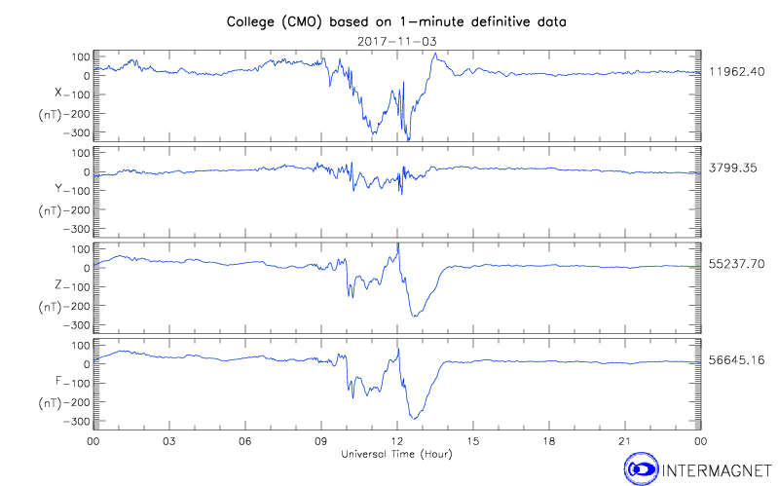

A. With your partners, explain how you can make sense of the magnetic field data at 1230 UT by approximating the auroral current as a line current running along a west-east line in the ionosophere near the observatory. Was the current (modeled as a conventional line current) running west or east?

B. You can make your results from part A more quantitative by using the plot below, which runs from 1000 UT to 1400 UT. Assuming that the auroral current can be modeled as a line current running through the ionosphere, at an approximate altitude of 100 km above the earth’s surface, deduce the following information about the current that was present at 1230 UT:

- Explain with your partners how you can tell that at 1230 UT the line current was not running directly above the CMO observatory. Was it instead due north or due south of the observatory?

- How far due north or due south (in km) was the line current?

- What was the (approximate) value of the current? (You may wish to use μ_{o} = 4π × 10² nT·m/A.)
(Note: Although the data below are plotted in nT, you should find the current to be rather impressive in size! If this had been a stronger magnetic disturbance—for which the perturbation to the magnetic field could reach as high as 2,000 nT—the current responsible for such a field would be approximately one million amperes.)

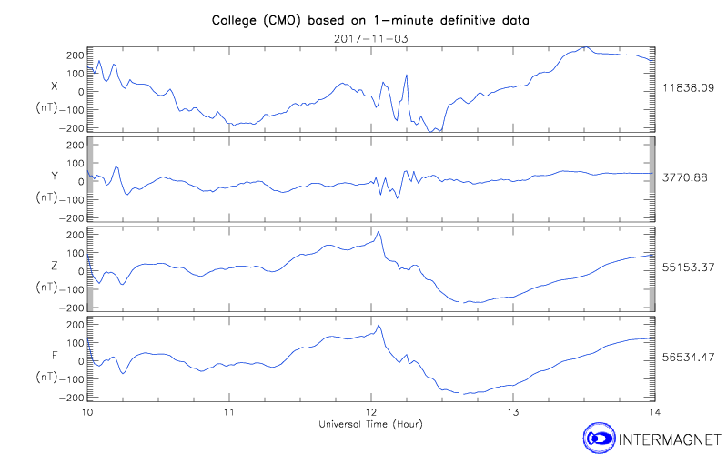

Data provided by the International Real-time Magnetic Observatory Network, www.intermagnet.org

