Thermopaper Science: Magic Patch
Inspired by The Physics Teacher’s
“A Student-Centered Interactive Color Quiz” by Edward P. Wyrembeck

Description: Students explore heat-sensitive, color-changing liquid crystal sheets.

Purpose: Students will understand how a change in temperature causes a material to absorb and reflect different wavelengths of light.
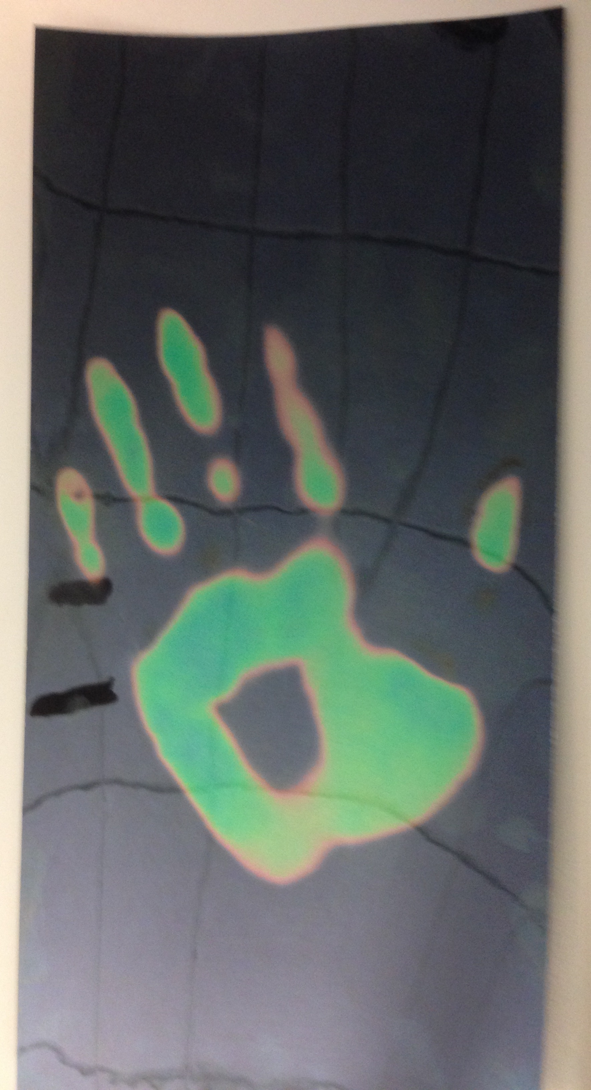
NGSS Connections:
Disciplinary Core Ideas:
- PS4.B: Electromagnetic Radiation
Crosscutting Concepts:
- Cause and Effect
- Patterns
Science and Engineering Practices:
- Developing and Using Models
Performance Expectations: Waves and Their Applications in Technologies for Information Transfer (1-PS4)
- 1-PS4-2
- 4-PS4-2

Materials:
- Magic Patch (1.5” x 1.5” patch of liquid crystal paper)
- Colored pencils/markers/crayons
Advanced Preparation:
- The magic patch reacts to temperature between 77° F and 86° F. If the patch is hotter or cooler than that range, it will be black. If your classroom is warmer than 77° F, you might need to go somewhere cooler in order to get the full effect of the patch.

Lab Activities for Students: Magic Patch

- Open up the plastic bag containing your Magic Patch, and try to remove it without touching it. Set it on the table in front of you, with the shiny side up.
- Place your thumb firmly against the top part of the patch for a few seconds, and take it away. What has happened to the patch? What is different? Watch carefully for the next few seconds, and observe what happens. The patch will change color when the warm thumb is placed against it, and will then quickly cool and change color eventually back to black. The patch will most likely be a dark blue when touched with fingers, but if it is sitting on a cold table then it may not reach that color, or it may change back to black very rapidly.
- Experiment with the patch a little more. Feel free to pick it up and hold it. What are the different colors it shows, and in what order? Fill out the chart below with your findings! The students should notice how the colors change with temperature. If it is held in their hands the color may fade more slowly than if it is against a cold table. They can change its color and then place it against a cold glass of water and watch it change almost instantly back to black. The range of colors observed should span the visible spectrum: red, orange, yellow, green, blue, indigo, and violet. Students, however, may identify less colors. The most obvious are red, yellow, green, blue, and perhaps purple. They may notice, though, that the color order is very similar to the ROYGBIV spectrum they have been taught, and identify the pattern.
The patch is colored in the pattern of the keyboard when placed against the cool keys.
Temperature | Color
Hot

Cool

- Where do you think the colors come from? Students will likely predict that the colors come from the heat in their hands.
- You might be surprised to learn that the colors do not “come from” the heat, but from the liquid crystals that are in the patch. Changing the temperature of the patch changes the orientation of the liquid crystals that are trapped against its surface. As the crystals change orientation, they begin to reflect different colors! Remember that we can see because light bounces off of the things around us and enters our eyes.
- When the patch is warm and its color is blue, which color is it reflecting? Remember that the light impacting the patch is white, which is a combination of all of the colors. Draw a diagram. The patch is reflecting whichever color it is at the time. When it is blue, it is reflecting blue light from the white light.
White light is made up of all colors,
but it is represented here as
red, blue, and green.
Only the blue light reflects.
- When the patch is cool and its color is black, which color is it reflecting? When it is black, it is absorbing all colors and reflecting none.
No light is reflected.
- What are some potential uses for these crystals? When might it be useful to detect heat using color? What if they could change color based on something else instead of heat?
Liquid crystals have been used as thermometers, as well as to create heat maps. The liquid crystals inside of your patch are also the same kind of crystals that are inside of Liquid Crystal Display (LCD) screens. In the case of those screens, the crystals change color based on voltage, not temperature.

