Balloon Science: Inviting Chemistry and Physics to the Party
Inspired by The Physics Teacher’s:
“Accurate Determination of the Volume of an Irregular Helium Balloon”
by Jack Blumenthal, Rafaela Bradvica, and Katherine Karl.

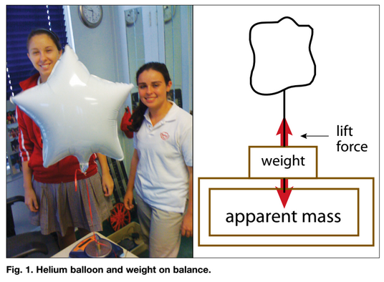
Description: In this application lab, students integrate chemistry and physics concepts by measuring the volume of helium in an irregular balloon using gas laws and force diagrams.

Purpose: Determine the volume of helium gas in an irregularly-shaped Mylar balloon.

NGSS Connections:
Disciplinary Core Ideas:
- Matter and its Interactions: MS-PS1, HS-PS1
- Motion and Stability: Forces and Interactions: MS-PS2, HS-PS2
Crosscutting Concepts:
- Systems and system models
Science and Engineering Practices:
- Developing and using models
- Analyzing and interpreting data
- Using mathematics and computational thinking
- Obtaining, evaluating, and communicating information
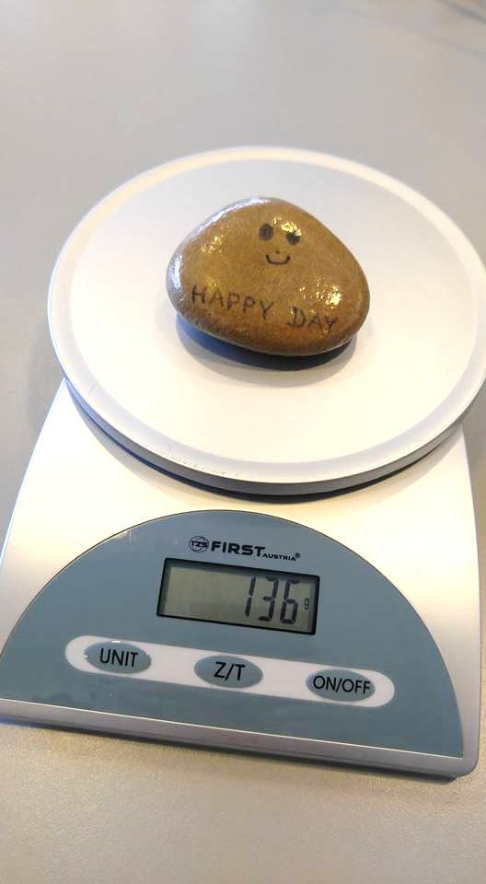
Materials:
- Mylar balloons partially filled with He (it is important that they be filled just under capacity to ensure that the pressure inside of the balloon is approximately equal to the pressure outside of the balloon)
- empty Mylar balloons
- ribbon, scissors
- mass or rock (enough to hold down the balloon and to not overload the electronic balance)
- electronic balance
- mobile device (to measure temperature, pressure, relative humidity) or access to local weather station data or probeware
- reference for gas constants

Prior Conceptual Understandings Required
- Ideal Gas Law (qualitatively and quantitatively)
- Conversions between mass, molar mass, and number of moles
- Conversions between mass and gravitational force (weight)
- Buoyant Force (variables that influence it, and how it is calculated)
- Free body diagrams (balanced and unbalanced systems, force vectors)

Modifications:
- To simplify this lab, consider presenting the traditional PV=nRT equation using PV=mRT, using the appropriate conversion factors for R.
- To simplify the math, it is possible to talk about the scale reading as “apparent mass,” but do so with extreme caution, as students are likely to struggle to make sense of force diagrams that reference “apparent masses” rather than “total force.”
- To increase the precision of this lab, consider using a hygrometer to determine the percent humidity of the air and to reference the appropriate ideal gas constant for the combination of dry air and water vapor surrounding the balloon.

Lab Activities (in brief):
- Suggested pre-lab activity: Determine the variables that influence buoyancy and derive the expression for buoyant force.
- Discuss what variables need to be known in order to determine the volume of a gas (and measure those that are known).
- Use force diagrams to determine how to measure the buoyant force on the balloon
- Relate PV=mRT to buoyant force (where R, T, P are known, and g is multiplied by an unknown volume to give an expression for buoyant force.
- Solve for volume.
- Suggested post-lab activity: Discuss/perform error analysis.

Balloon Science: Inviting Chemistry and Physics to the Party

Student Worksheet
Note to teacher: Italicized commentary are notes for teachers. Red statements show sample correct student responses. Highlighted yellow items are areas where students are likely to get “stumped.

Purpose: Determine the volume of helium gas in an irregularly-shaped Mylar balloon.

Guiding questions:

- What factors influence the volume of a gas?
Encourage students to think about the Equation of State for an Ideal Gas.
Pressure, the amount of gas, temperature, the gas constant. PV=nRT, so V=(nRT)/P

- Which of these factors can we measure or determine to calculate the volume? How will they be measured? If you can make the measurement, record it!

Factor | Describe how it could be measured | Record the measurement
P, pressure | Use a barometer (traditional, nearby weather station, or a smartphone). So long as the gas inside of the balloon is not completely filled, it is safe to estimate that the pressure of the gas inside of the balloon is equivalent to the pressure of the air outside of the balloon. | X Pa
n, number of moles | The number of moles is related to the molar mass (M_{He} = .004 kg/mol), which is also related to the total mass and weight. | ?
R, ideal gas constant | Look it up in a reference book. | R_{He} =  2077 J/kgK
T, temperature | Use a thermometer (traditional, nearby weather station, or a smartphone) | X K

- It’s more direct to measure the weight of the He gas, then determine the number of moles. Develop a procedure to determine the total weight of air present in the balloon. You have the following items available to you:
  - Electronic balance
  - Rock
  - Small piece of tape
  - Floating balloon filled partially with He, attached to a ribbon
  - Identical uninflated balloon and ribbon
  - Resources to get gas constants

It’s not as easy as placing the balloon on the scale and reading the numbers! First, encourage students to secure the balloon to the rock and place it on the scale.

Before you record the numbers on the electronic balance, draw force diagrams for the following:

Ask them to draw TWO force diagrams - one for the rock and one for the bag (balloon/ribbon/gas combination). Ensure that students do not overlook the buoyant force. Within reason, ensure that all of the force diagrams have proportional force vector lengths, and that each system is balanced. For added challenge, ask students to identify force pairs!
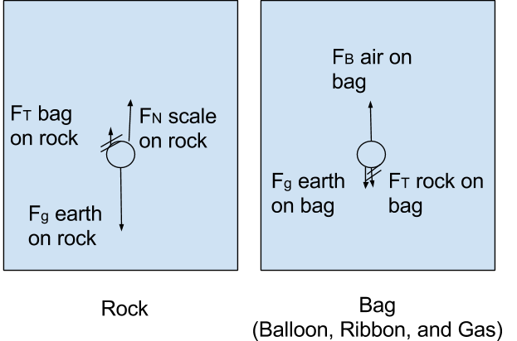

- Using the force diagrams to guide you, write an expression for the force that could be determined from the measurement on the scale.
F_{N scale on} _{rock} = F_{g Earth on rock} + F_{g Earth on bag} - F_{B air on bag}

- Break apart this expression so that you can get the force of the earth on the He gas (weight) alone!
Force on scale = F_{g Earth on rock} + F_{g Earth on balloon and ribbon} + F_{g Earth on He} - F_{B air on bag}

- Of all of these forces in the equation, how could we measure each one in order to have the weight of the He (F_{g Earth} on He) be the only unknown?

Factor | Describe how it could be measured | Record the measurement
F_{N scale on} _{rock} | Read the mass from the electronic balance, and multiply by gravitational force constant | X N
F_{g Earth on rock} | Remove the balloon and ribbon, read the mass of the rock, and multiply by the gravitational force constant. | X N
F_{g Earth on balloon and ribbon} | Place the identical uninflated balloon and ribbon on the scale and read the mass of the items directly off of the scale, and then multiply by the gravitational force constant. | X N
F_{B air on bag} | This is equal to the weight of the displaced air... | ?

- At this point, it seems as though the quest to measure the volume of the He in the balloon has only gotten more complicated! Using Archimedes’ Principle, explain what information must be known to determine the weight of the displaced air.
  - Number of moles of air displaced by the He
  - Molar mass of air displaced by the He

Typically, with two unknowns, scientist and mathematicians will use a “series of equations” Two equations with two unknowns each should solve this problem.

In the spaces below, start with the Ideal Gas Law, and create two separate expressions for the number of moles of He and displaced air.

 | He | Displaced Air
Expressions for n | PV = nRT  n_{He} = (P_{He}V_{He})/(R_{He}T_{He}) | PV = nRT  n_{air} = (P_{air}V_{air})/(R_{air}T_{air})

- Ultimately, we are interested in developing expressions for the weight of the He and the weight (buoyant force caused by) the displaced air so we can place it into the equation from 5. Rewrite the above expressions so that you could solve for mass, and then write a modified expression to solve for weight.

 | He | Displaced Air
Expressions for mass  (Hint: n = m/M)  M is molar mass for the substance | PV = nRT  n_{He} = (P_{He}V_{He})/(R_{He}T_{He})  m_{He}/M_{He} = (P_{He}V_{He})/(R_{He}T_{He})  m_{He} = (P_{He}V_{He}M_{He})/(R_{He}T_{He}) | PV = nRT  n_{air} = (P_{air}V_{air})/(R_{air}T_{air})  m_{air}/M_{air} = (P_{air}V_{air})/(R_{air}T_{air})  m_{air} = (P_{air}V_{air}M_{air})/(R_{air}T_{air})
Expression for weight | m_{He}g = (gP_{He}V_{He}M_{He})/(R_{He}T_{He}) | m_{air}g = (gP_{air}V_{air}M_{air})/(R_{air}T_{air})

- Using the expressions for weight, substitute these into the equation from 5.
Force on scale = F_{g Earth on rock} + F_{g Earth on bal + ribb} + ((gP_{He}V_{He}M_{He})/(R_{He}T_{He})) - ((gP_{air}V_{air}M_{air})/(R_{air}T_{air}))

- Explain what is similar and what is different about V_{He} and V_{air} in the expressions above. Provide a justification!
The volume of the He is equal to the volume of air that it displaced, so they are identical!

- Insert all known values, and solve for V!

Molar masses, M, and ideal gas constants, R, need to be referenced from a standard source. The ambient temperature and pressure are the same for the gasses. Ensure that students use appropriate conversion factors for g when determining total weight.
Force on scale = F_{g Earth on rock} + F_{g Earth on bal + ribb} + ((gP_{He}VM_{He})/(R_{He}T_{He})) - ((gP_{air}VM_{air})/(R_{air}T_{air}))

