Body Science: Determining the percent body fat of a sausage “cadaver” through the lenses of biology, chemistry, and physics

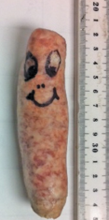
Student Worksheet

Purpose: Determine the percent body fat of a “cadaver” through hydrostatic weighing.

Guiding questions:

- What kinds of factors influence your total body density? (...or the body density of various sausages?) Why is an understanding of this important?

- Describe what fundamental factors you will need to measure in order to get the body density for your cadaver, and explain how you will measure it. If you can make the measurement, record it!

Factor | Describe how it could be measured | Record the measurement

- As you will note, no tool is available to measure the displaced volume of water by the sausage! Instead, you will need to determine the buoyant force acting on the sausage. Using only an electronic balance, your cadaver, and a string, explain how you will determine the buoyant force acting on the cadaver when it is suspended in the water. Draw a force diagram for the cadaver and for the water (before and after the cadaver is submerged) to accompany your explanation.

Cadaver and cup of water before the sausage is submerged in the water:

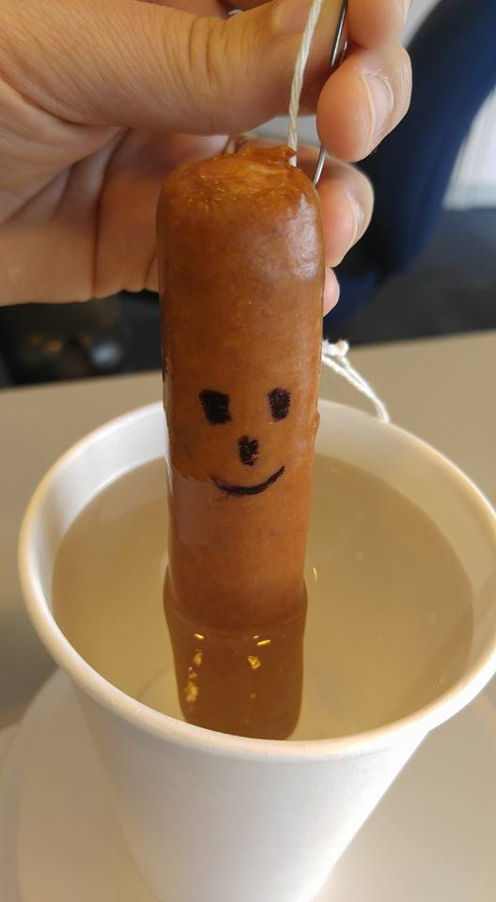

Cadaver and cup of water after the sausage is fully submerged in the water:

- Create an expression for the force of the scale when the cadaver is fully submerged in the cup of water. Explain how buoyant force can be measured indirectly.

- Describe how you will use the measurement of buoyant force to determine the volume of the cadaver, and then solve for the volume of the cadaver. Hint: ρ_{water} = 1 g/cm³

- Solve for the total body density of the cadaver.

- Reflect on the total density of the cadaver compared to the known density of water. Do your results make sense? Why or why not?

- The density of fat is 0.9 g/cm³, and the density of muscle tissue is 1.1 g/cm³. What does your value of total body density from #6 above suggest about the percent body fat (PBF) of your cadaver? Explain.

- The PBF of a person’s body is very important to health. Explain why it is not enough to know a person’s weight to determine if they are overweight or obese. Explain why it is not enough to know a person’s BMI (Body Mass Index).

- To determine the actual PBF, we need to differentiate between the total body, the tissue (muscle), and the fat.

$$M_{body}= ρ_{body}V_{body}= ρ_{fat}V_{fat}+ ρ_{tissue}V_{tissue}= ρ_{fat}V_{fat}+ ρ_{tissue}{(V_{body}-V}_{fat})$$

PBF is then defined as the total fat mass divided by total body mass.

$PBF= \frac{M_{fat}}{M_{body}}= \frac{ρ_{fat}V_{fat}}{ρ_{body}V_{body}}$ = $\frac{ρ_{fat}}{ρ_{body}}(\frac{V_{fat}}{V_{body}})$

Show, algebraically, how the above two expressions can be combined to result in:

$$PBF= \frac{ρ_{fat}}{ρ_{body}}(\frac{ρ_{tissue }- ρ_{body }}{ρ_{tissue }- ρ_{fat }})$$

Hint: Show that:

${ρ_{body}V_{body}= ρ}_{fat}V_{fat}+ ρ_{tissue}{(V_{body}V}_{fat})$ is equivalent to $\frac{V_{fat}}{V_{body}}= \frac{ρ_{tissue }- ρ_{body }}{ρ_{tissue }- ρ_{fat }}$.

- Using the expression above, and the densities of fat and muscle from #7, show how the PBF equation can be expressed as:
$$PBF= \left(495/ρ_{body }\right)-450 \%$$

- Calculate the PBF of your cadaver. Is your cadaver clinically obese? (Clinical obesity is body fat percentage in excess of 25% for men, and in excess of 32% for women).

- If available, check the nutrition information for your sausage. Does the calculated PBF value match up with the percentage of calories per sausage from fat? Explain how you made this comparison, and provide a rationale for why your calculated value might be different.

- The use of the sausage was a “model” for the human body. How might the sausage model be accurate or deficient? Explain.

