Microchip Report
Seed Group Meeting: March 1-2
AAPT: Rebecca Vieyra, Pat Callahan, Jack Hehn (guest: Caroline Hall)
AMTA: Colleen Megowan, Wendy Hehemann
Phys-TEC: Renee-Michelle Goertzen, Jon Anderson

Facilitated on March 1 by Terri Taylor, American Chemical Society

On 1 March 2016, the American Association of Physics Teachers (AAPT), the American Modeling Teachers Association (AMTA), and PhysTEC (collectively referred to as “the partners” in this document) came together as a result of funding provided by 100Kin10. On 2 March 2016, Rebecca Vieyra, Pat Callahan, Colleen Megowan, and Wendy Hehemann, joined briefly by Caroline Hall via teleconference, gathered for a few additional hours. This report provides a detailed summary of the items discussed and actions agreed upon. This report will be made available to both 100Kin10 and to the leadership of the partners. This report will be provided to the AAPT Board of Directors by March 11 in anticipation of the April board meeting to request approval for next steps in the Professional Development and Leadership Plan.

(Note: Due to the PhysTEC Conference, PhysTEC has not had the opportunity to fully review or endorse this report in advance of its submission to the AAPT Board of Director. Any views attributed to PhysTEC by the authors of this report may be unintentionally incomplete or inaccurate, and will be reviewed in full by PhysTEC at their convenience).

Contents
Seed Meeting Objectives 3
Collaborative White Paper 4
What is our greatest accomplishment through our K-12 PD&L programs? 4
What is our greatest unmet need in our K-12 PD&L programs and among those we serve? 4
What are the foundational principles of our K-12 PD&L programs? (Or, what should they be?) 5
What risk are we not yet taking that we should be taking in our K-12 PD&L programs? 5
What is our greatest vulnerability in our K-12 PD&L programs? 6
Meeting Outcomes 7
Vision 8
Defining the Needs of the Physics Education Community 9
Our “Customers” and Colleagues 9
Their Needs 10
Existing Playing Field 11
Define Existing PD&L: Offerings, Scope and Engagement, Impact, and Collaboration/Competition 11
Evaluate Existing PD&L: Offerings, Scope and Engagement, Impact, and Collaboration/Competition 12
Potential Future Collaborations 14
Qualifiers for Good PD&L 14
Potential Collaborative Opportunities 15
Additional Big Questions to Consider 16
Next Steps 17
Modifications to the Professional Development and Leadership Plan 17
Next steps in the Professional Development and Leadership Plan 17
Activities in Parallel 17
Addendum: Professional Development and Leadership Plan 19
Plan 19
Appendix A: Potential Taskforce Members 22
Appendix B: AIP and PhysTEC Data on High School Physics 24
Appendix C: Potential “storylines” for PD&L Models 28
Appendix D: Characteristics for Consideration of new PD&L Models 29

Seed Meeting Objectives

Overarching Goal: The AAPT, AMTA, and PhysTEC are seeking to create a new set of aspirational and coherent professional development and leadership (PD&L) models for the preK-12 physics education community in order to improve teacher practice and to retain excellence.
These proposed PD&L models should:
- Serve the needs of the wider physics education community
- Be of mutual benefit to AAPT, AMTA, and PhysTEC
Seed Meeting Objectives:
- Prepare a report for the AAPT Board of Directors and AMTA/PhysTEC Leadership detailing vision, existing playing field, potential future collaborations, and next steps in a Professional Development and Leadership Plan.
- Work in-tandem on next steps and parallel activities to advance collaboration.
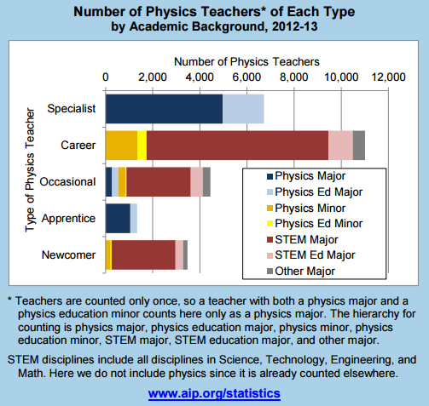
The “wider physics education community” is defined later in this document. However, data on high school physics teachers provides an excellent starting point.

Collaborative White Paper
Participants were asked to discuss responses internally with their organizations and to generate a cohesive answer to the following questions two weeks in advance of the meeting. This provided the group with some ground-work for exploring deeper questions at the meeting.
AAPT (responses in blue - please see non-condensed responses from Rebecca Vieyra, Pat Callahan, Steve Iona, and Caroline Hall here), AMTA (responses in red – provided by Colleen Megowan-Romanowicz), and PhysTEC (responses in green – provided by Monica Plisch/Renee Michelle Goertzen)

What is our greatest accomplishment through our K-12 PD&L programs?
I think AMTA’s executive board would point to the very existence of a sustainable national (becoming international) grassroots teacher organization of ~2500 teachers as probably at the top of our list of accomplishments, but I personally I think the creation and dissemination of 10 distinct Modeling Workshops in physics, chemistry, biology middle school science and physical science; 70 such workshops reaching ~1100+ teachers each summer should be at the top of the list (although without the first, the second could not happen).

PhysTEC’s greatest accomplishment is our promotion of Teachers in Residence (TIR) and the development of a PhysTEC TIR network. In the realm of PD&L for inservice teachers, TIRs bring together prospective and practicing teachers to meet and communicate on a regular basis. They design and deliver workshops to support local teachers and build stronger ties between physics departments and local physics teachers.

AAPT’s greatest accomplishments are the long-standing, nation-wide impact of our programs. PTRA’s rural and urban programs have been held at 32 and 23 different sites, respectively, over many years. We had significant impact on the development and revision of NGSS. Our programs reach teachers nationally and internationally through national meetings, our sections, and our online presence (comPADRE.org, eMentoring), and our publications (The Physics Teacher).

What is our greatest unmet need in our K-12 PD&L programs and among those we serve?
Our greatest unmet need is for sufficient dependable financial resources to ensure that our Workshops and the supporting curricular resources will continue to evolve and grow as teachers’ and their students’ needs evolve. We must continually revise and update what we do to optimize teachers’ ability to, for example, address special needs, utilize current classroom technology in their teaching practice and readily identify how what they are teaching aligns with national and state standards. One area in which this need is currently playing out is the need to develop Modeling Workshops to specifically address the needs of K-6 teachers, who currently attend our workshops for middle school teachers and then figure out how to adapt what they learn for use in their elementary classrooms.

It’s critical that new teachers receive support during the first few years that they teach, when they are most likely to leave the profession. Many PhysTEC teachers receive mentoring from the Teacher in Residence at the school where they were graduated, but when new teachers move away from their institution, they do not always find the induction support they need. Thus, it is essential all new teachers are provided with systematic, high quality mentoring and induction.

Our unmet needs include stable financial support for programs, a cohesive vision for programs that support teachers from induction through to teacher leadership, and resources that are both responsive to teachers’ immediate needs (lessons/labs/workshops) and support them long-term (community/leadership). These resources need to be well-advertised and valued in the physics education community. We need to meet teachers where they are - and find out more about what their needs actually are!

What are the foundational principles of our K-12 PD&L programs? (Or, what should they be?)
The Modeling Method of Instruction.

Physics teachers need both deep content knowledge and subject-specific pedagogical training to teach effectively. Thus, the PD&L programs must offer teacher opportunities to increase their knowledge of physics and how to teach physics.

AAPT connects high school teachers to teacher preparation programs, physics departments, and physics education researchers - collectively, the membership of AAPT define the principles of good physics teaching and preparation. Active, hands-on learning using research-based teaching methods should be at the core of all of our programs and resources. There are multiple good pedagogies: see PhysPort.org for a listing of these. AAPT does not endorse any particular method, curricula, or set of standards, although we have a series of policy statements that define our view on what teacher preparation, professional development, curriculum, and instruction in physics should look like. (Please see non-condensed responses with the full listing here).

What risk are we not yet taking that we should be taking in our K-12 PD&L programs?
We need to develop really good distance learning Modeling Workshops for teachers who cannot attend face-to-face workshops. We’ve taken some tentative first steps but they need to be refined and brought to scale, which means not only getting the Workshop syllabus and the technology platform right, but training Workshop Leaders to be effective in this learning environment.

We need to continue investing in distance learning options. Small numbers of future physics teachers at any one institution make it difficult to justify offering specialized coursework, and lack of instructor expertise can also be a barrier. PhysTEC and AMTA successfully piloted an online course, and developing it further would fill a critical need for both inservice teachers who can’t attend in-person workshop and teacher training programs that have small numbers of preservice teachers. We also need to build closer connections to existing networks such as AMTA.
In addition, ESSA is providing an opportunity that we should utilize by pursuing the development of STEM master teacher programs in all 50 states.

We need to revise, enhance, and more widely publicize the resources we currently have (PTRA lessons, TPT/AJP resource packets). We also need to think about programs that span a teacher’s career and be the discipline-specific voice in the wider education community (including CS, Eng., NGSS, AP). Encompassing this all, we need to adhere to a fluid framework to ensure that these efforts are done in parallel, yet following multiple pathways to meet the needs of various populations. This fluid framework needs to recognize innovation in our teachers, and be flexible enough to be responsive to changing demands of teachers and the workforce.

What is our greatest vulnerability in our K-12 PD&L programs?
At present our greatest vulnerability is our dependence on membership for cash flow. Despite the reach of our professional development offerings (90-hour workshops for over 1100+ teachers per year), they are not a profit center for AMTA. This results in an ongoing need for grant and contract income to meet expenses. At a time when the demand to develop new Modeling Workshops is growing rapidly, our ability to respond to meet that demand is slowed by the need to raise funds for every new initiative.

The greatest vulnerability is the changing business model in higher ed. As this model changes, we have to advocate to maintain support for faculty champions and for operating PD&L for teachers.

Our vulnerability is in the perceptions that others have of AAPT, including those of members, teachers, potential funders, or policy makers. Here are a few:
- Perception that discipline-specific PD is not useful for a teacher who teaches multiple science subjects.
- Perception that physics is irrelevant to careers that do not carry “physicist” in the title.
- Perception that membership in professional organizations is not important
- Perception that teachers need resources without appropriate pedagogical philosophy
Additionally, it is important for us to clearly define the emphasis and impact we want to have on the K-12 sphere (with core constituency being high school). We also need to balance the service we provide to the wider physics education community, while still paying the bills.

Meeting Outcomes
The seed group identified three overarching points of mutual agreement resulting from this gathering that they feel are the most important items for our respective leadership teams to know:
- Complementarity of Programs
A deep and broad analysis of our current offerings and our existing programs and principles demonstrated that our programs are complementary. It is possible to collaborate without any program “selling out. The most acceptable new programs would be ones that “package” our existing offerings together in a cohesive way, with possible modification of existing programs primarily as a “teaser” to our full offerings.

- Shared Identity: K-12 Physics Education Network
There is sufficient complementarity to promote and support a shared identity: all of our programs are teacher-driven, teacher-focused, and guided by principles that make teachers and students better. Collectively, our programs can be thought about as forming the “K-12 Physics Education Network.” New programs should ensure that the partners in this network benefit mutually, and that there is an appropriate “cycling” process that encourages teachers to interact with each partner collectively or separately at the appropriate point in their career (starting with the recruitment of physics teachers from K-12 populations, to pre-service, novice, in-service, experienced, and retired physics teachers).

- Connectedness: Shared Messaging and Branding
Because our programs can be accessed by teachers across the career spectrum, it is vital that we maintain a level of connectedness, shared messaging, and shared branding for collaborative efforts. Examples of shared messaging and branding might include sharing networks of teachers through streamlined communication channels, and even a shared logo. To accomplish shared messaging and branding, it will be vital to have a fluid, shared network of those in the wider physics education community. Central staff support to facilitate this connectedness (including vision, data management, communications, and marketing) will be vital, as will coordinated leaders throughout the network to communicate between the partners and at all levels.

Vision
Collaboratively, AAPT, AMTA, and PhysTEC are national and international leaders in physics education, physics education research, physics teacher professional development & leadership, and physics teacher preparation.
There are approximately 28,000 physics teachers nation-wide. Assuming that this number remains approximately equal over the next few years…
…in an ideal future…
- 18,000 Specialist and Career physics teachers are aware of the resources and services offered by AAPT, AMTA, and PhysTEC. Many are active members in AAPT and/or AMTA.
- 1,400 highly-qualified new physics teachers are prepared annually by a PhysTEC institution or are apprenticed into physics teaching positions by AAPT and/or AMTA professional development programs.
- 4,000 apprentice and newcomer physics teachers are supported by a discipline-specific teacher induction program throughout the duration of their early years.
- All physics teachers are aware of research-based instructional methods and curricular resources, and most use them effectively.
- All physics teacher turn to the AAPT and AMTA for their professional development and leadership needs.
- Physics teacher leaders turn to PhysTEC institutions to serve as Teachers In Residence, to inform good teacher preparation, and to bridge university-level physics education work with K-12 practice.
- Physics teachers are confident and competent practitioners in their field, and inspire a new generation of STEM-_{ready} students, physics majors, and future physics teachers.

Defining the Needs of the Physics Education Community

Our “Customers” and Colleagues
If our programs are to be responsive to the needs of the physics education community, it is important to identify the various groups of individuals that might have different needs. Some of these groups are population we already serve, and some are those who are not currently served directly but need more support. These groups were identified as follows:
- High school students interested in teaching physics
- Undergraduate/graduate students interested in teaching physics, but not enrolled
- Pre-service physics teachers (primarily HS, but also MS and pK-6)
- In-service teachers of physics (primarily HS, but also MS and pK-6)
  - Novice
  - Experienced
  - AP/IB
  - Physics First
  - Out-of-field (from other teaching fields)
  - Second-career (from technical fields)
  - Lone/isolated
  - “Forced” (those who are unwilling and unprepared)
  - “Occasional” (those who teach many other subjects, or tech physics irregularly)
  - Urban/rural
  - International/global
  - Interested in PER
- Post-service physics teachers
  - Retired teachers
- Informal physics/physical science teachers

Their Needs
In many cases, the needs of these teachers listed above overlap with one another. The following needs were identified and grouped by the types of need-based questions that teachers frequently ask:
- Who am I as a teacher of physics? This question suggests that teachers need:
  - A strong identity and understanding about their role and impact
  - A voice in local, state, and national physics education issues
  - To build their confidence levels as teachers and advocates
  - Pride in their craft and their profession
- Am I appreciated for what I do? This question suggests that teachers need:
  - Recognition (local, state, national, international)
  - Administrative appreciation
- Who can I turn to for help and to build/join a professional learning community? This question suggests that teachers need:
  - Mentoring
  - Communication channels (virtual – listservs, social media, sites)
  - Face-to-face support groups (active sections, alliances)
- Where can I find practical curriculum resources on teaching physics? This question suggests that teachers need:
  - Curricular guidelines
  - Lesson ideas/plans based on good PER and relevant to NGSS/other standards
- How can I improve my teaching practice? This question suggests that teachers need:
  - Pedagogical content knowledge-based teacher preparation and professional development
  - Education in cognition/metacognition
  - PD relevant to NGSS/other standards
- How can I become a physics teacher and maintain my credentials? This question suggests that teachers need:
  - Database of PhysTEC sites and PD providers
  - PD opportunities accessible to ANYONE regardless of location (graduate credit versus CEUs)
- Where do I go to get information on PD&L? This question suggests that teachers need:
  - Database of PD opportunities (including physics education graduate programs)
  - Database of leadership opportunities
- What kind of external support do I need to be successful? This question suggests that teachers need:
  - Support from mentors who are in similar school/climate situations
  - Support from administrators (and education for administrators) in terms of:
    - Time to do PD&L
    - Money to do PD&L
    - Appropriate evaluation methods

Existing Playing Field

Define Existing PD&L: Offerings, Scope and Engagement, Impact, and Collaboration/Competition

Broadly, the group felt strongly that each of the respective organizations offer complementary offerings, and that there is no need for us to step on each other’s toes. Some of the partners, in particular, felt that their programs were only intended to meet a specific set of needs, as is appropriate to their mission. Collectively, the offerings are comprehensive and can meet many of the identified needs of diverse teachers of physics. A lack of awareness and motivation from teachers is frequently more problematic than a lack of programmatic supports.
However, there is a persistent need to aggregate our work, position it different to the physics/general education/public community, and to more clearly and fluidly communicate it together.
The following items were shared by each of the respective associations in regard to their existing programs.
 | PhysTEC | AMTA | AAPT
Offerings | - Teacher-in-Residence programs and PD  - PhysTEC Site Teacher Advisory Groups  - Pre-service Modeling workshops  - TIR/VMT  - Connections to QuarkNet | - Modeling Workshops (summer, academic year, and online).  - HS/MS/TYC  - Physics: Mechanics, E&M, Waves/Light, CASTLE, Physical Sci/Physics First, WS leader training  - Chemistry, Biology, Earth Science, MS Phys Sci  - PD on request (teasers)  - Virtual teacher community  - Curriculum library  - Curriculum revisions | - PTRA Workshops and Summer Institutes  - eMentoring  - Conferences + Workshops (HS Teachers Camp / HS Teachers Day)  - Journals  - Webinars  - comPADRE  - Sections  - Committees (HS, preHS, etc.)  - Topical Groups (PER, Physics First)
Scope/ Engagement | - Pre- and In-Service Teachers  - Education of Physics Professors | - ~2,500 members (50% physics)  - Grade 6 undergraduate (including teacher prep and PER)  - Nationwide and becoming international | - ~2,000 HS teacher members (most are full-time/career physics teachers)  - Novice physics teachers (eMentoring, HS Teacher Camp/Day, PTRA workshops)  - Some “casual” physics teachers  - K-8 science teachers (PTRA workshop attendees)  - AACT/public (webinars)
Impact | - Changed the culture of physics departments so that they see physics teacher preparation as a part of their mission. | - Significant increase in student STEM achievement, interest, and identity.  - Teachers’ increased retention  - Offered at 5 teacher prep institutions | - Bridges pre-service, HS, 2YC, and 4YC faculty  - 55 PTRA urban/rural sites  - Policy (NGSS, ESSA)  - Pedagogy (PER, physport.org)  - Technology (Vernier, PASCO)  - Textbooks and Resources (Active Physics, comPADRE.org)  - International conferences and journals
Collaboration/  Competition | - Collaboration primarily exists at the leadership level between “all.”  - Little to no competition | - Collaboration: STEM teachersXYZ / alliances, AAPT, PhysTEC, Vernier, PASCO, LabAids  - Competition: Publishers and kit curricula, PLTW | - Collaboration: Co-lead PhysTEC, shared membership, 100Kin10 proposals, AACT (webinars/NSTA), OSA (outreach, equipment)  - Competition: NSTA, existing online learning resources, graduate programs, “flashier” programs with titles like “STEM” in them

Evaluate Existing PD&L: Offerings, Scope and Engagement, Impact, and Collaboration/Competition
After identifying the current programming, partners were asked to evaluate what needs were not being met by the programs, and what aspects they felt were particular points of strength, success, and pride.
Although the answers were quite varied, concerns continued to be raised around:
- Funding – not just the quantity to run the programs, but the challenge to play in the “big leagues” and to diversify our portfolios (not just NSF funding). There was also significant discussion regarding the fact that there is money for pay-by-participant programs, with teachers, schools, and districts covering the cost. There is a need for increased perception about the value of the programs.
- Growth and accessibility – all organizations recognized limitations associated with distance and scalability
- Community – similar to growth and accessibility, there is a clear need for face-to-face and online places where teachers can go for professional learning networks
- Awareness – although not explicitly laid out, it was clear from discussions that not all of the programs are being fully utilized by those teachers who are in need of services, in large part because of a lack of awareness that they exist.
 | PhysTEC | AMTA | AAPT
Offerings | - Continued need for sustainability and institutionalization in terms of people and money. (It rends to rely on a “champion.”) | - “Great programs are not scalable.” – How to maintain fidelity?  - Investment – Return – “What does it ‘buy’ me?”  - Distance learning – identifying “good enough-ness”  - Money – to prepare leaders, evaluate program, evolve | - Money to fund leadership development and core resource development  - Developing an identity for the resources – “What are we standing behind?”  - Accessibility to all who need services  - Conflicts associate with family responsibilities, other jobs, time, distance
Scope/ Engagement | - Some pre- and in-service teachers no longer have access to a TIR, because they no longer have a Phys-TEC supported site, the teacher has moved away from the site, or because the site never had a TIR as part of the program. | - K-6 teachers  - People who cannot attend face-to-face | - Casual, out-of-field physics teacher  - Lack of proactive presence in the K-6 physical science education space  - Minority/urban/rural teachers  - Middle-aged teacher with family
Impact | - The program helps to develop master teachers and their surrounding community. Teacher advisory groups often become active “sections.” | - Teacher confidence and competence  - Student STEM identity  - Teachers’ need/desire for community  - Often overlooked, some teachers believe they should “have it for free,” but it has been over a decade since there was adequate public funding to make this possible. | - PER is being brought to the HS level  - Teachers have a place to share and publish their resources professionally  - Existing structure for mentoring (not fully utilized)  - Need a better way to communicate PD&L engagement opportunities  - Need for blended/distance learning  - Need to reach out to STEM, CS, and Engineering fields  - Better implementation of NGSS in resources
Collaboration/  Competition | - Some pre-service teachers participate in partners’ in-service programs (i.e. Modeling, AAPT conferences). | - Collaboration is an opportunity to learn from one another.  - Because of its grassroots origins, AMTA’s capacity is often misunderstood.  - It is important to build community in-place. | - A lack of 100% collaboration is causing us to lose teacher between the gaps in their career spectrum.  - There is a big disconnect between pre-service and in-service offerings.  - Our networks are disjointed.
External Competition | - Other organizations seeking funding. | - There is finite funding to go around.  - Groups of people who think there is a “quick fix” (e.g. a program they can buy) and do not include teachers in decision-making. | - We are not as large or flashy as other organizations (i.e. NSTA, NCTM)  - Lack of physicist identity when they join the workforce (this has implications for funding)

Potential Future Collaborations

Qualifiers for Good PD&L
In our discussions, three primary qualifiers were identified that must be present in any future PD&L program. These programs must include the following:
- Improvement of Practice: Physics teaching must be improved by the proposed programs. Success in this area would look like:
  - Greater teacher confidence
  - Strong teacher identity
  - Teachers sharing what works
  - Increased subject matter expertise
  - Improved student outcomes
  - Recognition for the efforts of teachers
- Community Membership and Building: Programs should not be created in isolation. PD&L programs should prepare teachers to be a part of a long-standing professional learning network. This could be accomplished by:
  - Membership and engagement in existing organizations (AMTA/AAPT)
  - Online communities (listservs, social media, websites, distance learning resources)
  - Membership and engagement in local AAPT sections and alliances (STEM Teachers XYZ, physics alliances)
  - Cohort models
  - Mentoring models
- Administrative Support: Regardless of excellence in PD&L programs, teachers need the respect and authority to both engage in professional development and leadership and to teach students using research-based practices. More broadly, administrators need to value physics education. Garnering administrative support for PD&L programs and involvement by teachers might entail:
  - Campaigning for the value of physics in K-12 education
  - Educating them about the importance of PD&L to teacher improvement and retention
  - Helping them to appreciate physics and their physics teacher

Potential Collaborative Opportunities
Coordination of a “K-12 Physics Teacher Network”
The K-12 Physics Teacher Network would be a formalized entity of PhysTEC, AMTA, and AAPT and a coordination of our activities (somewhat akin to the AIP as the umbrella organization for the 10 major physics associations). Components of this coordination of existing programs that would be enhanced by this kind of collaboration might include:
- Network coordinator position to facilitate regular interaction between partners
- Coordination of a network of volunteers from respective partners around the nation to:
  - Identify and energize potential teacher leaders / master teachers for engagement in the network’s programs.
  - Serve as a resource person for physics teachers, especially novice physics teachers and those interested in physics education to direct them to the appropriate programs and sites.
  - Identify local, state, national, and international PD&L opportunities for physics teachers.
  - Submit “new ideas”
- Weekly or bi-weekly publication of relevant and timely physics teaching resources:
  - Teaching ideas (immediate-use)
  - Make + Take ideas (immediate-use)
  - “Best of” social media and blogs
  - Synthesized PER applicable to K-12
  - PD&L opportunities
  - Physics news bites (for teachers and students)
  - Physics education policy
P-TIMM (Physics Teacher Induction through Mentoring and Modeling) – HS-focus
As previously submitted as a Letter of Inquiry to 100Kin10 (see the “pitch” presentation given to 100Kin10 foundations), this collaborative effort would include:
- Induction program for PhysTEC graduates for the first two years in the field
- Master teacher paired with the novice teacher through the AAPT’s eMentoring program
- An online AMTA MMI online workshop
- Two full years of ongoing mentoring support, year-round professional development (based on PTRA and PhysPort.org curriculum and instruction materials), including video assessments done peer-to-peer between the mentor and mentee

Physics Ambassador Program – K-12-focus
This program would select previously-identified leaders in K-12 science primarily from the Presidential Award for Excellence in Math and Science Teaching (PAEMST) cohorts and semi-finalists, and other national teacher leaders (Einstein Fellows, State Teachers of the Year, PhysTEC TIRs, Toshiba/Shell awards etc.). These teacher leaders would be fast-tracked for a career of teacher leadership opportunities, as follows:
- AAPT/AMTA/PhysTEC might annually put on a week-long leadership experience to become a “Physics Ambassador,” alternating each year between K-6 and 7-12, as per the PAEMST awardee cohort that year.
- The week-long leadership experience might include:
  - 1.5-2 days of PTRA workshop “teaser”
  - 1.5-2 days of AMTA workshop “teaser”
  - 1-2 days of curriculum development by the teachers
  - (Introduction to grant-writing?)
  - Scholarship to attend a full PTRA Summer Institute or to “intern” at a full PTRA workshop, OR to attend a fully MMI workshop.
  - If the teacher has been identified as a teacher leader, the individual can be fast-tracked to become a PTRA or MMI workshop leader to be an ambassador for change in their own area.
- Additionally, it is possible that we might be able to work with some of the sponsors of the awarding organizations (i.e. Toshiba/Toyota/Exxon/Shell) to encourage them to sponsor this leadership institute as a carry-over of the impact of their recognition programs.

Additional Big Questions to Consider
- With whom should we ally?
  - Exhibitors/companies
  - Engineering and CS providers
  - Informal science educators/programs
  - “Big names” in science education (our membership, our invited speakers, celebrities)
- How can we extend our campaign for physics to those who really help students make career decisions?
  - Guidance counselors
  - Gate-keepers (families, communities, companies, universities)
- How can we influence federal policies that separate pre-service and in-service offerings – and funding? (They should reflect one another!)
- What existing models of PD&L currently exist?
  - Look at BSCS

Next Steps

Modifications to the Professional Development and Leadership Plan
The AAPT, AMTA, PhysTEC, and the AAPT Board of Directors can offer suggestions to the existing plan.

Next steps in the Professional Development and Leadership Plan
This report will be presented at the April AAPT Board of Directors meeting. Questions for the board include:
Timeline for Next Steps (in PD&L plan and in ongoing collaborative efforts)
- Seek funding for a Conference to bring together a Task Force to make a final decision about the type of PD&L programs we should pursue and to determine the mechanics for supporting the program. In parallel, we will begin to pursue funding for the potential collaborative programs that were identified in the meeting.
- Timeline:
- March: Present report to the board. Submit STEM+C NSF Proposal (AAPT/AMTA collaboration)
- April: Seek out and request NSF Conference Grant Funding (~$50,000 for 3 day gathering of ~25 Task Force members) through appropriate programs or calls for proposals. Identify other potential funding sources and backers. Revise P-TIMM program and re-submit to 100Kin10 through the LOI process.
- May: Prepare for 100Kin10 Modeling Physics, Computational Physics, and Bootstrap Grant (AAPT/AMTA collaboration)
- June: Continued preparation of Task Force and ongoing collaborative projects.
- July: Continued preparation of Task Force and ongoing collaborative projects.
- August: Participate in 100Kin10 Modeling Physics, Computational Physics, and Bootstrap Grant
- September/October: (Ideally) – Task Force Conference.
- AAPTWM17: Task Force Report to the Board. Final decisions. Development of “Working Team” by the Task Force. Work begins. (Fundraising and continued program development).

Activities in Parallel
AAPT, AMTA, and PhysTEC continue to collaborate under the guise of 100Kin10, and will continue to seek funding for programs that we have envisioned, including the P-TIMM proposal.

Addendum: Professional Development and Leadership Plan

Plan
AAPT High School Physics Teacher PD and Leadership Taskforce

Overview:
At the October 2015 Board meeting, a request was made for a forward-looking proposal describing possible professional development (PD) and leadership programs for high school physics teachers. In response, this proposal is presented under the expectation that the AAPT is seeking to expand its current offerings (including, but not limited to, the PTRA program). These offerings must address the diverse needs of the (pre)K-12 physics education community while meeting a variety of criteria to ensure that the selected programs are high-quality and sustainable.
This proposal aims to create a taskforce to address this multi-faceted challenge.

Prepare “seed” report for taskforce (late Winter 2016)
Before launching into idea-development for the AAPT, it is important that we recognize both our role with respect to our partner organizations in these efforts (notably, AMTA and PhysTEC), as well as take a deep evaluation of what we have done, are doing, and could be doing better.
Using a 100Kin10 Collaboration grant (Microchip), a “seed” group will come together to review the current major offerings for high school physics teacher PD and leadership, including the AAPT/PTRA, AMTA, and PhysTEC. This “seed” group will prepare a preliminary report to the larger taskforce that will provide the groundwork to help the AAPT understand its role in coordination with our partners. The report will include:
- Current offerings (What are we doing to advance physics education?)
- Level of engagement (Who is engaged in our programs?)
- Coordination (How are we working together to advance our goals? How could we improve?)
- Limitations and funding (What are the current obstacles and supports that our organizations have?)
- Standards and key characteristics (What defines our PD and leadership offerings? Is there compatibility between our programs?)
- Future vision (What are the long-term goals for our organizations?)
- Suggested opportunities for collaboration (Are there any collaborative efforts that are currently being overlooked that should be seriously considered by the Taskforce?)
By providing this report to the much larger taskforce, it will give all interested parties (especially any taskforce members who are “external” to our organizations) a realistic foundation upon which to build new ideas.

Prepare taskforce (Spring 2016)
The proposed taskforce members (Appendix A) would be called together (virtually) in the spring to set the goals of their task as well as to assign pre-work.
Goals:
- Define AAPT’s national/regional role in preparing and retaining high school physics teachers and physics education leaders.
- Determine multiple viable models for offering professional development and leadership opportunities to meet the diverse needs of our members and the general physics education community.
  - PTRA
  - Additional models
- Create an action plan for moving forward with trying new offerings
Pre-Work:
- Call for volunteers for the taskforce through Board appointments, HS Committee, pre-HS Committee, PTRA, and the general membership.
- Taskforce reviews the “seed” report from AAPT/PTRA, AMTA, and PhysTEC
- Taskforce reviews research associated with teacher needs (Appendix B)
- Taskforce shares examples of existing teacher PD an Leadership programs

Taskforce Activities (early Summer 2016)
Gathering: Three-day gathering (easier in the summer, but a long week-end during the school year is also possible). This gathering could occur at the ACP. Funding for this gathering could come from a 100Kin10 Microchip collaboration grant and/or from an NSF Conferences grant.
- Identify audience(s) (pre-HS, HS, in-service, pre-service, rural, urban, underrepresented, underserved, etc.)
- Identify needs (different needs for different audiences).
- Identify goals for PD and leadership.
- Determine what AAPT might select as a storyline to ensure coherence and continuity (Appendix C)
- Identify possible models.
- Rank models with respect to considerations (Appendix D)
- Generate new models / combination of models.
- Prepare a detailed implementation, business, and evaluation plan – one month, 6 months, 1 year, 5 year, 10 year.
- Identify needed support structures (volunteers/staff, infrastructure, technology, funding amount and sources).
- Determine next steps

Taskforce Deliverables (late summer/early fall 2016)
- Prepare a report to the board with next steps and rationale (to be presented at the SM 2016 Board gathering)
- Create PD and Leadership program oversight team

Appendix A: Potential Taskforce Members

(Individuals in bold have already expressed their interest in working on a collaborative PD and leadership discussion).
Role | Name | Additional Qualifications
BOD | Gay Stewart | NGSS
PTRA / PTRA Oversight | Karen Jo Matsler, Pat Callahan, Jan Mader, Katya Denisova | BOD, K-8 focus, Local (Katya)
AMTA | Colleen Megowan
Local Member / Section Leader | John Burk | Local
High School Committee | Diane Riendeau, Martha Leitz, Kelly O’Shea, Steve Iona | U-Teach, PhysTEC, AP
Pre-High School Committee | Jon Gaffney, Brian Jones
Techie | Frank Noschese, Lee Trampleasure, James Lincoln
eMentor | Marc Reif | AAPT eMentoring / New Teacher Center mentor
eMentee | Stephen Sholtas | Local, SCALE-UP (CIT), STEM Teacher Network
TIR PhysTEC | Marc Reif, Jon Anderson
PhysTEC | Monica Plisch | Local
EXTERNAL HS Teacher | Sally Mitchell  Ophelia Barizo | Local, AACT past-president, AEF  Local, STEM Coordinator, AEF
EXTERNAL K-8 Teacher | Florentia Spires | Local, AEF
EXTERNAL PD Provider | DaNel Hogan | AEF, runs STEMAZing project
Adviser | Jack Hehn
eLearning | Rebecca Vieyra
ComPADRE | Caroline Hall, Cathy Izrailson
International Committee | Recruit an international HS member (i.e. Jean Luc Richter) | Runs SoS iStage development, publication, and dissemination
NSF | Nafeesa Owens | Runs teacher leader programs at NSF (RETs, PAEMST, works with Einstein program, etc.)
ACS/AACT | Susan Mitchell, Terri Taylor, Adam Boyd | Past AACT president, ACS rep, AACT EO

Appendix B: AIP and PhysTEC Data on High School Physics

Teacher Needs Data

AIP Data on High School Physics
https://www.aip.org/statistics/reports/highschool
The data below provides some fundamental insights into the needs of high school physics teachers. (Questions for the taskforce: Do these needs differ for pre-HS teachers and informal physics educators? Are there additional groups (i.e. underrepresented and underserved groups) that might not be fully represented in this data?)
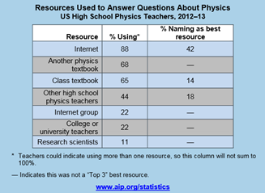
High School Physics Teacher Preparation (September 2015)
o 40% teachers have taken a “physics teaching” university course
o Despite similar teacher preparation, women feel significantly less prepared to teach basic physics, applying physics, use of demonstrations, computer use, and recent developments.
o 59% of physics teachers consider themselves to be physics specialists
o Teachers view the Internet as the best, most frequently used source for answers to physics questions.
o 35% of physics teachers took a workshop, 25% took a lab, and just under 25% attended a professional association meeting

Underrepresented Minorities in High School Physics (June 2015)
o Blacks and Hispanics continue to be underrepresented in high school physics classes.
o Physics is less likely to be offered or to have high student enrollments in schools that are “worse off” than other schools in the local area.
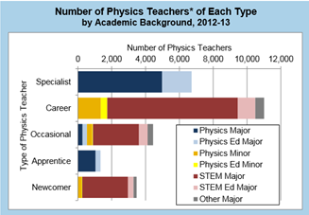
Who Teaches High School Physics? (December 2014)
o 27,000 high school physics teachers
o 24% have an AAPT membership (national and/or local section)
o 32% graduated with a degree in physics or physics education
o 32% teach physics exclusively
o 40% primarily teach non-physics
o The proportion of teachers with a major or minor in physics or physics education has declined slightly from 1993 to 2013.

What High School Physics Teachers Teach (December 2014)
o Most physics teachers are self-taught and teach out-of-field.
o Of the 27,000 physics teachers at the time of this study:
§ 15,000 hold a degree in STEM or STEM Ed (but not physics or physics ed)
§ 8,600 hold a degree in physics or physics ed
§ 3,000+ have degrees from outside of STEM fields
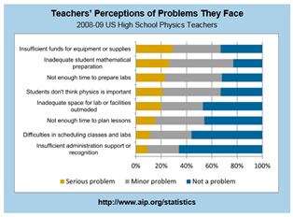
Challenges High School Teachers Face (April 2012)
o The most frequently cited challenges are insufficient funds and lack of student preparation in mathematics.
o Since 2001 to 2002 (as reported in 2007), 28% of elementary districts have decreased time spent on science (by 75 minutes per week, on average), and 45% have increased time spent on mathematics (by 89 minutes per week, on average).
o In 80% of schools where physics is taught, the physics teacher is the only physics teacher.

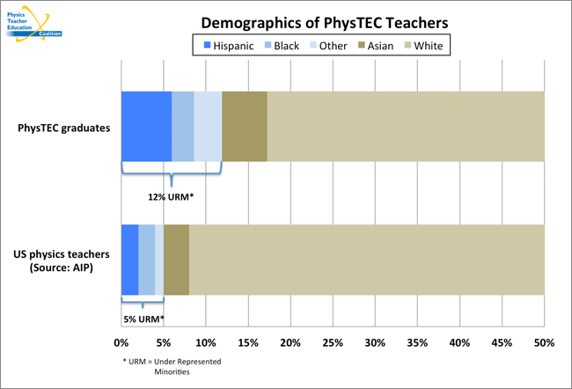
PhysTEC Data on High School Physics
http://www.phystec.org/Outcomes/

Demographics of High School Physics Teachers
- 12% of PhysTEC graduates are underrepresented minorities (URM).
- 5% of physics teachers are URM.

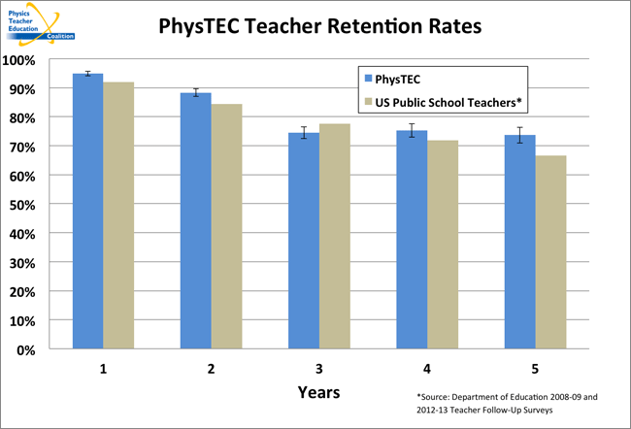
Teacher Retention Rates
- PhysTEC retention rates are slightly higher than the average for K-12 public school teachers
- On average, about 30% of PhysTEC graduates leave the classroom after five years.

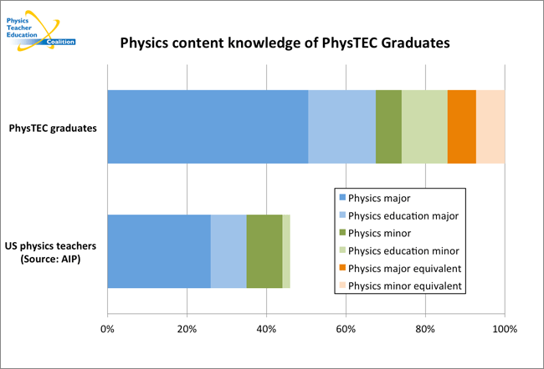
Physics Content Knowledge

Appendix C: Potential “storylines” for PD&L Models

Appendix C: Potential “storylines” for PD and leadership models
o Framework for the NGSS
o “Physics in the NGSS” document
o Framework components:
§ Disciplinary Core Ideas
§ Crosscutting Concepts
§ Science and Engineering Practices
o Research-Based Teaching Methods (RBTMs) – See PhysPort’s 14 RBTMs created for HS and 23 RBTMs adaptable to HS. Some of the more widely used selected methods are:
o PhET Interactive Simulations
o Teaching with Clickers
o Diagnoser Tools
o Modeling Instruction
o Minds-On Physics
o Physics Union Mathematics
o Peer Instruction
o Ranking Task Exercises in Physics / TIPERs
o Physics and Everyday Thinking
o Mentoring
o PD and leadership go hand-in-hand
o Professional learning community-based PD
o Curricular Supports
o PTRA Resources
o AAPT Publications
o AAPT Films
o Aeronautics for Introductory Physics

Appendix D: Characteristics for Consideration of new PD&L Models

The following are a list of some characteristics that should be considered when looking at any PD and leadership model. (Questions for the taskforce: What characteristics might be missing or irrelevant? What characteristics are the highest priority?)
Dimension | Details
Addresses a physics teacher need | · Physics knowledge  · Physics pedagogical content knowledge  · Community  · Resources  · Leadership  · Mentoring
Employs research-based practices for PD | · Discipline-specific  · Focuses on implementation (not just learning)  · Over time and ongoing  · Coaching and mentoring  · 80-120 hours to effect significant changes
Employs research-based practices for physics education | · See PhysPort.org for a listing of research-based Teaching Methods.
Cohesive | · Relies upon a set of AAPT principles or guidelines  · Branded as an AAPT national program
Builds teacher leadership | · Empowers teachers to be agents of change.  · See www.teacherleaderstandards.org
Flexible and Broad | · Can engage multiple teachers at many levels (local, section, national) and through multiple media (in-person, online, in print, etc.)  · Serves the broader physics education community (members + non-members)
Retains participants year-to-year | · Ongoing (but refreshed) engagement each year.
Engages new participants each year | · Room for growth in participation.
Actively welcomes teachers of diverse backgrounds | · Selection process encourages participation of teachers from under-represented groups
Cost | · Grant-funded (NSF, Corporate, Private, etc.)  · National, state, local  · District  · Teacher
Return on Investment | · Sustainable  · Development of “products” or “resources”  · Member benefit
Multiple learning pathways | · In-person  · Online  · Blended
Teacher Incentive for Engagement | · Graduate Credits  · CEU’s  · Money  · Digital Badges  · Recognition  · Free Membership or Perks  · PhysMTL Certification
K-12 Spectrum | · Has potential to grow to incorporate teachers across the K-12 spectrum, including teachers who do not routinely identify themselves as “physics” teachers.

