Nerve Science: Using Gelatin Circuits to Understand how Neurons Work through Physics and Biology
Inspired by The Physics Teacher’s:
“Bridging Physics and Biology Using Resistance and Axons”
by Joshua M. Dyer
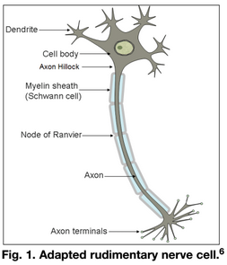

Description: Students model signal transmission along a model “neuron” by sending a small electric current through a vinyl tube filled with salted gelatin.

Purpose: Determine the relationship between resistivity of an “axon” and its length and cross-sectional area. Model demyelination of an axon, and understand its impact on neural transmission.

NGSS Connections:
Disciplinary Core Ideas:
- Matter and its Interactions: MS-PS1, HS-PS1
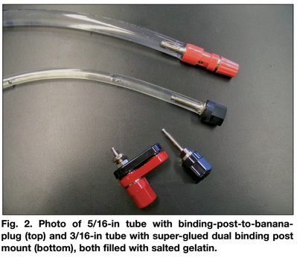
- Motion and Stability: Forces and Interactions: MS-PS2, HS-PS2
- From Molecules to Organisms: Structures and Processes: MS-LS1, HS-LS1
Crosscutting Concepts:
- Patterns; Cause and effect: mechanism and explanation
- Systems and system models
- Energy and matter: flows, cycles, and conservation
- Structure and function
Science and Engineering Practices:
- Developing and using models
- Analyzing and interpreting data
- Using mathematics and computational thinking
- Obtaining, evaluating, and communicating information

Materials:
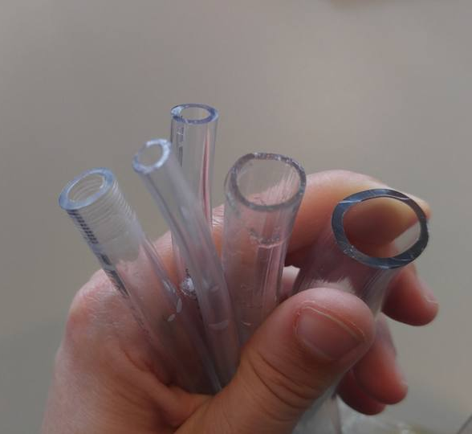
- flexible vinyl tubing of varied diameters (at least two – one thick, and one thin)
- binding-post-to-banana-plugs (or any kind of plug/stopper)
- super glue (optional)
- needles or metallic flathead tacks
- clear gelatin (1 packet)
- salt (1 tsp per packet of gelatin)
- multimeters (with ammeter and voltmeter capabilities)
- variable power source
- 12kOhm resistors

Advanced Preparation:
- Cut the vinyl tubes to 1.5-3 ft. in length.
- Place tacks or needles along the tubes to represent the nodes of Ranvier (they can also be added later) at points every 5 cm down the tube.
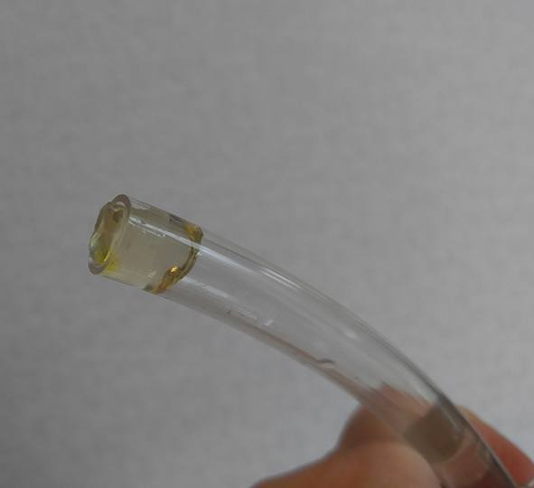
- Stopper one end of each tube with a binding-post-to-banana-plug or some other stopper. Gummy candies work well as cheap alternatives.
- Prepare one gelatin packet as described, adding in 1 teaspoon of table salt per packet.
- Using a funnel, pour the salted gelatin into the tubes.
- Stopper the other end of the tube.
- Refrigerate the tubes.
- If desired, mount the tubes on a ruler or meter stick using paper clamps to keep the tubes linear.
- Resistivity probes can be fashioned from 12kΩ and 47kΩ resistors, needles, and 0.924-mL micro vials – see the TPT article for details.

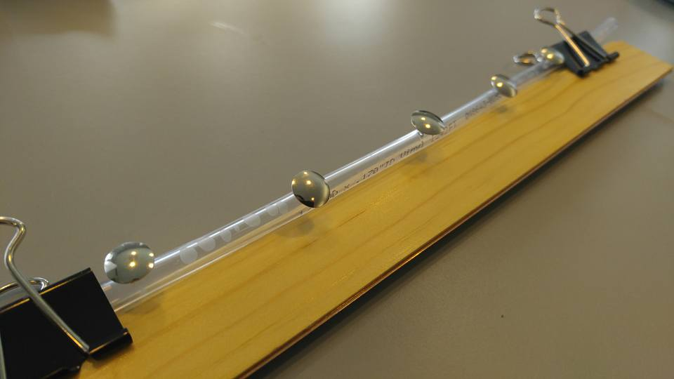
Activities (in brief):
- Discuss electricity in the human body.
- Introduce how axons are thought to behave
- Investigate how differences in length and cross-sectional area could influence axon function.
- Collect data on resistance versus length, and resistance versus cross-sectional area.
- Introduce probes - investigate effects on resistance (and information transfer).
- Discuss impacts of demyelination on the human body.

Prior Conceptual Understandings Required
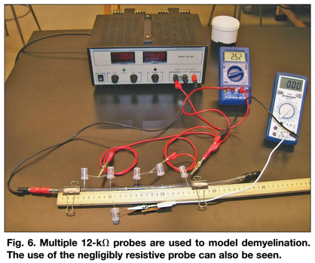
- Current, voltage/voltage drops, resistance
- Simple circuit setup
- Use of an ammeter and voltmeter

Modifications:
- Instead of using needles at the nodes of Ranvier, use metallic thumb tacks.
- If binding-post-to-banana-plugs are not available, seal the ends of the tubes with caulk or “gummy” candy.

Nerve Science: Using Gelatin Circuits to Understand how Neurons Work through Physics and Biology

Student Worksheet
Note to teacher: Italicized commentary are notes for teachers. Red statements show sample correct student responses.

Purpose: Determine the volume of helium gas in an irregularly-shaped Mylar balloon.

Background (from “Bridging Physics and Biology Using Resistance and Axons” by Joshua M. Dyer):

Neurons are nerve cells that are composed of three major sections, as shown in Fig. 1: the dendrites, the cell body, and the axon. These nerves cells transmit electro-chemical signals to cells such as other neurons, muscles, and endocrine cells. This signal transmission is, for example, how the brain tells muscles to contract. Multiple signals enter the neuron through the dendrites. The separate electrical impulses through these dendrites combine at the cell body. This signal then becomes attenuated as it travels through the cell body toward the axon hillock and is known at this point as the graded potential. This signal reduction is natural since the cell body is composed of cytoplasm, which has electrical resistance. An electrical threshold exists at the axon hillock, determining if an action potential will occur and the signal will continue to pass down the neuron. If the graded potential is smaller than the threshold, then an action potential will not occur and the signal will be stopped. Now, as the signal travels through the axon, it will attenuate further.
At each node of Ranvier including the axon hillock, the signal, assuming it stays above threshold, is reconstructed by a sodium ion channel located at the node, thus boosting the signal voltage up and mitigating the natural signal degradation. To aid in transmitting this signal, some animals, including humans, produce a fatty tissue called myelin, which insulates the axon from surrounding materials and minimizes signal leakage from the axon. The myelin also contributes to the capacitive properties of the axon and affects the speed that electrical impulses are transmitted through nerves. In humans, however, certain congenital problems can cause demyelination, allowing the signal to leak out of the axon between the nodes of Ranvier and fall below threshold, resulting in overall loss of the signal. Demyelination is believed to be the underlying cause of the disease multiple sclerosis.
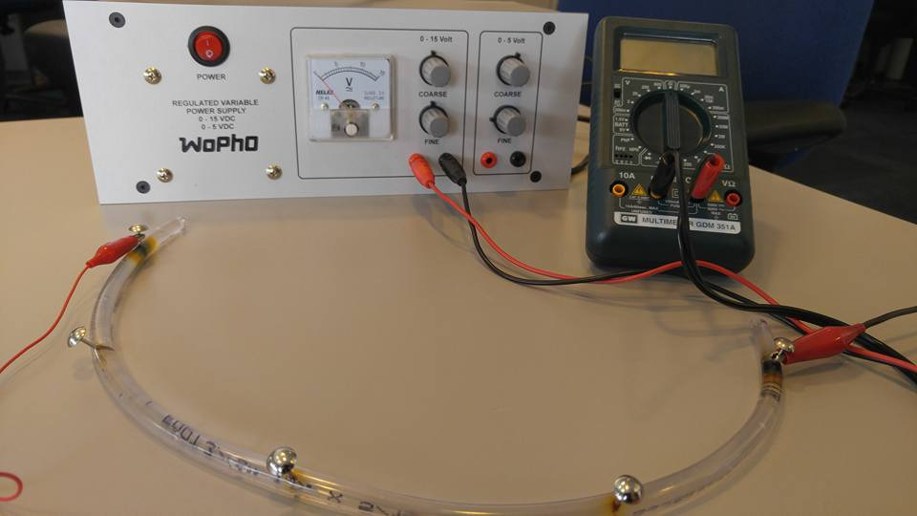

Guiding questions:

Prepare a “neural pathway” that includes a power source, a current meter, and a thin neuron with four segments. See the next page’s diagram, and check with your teacher to ensure that you have the correct setup before turning on the circuit!

Battery
A

  - Explain how the physical components above relate to the biological components of an organism’s nerve cells. How is this model accurate or insufficient?

The model is fairly accurate in representing the following components of a neuron:
- whole circuit neuron
- vinyl tube and gelatin axon
- positive terminal of the power source cell body
- negative terminal / ground of the power source axon terminal
- needles or tacks along the axon nodes of Ranvier

The model is insufficient in the following ways:
- The cell body normally receives electrical impulses from multiple dendrites, not from a single power source
- The axon is normally covered by the Myelin sheath – this is not directly represented by any physical component. (Note: The thickness of the tubing does NOT represent the Myelin sheath).
- There are multiple axon terminals for most neurons

  - On the diagram above, label the appropriate voltage increase across the battery, the current through the ammeter, and the current through each segment of the axon. Justify how you labeled these values (where did they come from?)

Ensure that students use an external voltmeter to measure the actual voltage increase by the power source – sensors internal to the power source are frequently inaccurate, and will differ from the multimeter used to measure voltage drops across the individual components. The current registered on the ammeter should be the exact same value that is listed as flowing through each segment of the axon.

The voltage across the battery is _____ V. (Using a standard DC power source, this number should be somewhere between 0-15 V). This was measured by placing the two ends of a voltmeter right at the terminals of the power source. The current through the ammeter is _____ A. Because there is a single pathway for electricity to flow, this amount of current in the same in each segment of the axon.

  - Determine the resistance of the full axon. Explain how you did this. If requested, provide a data set and a graph to support your answer.

Using the voltage drop across the full axon and the total current flowing through it, Ohm’s Law can be used to calculate the resistance.

Students can be asked to collect multiple data points and to produce a graph of V vs. I, as shown below. The slope of the graph shows the average resistance.

  - With the assistance of a voltmeter, determine the voltage drops across each individual segment of the axon. What is the relationship of the voltage drop across each segment to the total voltage drop across the model axon? How is this different from / similar to what would actually be observed with a real neuron?

When added up, the voltage drop across each segment is equal to the total voltage increase across the battery. In real life, this relationship would be more complete, because the axon hillock actually increases the potential of the signal before transmitting down the axon.

  - Determine the resistance of each segment of the axon, and label it on the diagram on the previous page under the current arrows. What is the relationship of the resistance of each segment to the total resistance of the axon? Explain why you think this is the case.

When added up, the resistance of each segment is equal to the total resistance of the axon. This is because each “segment” is like a resistor in series.

  - Given your observations of this model, what do you think is the relationship between the length of an axon and its resistance? After making a prediction and recording it below, collect data and produce a graph to determine the actual relationship.

Using this model, longer neurons have a higher resistance.

  - Prepare a “neural pathway” with a thick neuron. Make the same observations and recordings on this diagram below as the one you did above for the thin neuron (questions #2, 3, 4, and 5).

Battery
A

  - Generally, what can you say about the electrical properties of a thick neuron compared to a thin neuron? Provide a rationale for your answers.

Thick neurons have much less resistance than thin neurons. More current is observed flowing through the thick neuron.

Resistance and Resistivity

  - You have observed that the resistance in an axon is dependent both upon its length, L, and its cross-sectional area, A (thickness). What other variables might influence the total resistance of the axon?

The actual material in the vinyl tube (i.e. the gelatin and the salt) influence the total resistance. The percent of conductive material in the gelatin will also influence this.

Students might refer to “conductivity.” Be sure to guide students toward an understand of resistivity, which is the inverse of conductivity. Resistivity is the ability of a material to impede electron flow.

  - Proposal a possible mathematical expression that might describe this relationship algebraically. Provide a rationale for your thinking.

Resistance and length are directly related (as length increases, resistance increases by the same factor), so R ∝ L. Resistance and thickness seem to be inversely related (as thickness increases, resistance decreases), so the simplest relationship could be R ∝ 1/A. Resistance is also likely to be directly proportional to L, so the simplest relationship could be R ∝ ρ. In sum, the most likely relationship is R = (ρ L)/A.

  - Access the “Resistance in a Wire” simulation (https://phet.colorado.edu/en/simulation/resistance-in-a-wire), and explain how resistivity, ρ, is modeled in the salted gelatin. Provide a possible explanation for how resistivity could be changed. (If time allows, modify the salted gelatin, and perform an experiment to determine if you were able to change the resistivity!)

The resistivity is modeled by the percentage of salt in the gelatin. If the amount of salt were to be increased, then the resistivity would be decreased.

If possible, prepare in advance a number of axons with various amounts of salt that students may use for testing. (Extension: Prepare quantities of axons with known amounts of salt, and allow students to determine the relationship between the total resistance and the amount of salt. Then, provide students with an additional axon with an unlabeled amount of salt, and let them determine the quantity).

  - Considering that salt is also the primary mode of conduction in animal cells (specifically, through sodium-potassium pumps), explain what you think might be the effects of the on nerve cell behavior and function if an organism is deprived of salt.

Salt deprivation (hyponatremia) results in overall loss of muscle function.

Modeling Signal Transfer

  - Using the thin neuron, acquire a single 47kΩ resistor and place it about halfway down the length of the tube, and between the probe end of the voltmeter and where the probe connects to the axon. Explain how the addition of this resistor models signal transfer from one tissue to another.

This demonstrates how the electrical signal in neurons weakens from one nerve cell to the next (and shows why the axon hillock is important for increasing the potential of the signal).

  - Assuming that 8V is the required threshold for the axon hillock and each node of Ranvier, what happens to the voltage of the neuron, and what happens to the total current flowing through the neuron when transferring the electrical signal?

Although there is no difference in the initial potential (voltage) of the electrical signal before and after adding the resistor, there is an overall decrease in current along the neuron.

Modeling Multiple Sclerosis and Demyelination
  - Demyelination of neurons results in weaker, slower signal transmission in nerves. Explain how the image below, using a set of 12kΩ resistors, models this.

Resistors are added along the entire axon. This decreases the voltage much more quickly and therefore decreases the current. Some of the signals will get so weak that they might be unable to transfer along the axon or to another tissue.

  - What kind of physiological effects might you expect to see from a patient who experiences demyelination of their nerves?

Slow response rate, loss of movement, problems thinking, digestive problems, etc.

  - Famously, the “giant squid axon” is a huge axon fiber with a diameter of up to half a millimeter. However, the nerve cell does not have any myelination at all. Explain why the axon is so large.

Because demyelinated nerve cells lose their signal so quickly losing it to the outside along its path, a large axon is necessary for the squid to be able to carry a much higher amount of current yet still make it along the long axon.

