Geo-Electric Field Science: Using Topographic Maps and Clay Models to Teach Electric Field and Potential

Student Worksheet
Note to teacher: Italicized commentary are notes for teachers. Red statements show sample correct student responses. Highlighted yellow items are areas where students are likely to get “stumped.”

Purpose: Draw, build, and interpret electric fields using topographic maps.
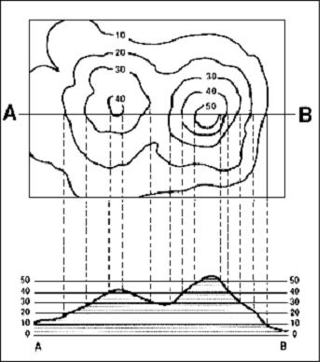
Credit: USGS
Background: Electric fields can be visualized by thinking about a gravitational field on a topographical map. In this activity, you will first make sense of a topographical map, then make a physical model to draw. Topographic maps give a sense of the three-dimensional shape of a landscape, such as in the image shown to the right. Contour lines give information about elevation. Visualizing a topographical map by looking at a profile can also be helpful. In the image to the right, a profile for the line drawn from points A to B is show immediately beneath it.

Guiding questions:

Look closely at the topographical map of a Hawaiian island on the following page. Answer the following questions in regard to the geographical information it presents.

  - What is constant along the contour lines?

  - What is indicated by a region where the lines close on themselves, such as around points A, B, C, or D?

  - In the space below, draw a profile view for a line that cuts directly West-East and through point D.

  - Imagine you allowed a ball to roll down from point D. How would the motion of the ball be different if it rolled eastward versus westward? Why?

Using clay, make a three-dimensional model of the island to the best of your ability. Using a sharp pencil, engrave at least 10 contour lines.

  - Before moving on, get approval of your clay model with contour lines by your teacher and get your teacher’s signature:

Using a dropper, drop individual droplets of water onto your clay model’s peaks, and note the direction that the droplets flow. Using a sharp pencil, draw in at least 20 small arrows showing the path of the water droplets.

  - Before moving on, get approval of your water droplet paths by your teacher and get your teacher’s signature:

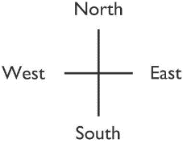
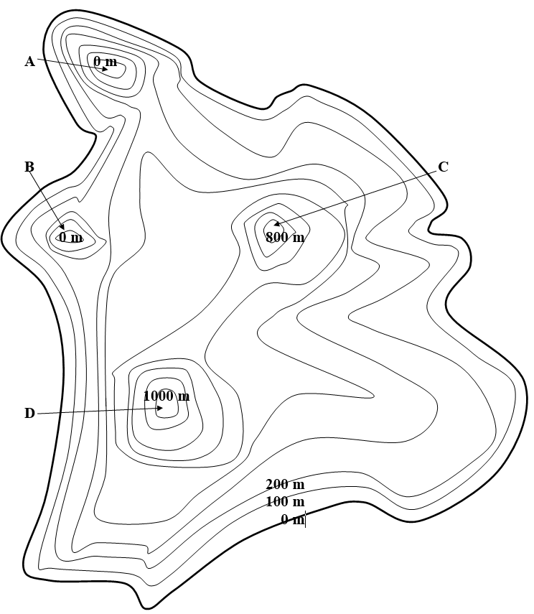

Now consider both the topographical map and the clay model of the island as if it represented an electric field. Note: For the purpose of this activity, assume that strong positive charges are the source of positive electric potential, represented by high altitude on a topographical map. In contrast, assume that strong negative charges are the source of “ground,” or a potential of zero.

  - What would be located at points A, B, C, and D? (What makes the mountains and valleys in an electric field?) Explain.

  - What would cause points C and D to have differing heights?

  - What is represented by the water’s path? Explain.

  - What is represented by the contour lines? Explain.

  - Return back to your profile view from question 3.

      - On which side of point D is the electric field the strongest? How do you know? Label a corresponding area on the graph as “E.”

      - On which side of point D is the electric field the weakest? How do you know? Label a corresponding area on the graph as “F.”

      - Describe how the motion of a moveable charged particle might be different if it moved down either the eastward or westward side of point D. Explain how you know.

  - Would it ever be possible for a charged particle to flow along a contour line? Why or why not? (Would it ever be possible for a water droplet to flow along a contour line?)

  - What must be true about a clay model to have an electric field of zero? Can this only happen at “sea level”?

  - Look closely at the geometric relationship between the contour lines and the rain lines. What is their relationship?

  - Describe the motion for a freely-moving positive test charge placed at the following points:
    - A:
    - B:
    - C:
    - D:

  - Describe the motion for a freely-moving negative test charge placed at the following points:
    - A:
    - B:
    - C:
    - D:

  - Using the image on the following page of a hilly terrain and the two sample “field lines,” draw in at least 10 field lines, including arrow heads to show direction. Note: As few elevations are given on this map, you may assume that the graph displays peaks only, and no valleys.

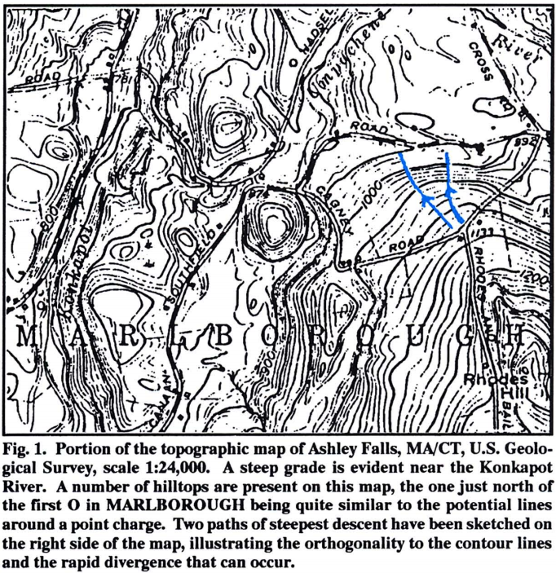

  - Using the image below, describe how you would use clay to model the two point charges below. If it’s helpful, include a profile sketch of this image, or create a clay model.

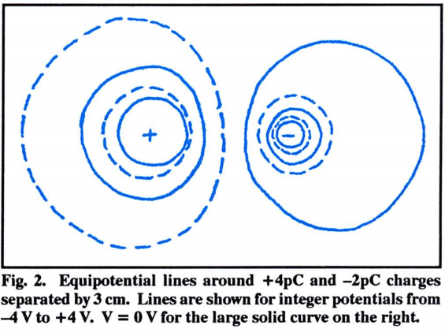

  - Observe James Lincoln’s Electric Field Visualized with Crystals YouTube video.
      - For each of the following scenarios, draw in the electric field lines (using arrows to denote direction), and equipotential lines.
      - Describe the electric field as a three-dimensional shape.
      - Include a profile sketch (of a horizontal mid-line passing through it) of the three-dimensional shape.

Two Point Sources (Dipole)
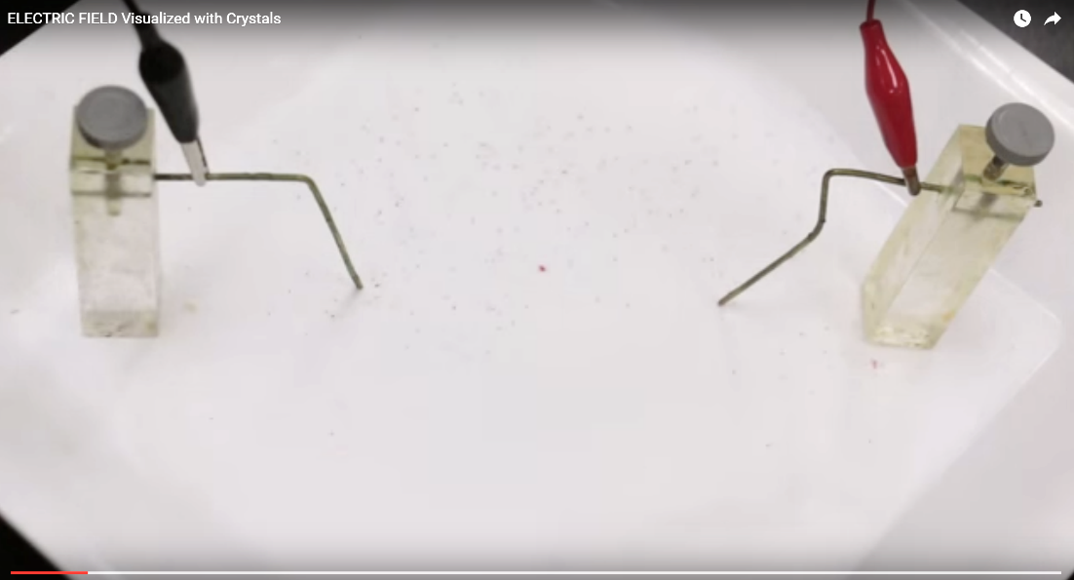

Point Source and Bar

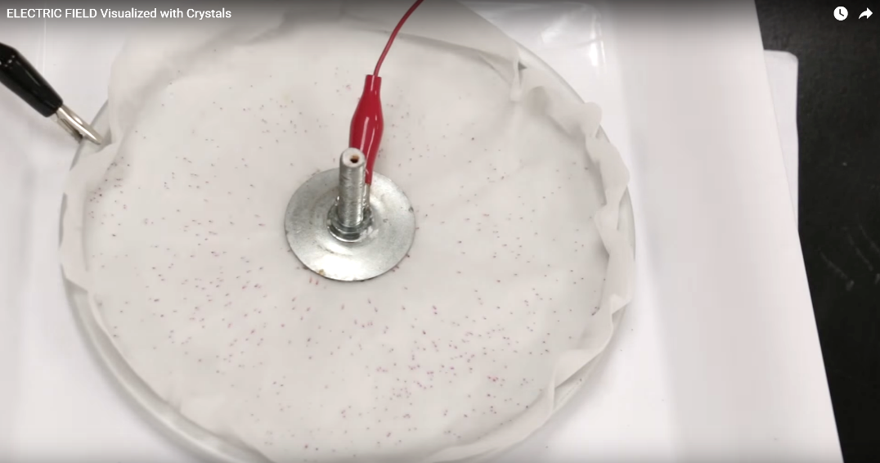
Point Source and Ring

Two Bars (Parallel Plate Capacitor)

  - Reflect back on both topographical maps and electric field maps. In paragraph form, describe the similarities and differences between them and how particles might interact differently in those fields.

