Concept Questions: Angular Momentum

Description: These questions with selected response answers test specific concepts relating to orbital angular momentum (factors that affect the magnitude of angular momentum, angular momentum as a vector quantity).This resource is designed to be used either as homework or in small discussions with methods such as Peer Instruction, Teaching with Clickers, or CAE Think-Pair-Share.

- Understanding the factors that affect the magnitude of angular momentum

Requisite concepts:

Angular momentum is conserved in orbits (central forces). The magnitude of angular momentum is equal to mrv for circular (or nearly circular) orbits, where v is the magnitude of the orbital velocity.

In addition, for question 1.1, students must be familiar with what makes annular eclipses different from total solar eclipses (both with regard to the phenomena themselves and the role played by the Earth-Moon distance for each). The differences in the observations that one would make during both kinds of eclipses can best be represented or demonstrated with images/pictures of actual annular/total solar eclipses.

For question 1.5, students must understand that the frequency of eclipses is affected by the (synodic) orbital period of the Moon (the shorter the period, the greater the likelihood of the Moon and Earth lining up with the Sun near a nodal crossing).

1.1. During an annular solar eclipse, the Moon’s orbital velocity is:
- greater than that during a total solar eclipse
- equal to that during a total solar eclipse
- less than that during a total solar eclipse
- cannot tell without more information

[based on Peer Instruction for Astronomy, Paul J. Green (Prentice Hall, 2003), p. 79.]

Ans. for 1.1: (c)

1.2. The Moon is farther from the Earth during an annular solar eclipse than during a total solar eclipse. During which of these types of solar eclipses does the Moon have a greater orbital velocity?
- annular
- total
- the orbital velocity is the same magnitude for each
- cannot tell without more information

Ans. for 1.2: (b)

1.3. In the distant future, imagine we are able to change the orbits of objects in the solar system by attaching giant rockets to them. Imagine we are able to do so with the Moon, by attaching rockets that gradually push the Moon in the direction of its orbital velocity. Which would result?
- Annular solar eclipses would become less common, and the Moon’s orbital velocity would increase.
- Annular solar eclipses would become less common, and the Moon’s orbital velocity would decrease.
- Annular solar eclipses would become more common, and the Moon’s orbital velocity would increase.
- Annular solar eclipses would become more common, and the Moon’s orbital velocity would decrease.

Ans. for 1.3: (c)

1.4. In the distant future, imagine we are able to change the orbits of objects in the solar system by attaching giant rockets to them. Imagine we are able to do so with the Moon, by attaching rockets that gradually push the Moon opposite the direction of its orbital velocity. Which would result?
- Annular solar eclipses would become less common, and the Moon’s orbital velocity would increase.
- Annular solar eclipses would become less common, and the Moon’s orbital velocity would decrease.
- Annular solar eclipses would become more common, and the Moon’s orbital velocity would increase.
- Annular solar eclipses would become more common, and the Moon’s orbital velocity would decrease.

Ans. for 1.4: (b)

1.5a. In the distant future, Disney Imagineers want to produce solar and lunar eclipses with greater frequency. They can accomplish this by attaching giant rockets to the Moon that can very gradually push the Moon. Which would be the optimal plan for the Imagineers to follow?
- Have the rockets push the Moon in the direction of its orbital velocity.
- Have the rockets push the Moon opposite the direction of its orbital velocity.
- Have the rockets push the Moon perpendicular to its orbital velocity.
- None of these plans would create more frequent solar eclipses.

Ans. for 1.5a: (a)

1.5b. In the distant future, Disney Imagineers want to produce solar and lunar eclipses with greater frequency. They can accomplish this by attaching giant rockets to the Moon that can very gradually push the Moon. Which would be the optimal plan for the Imagineers to follow?
- Have the rockets push the Moon in the direction of its orbital velocity.
- Have the rockets push the Moon opposite the direction of its orbital velocity.
- Have the rockets push on the Moon’s north pole.
- Have the rockets push on the Moon’s south pole.

Ans. for 1.5b: (a)

Concepts tested:

Questions 1.1 and 1.2 probe whether or not students can correctly determine apply angular momentum conservation by recognizing that increasing (decreasing) the orbital distance results in decreasing (increasing) the orbital velocity.

Questions 1.3 and 1.4 probe whether or not students can correctly determine that increasing (decreasing) the angular momentum will result in increasing (decreasing) the orbital distance and decreasing (increasing) the orbital velocity.

Questions 1.5 a & b probe whether or not students can correctly attribute an increase in orbital velocity to a decrease in orbital period for the Moon, and hence an increase in likelihood of the Moon, Sun, and Earth lining up with one another at/near a nodal crossing. Note: These questions, including the distractors, are still in development; after classroom testing and testing with focus groups the version of the question with the strong detractors will be retained.

B. Understanding the angular momentum as a vector quantity

Requisite concepts:

Vector angular momentum is conserved in orbits (central forces). The direction of angular momentum is perpendicular to the plane of orbit. Students need to know that an eclipse happens when the Moon crosses the ecliptic plane along the Sun-Earth line. If the Moon is on the dayside of the Earth, the eclipse is a solar eclipse. If it is on the night side, it is a Lunar eclipse.

1.6. The diagram here shows the Moon’s orbit around Earth somewhere in the Earth’s orbit around the Sun. The diagram shows the view from a point in the ecliptic plane (the plane that contains the Earth’s orbit around the Sun). The portion of the Moon’s orbit above and below the ecliptic plane are indicated. If the Moon were actually located at either place where its orbit intersects the Sun-Earth line, a lunar or solar eclipse would occur.

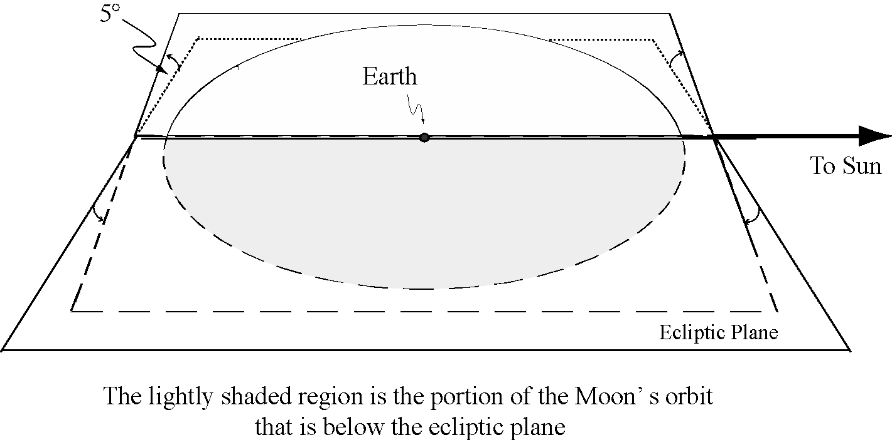

Is there any time when the plane of the Moon’s orbit is parallel to the ecliptic plane?
- Yes, 3 months before or after an eclipse.
- Yes, 6 months before or after an eclipse.
- Yes, during every New or Full Moon.
- No, the Moon’s orbital plane is never parallel to the ecliptic plane.

Ans. for 1.6: (d)

Concepts tested:

Question 1.6 probes whether or not students understand that the plane of the Moon’s orbit remains at a fixed orientation relative to ecliptic (and hence its orbital angular momentum is constant in direction as well as magnitude).

