Lecture Tutorial: Auroral Currents

Description: This guided inquiry tutorial gives students the opportunity to practice and extend their knowledge of magnetic fields produced by current-carrying wires. They examine perturbations in the Earth’s magnetic field as measured by the International Real-time Magnetic Observatory Network (using data publicly available at Intermagnet.org to infer the direction and strength of currents running through the ionosphere. This resource is designed to supplement Lecture-Tutorials for Introductory Astronomy for lecture-style classrooms as well as for use in recitation or tutorial classrooms.

Prerequisite ideas:
● Right-hand rule for relating the current in a long wire and the direction of the resulting magnetic field
● Magnitude of the magnetic field produced a perpendicular distance r away from a straight and very long wire carrying a constant current I: $\left|{\vec{B}}_{wire}\right|=\frac{μ_{o}I}{2πr}$.

Some instructor notes:
● Diagrams that show the relevant currents flowing in directions perpendicular to the page (that is, either into the page or out of the page) should be particular helpful for guiding students’ thinking. Even so, watch for students who may have difficulty recognizing that in those situations the magnetic field vectors are purely in the plane of the page.
● The last three pages of this document contain figures that can be used as visual aids, to help students with the tasks in Section II.B (p. 4 of the student handout). One figure, photocopied on paper, is an enlargement of the figure on p. 4. The other two figures, photocopied on clear transparencies, represent possible directions for the electrojet current (whether into or out of the page) and the corresponding magnetic field lines produced by that current.
● It may help to bring wires or lengths of string to serve as additional visual aids, especially if students need help with applying the appropriate right-hand rule.

Suggested post-test problem:

The magnetic field at the origin of a (right-handed) Cartesian coordinate system is measured to be: B_{x} = + 450 nT, B_{y} = – 600 nT, B_{z} = 0. (Ignore the magnetic field of the Earth itself.) It is known that the source of this magnetic field is a very long wire that runs parallel to the z-axis and that carries a steady current of 2.25 A.

There are TWO (2) possible locations for this wire. For each possibility, (a) determine the exact location where the wire intersects the x-y plane, and (b) deduce the direction of the current. Clearly show all work.

Note: This problem is “near transfer” task that should be adequately handled by the students after the tutorial. The primary differences between this problem and tasks in this tutorial are as follows:
- The problem prompts students to find two possible locations of the current-carrying wire. In the tutorial, since the current had to be running above (not below) the tabletop, the students didn’t have to consider both options.
- The students must find the full distance between the observation point and the wire, rather than be told the “component” of that distance (which in the tutorial was along the z-axis).

Lecture Tutorial: Auroral Currents

In this tutorial we will explore the magnetic effects of auroral currents—currents in Earth’s ionosphere that are associated with the aurora (e.g., the “Northern Lights”). We will find that we can model their behavior using what we know about the magnetic field caused by line currents. Note: Throughout this tutorial, ignore the effects of the Earth’s (unperturbed) magnetic field.

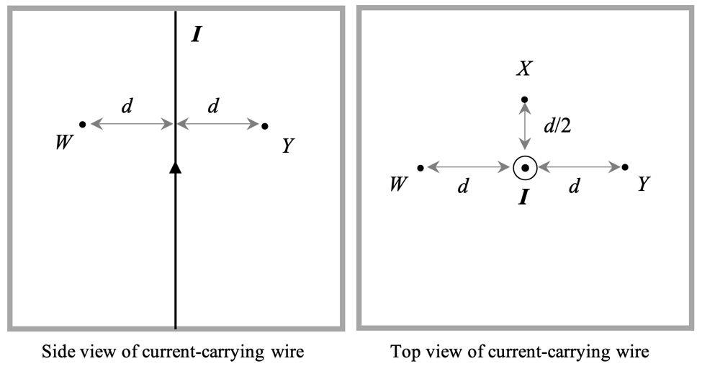
Review: Line currents as sources of magnetic fields
- A very long, straight wire carries a (conventional) current I, as shown in the side view and top view diagrams provided.
In the side view diagram the current flows toward the top of the page.
In the top view the current is directed out of the page.

Three locations, W, X, and Y, are labeled near the wire. Location X (which appears only in the top view) is closer to the wire than are locations W and Y.

      - At each location, clearly indicate the direction of the magnetic field at that location. Support your answer by using an appropriate “right hand rule.”

      - Rank locations W, X, and Y according to the magnitude of the magnetic field at those locations, from greatest to smallest. Explain how you can tell.

- Imagine that you and a classmate are about to study magnetic fields by currents in physics lab. You start by defining a coordinate system in which due north is the +x direction (the direction of the +$\hat{i}$ unit vector) and due east is the +y direction (the direction of +$\hat{j}$).

1. Which direction should you assign to as the +z direction (the direction of +$\hat{k}$), to ensure that your coordinate system is right-handed: Vertically upward or downward? Explain.

Note: Your answer here may seem counter-intuitive, but we will see how this coordinate system will be used when we examine actual data from magnetic field observatories.
Imagine now that you and your classmate start your lab by orienting a long wire horizontally above your lab table. The wire is made to carry a steady current in the +$\hat{j}$ direction (eastward).

The perspective view diagram (below left) shows the tabletop, the wire, and the vantage point of your classmate. The side view (below right) illustrates what your classmate sees from their vantage point.
C
D
$$\hat{j}$$
$$\hat{i}$$
Current
$$\hat{k}= ?$$
Side view (as seen by classmate)
Current-carrying wire (directly above points C and E)
$$\hat{i}$$
$$\hat{j}$$
D
E
C
$$\hat{k}= ?$$
Classmate
Perspective view
North
East
North
East

2. In both diagrams above the unit vectors +$\hat{i}$ and +$\hat{j}$ are already drawn. On each diagram draw and label the accompanying unit vector +$\hat{k}$ (denoting the +z direction).

3. Three locations (C, D, and E) are marked on the tabletop. For each location, determine whether each component of magnetic field (B_{x}, B_{y}, and B_{z}) is positive, negative, or zero. Support your answers by drawing magnetic field vectors and/or field lines in the side view diagram.

- Location C: Directly below the wire
- Location D: Several cm due north of Location C
- Location E: Several cm due west of Location C

You should find that one component of the magnetic field is equal to zero at all three locations. Identify which component that is (B_{x}, B_{y}, or B_{z}), and give a reason why this result makes sense.

If the wire carries current 0.40 A and is located 25.0 cm above the table, calculate for location C the values of B_{x}, B_{y}, and B_{z} (in nT = 10⁻⁹ T). Clearly show all work. (Note: You may find it helpful to use μ_{o} = 4π × 10² nT·m/A.)

Modeling currents associated with aurora
The aurora are created by electric currents from space that flow along the magnetic field into and out of the ionosphere. These charged particles move horizontally through currents called the auroral electrojets.

Imagine now that you and your partners—working as physicists for the U.S. Geological Survey—are reviewing magnetic field data from an observatory at College, Alaska, (near the city of Fairbanks) that were taken on a day (November 3, 2017) of a small magnetic disturbance that produced auroral electrojet activity. The zero level in the plot below refers to the undisturbed magnetic field, so that deviations from zero in the magnetic field are due to the electrojets.

Note: The (right-handed) coordinate system used for these data is defined just as you have been using thus far in this tutorial: +$\hat{i}$ points due north and +$\hat{j}$ points due east. The data displayed in the three graphs show the deviations of the Earth’s (baseline) magnetic field in terms of the components B_{x}, B_{y}, and B_{z}. The time (horizontal axis) is given in Universal Time (UT), or Greenwich Mean Time (GMT).

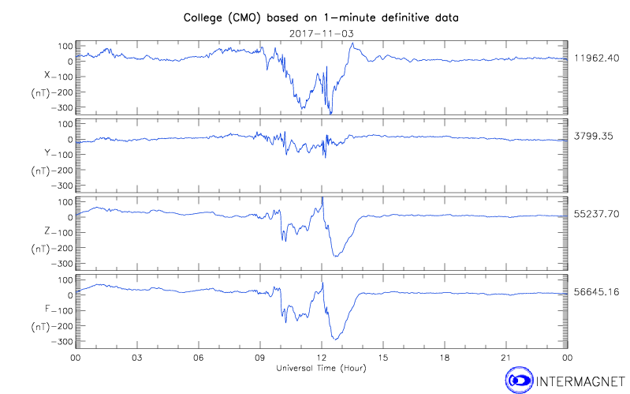

A. Notice that largest deviation of the magnetic field was observed at 1230 UT (see dashed line above). Read the (approximate) values of the magnetic field components at that time:

B_{x} : B_{y} : B_{z} :

B. We can now analyze the magnetic field data from the preceding page to deduce the location, direction, and (peak) current in the auroral electrojet causing this magnetic field disturbance. We will work with the assumptions that the electrojet can be modeled as a line current running along a west-east line through the ionosphere, approximately H = 100 km above the earth’s surface.

1. On the side view diagram below, carefully sketch a vector at the location of “CMO” that represents the (peak) magnetic field that you determined on the preceding page.

Determine the magnitude (in nT) and direction of the (peak) magnetic field. Express the direction as an angle above or below horizontal.

2. On the side view diagram below and on the rest of this page, use your knowledge of magnetic fields by line currents to do the following:

- Use the diagram below to determine whether the line current (at the height H above the Earth’s surface) was traveling north of, south of, or directly above the CMO observatory.

- Finally, calculate (i) the distance between the CMO observatory and the electroject and (ii) the peak current in the electrojet. (Note: As before, you may use μ_{o} = 4π × 10² nT·m/A.)

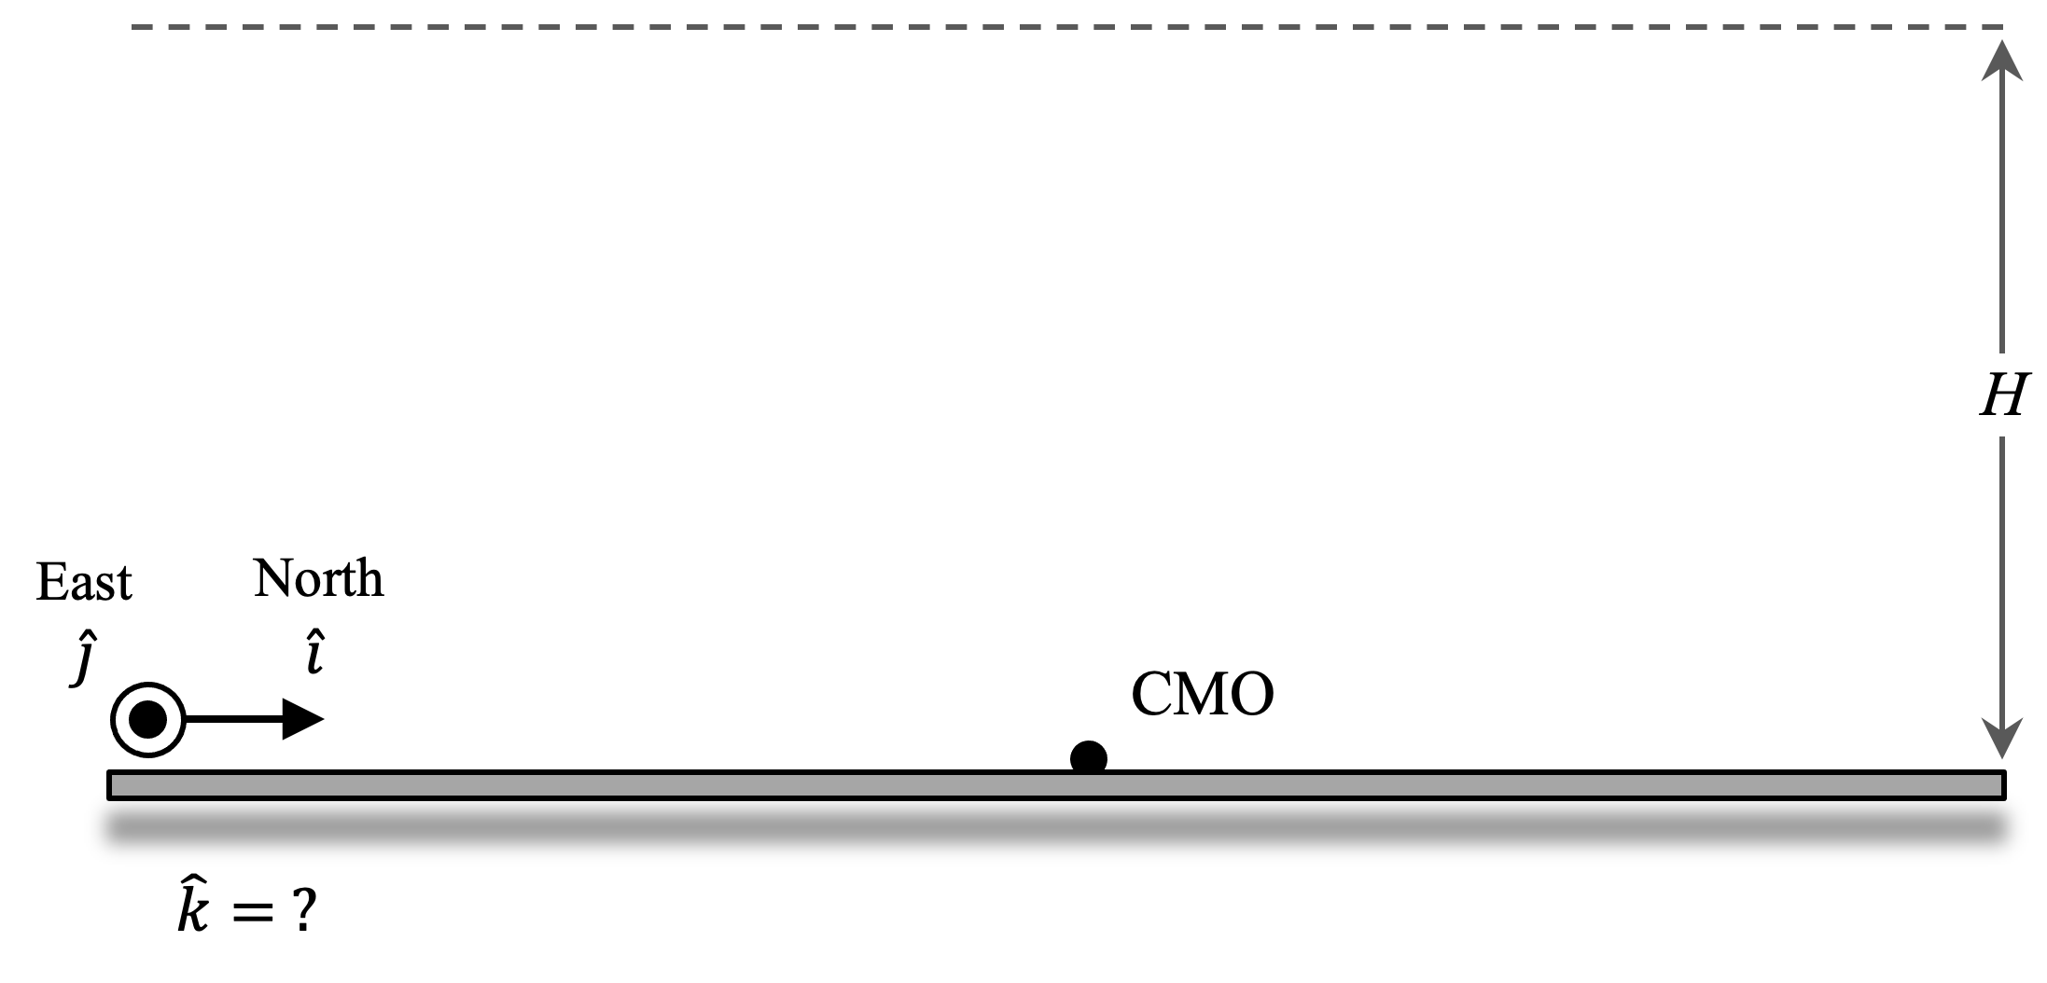

(Note: Although the magnetic field values are in nT, you should find the current to be rather impressive in size! Even stronger magnetic disturbances could reach as high as 2,000 nT; the current responsible for such a field would be approximately one million amperes.)

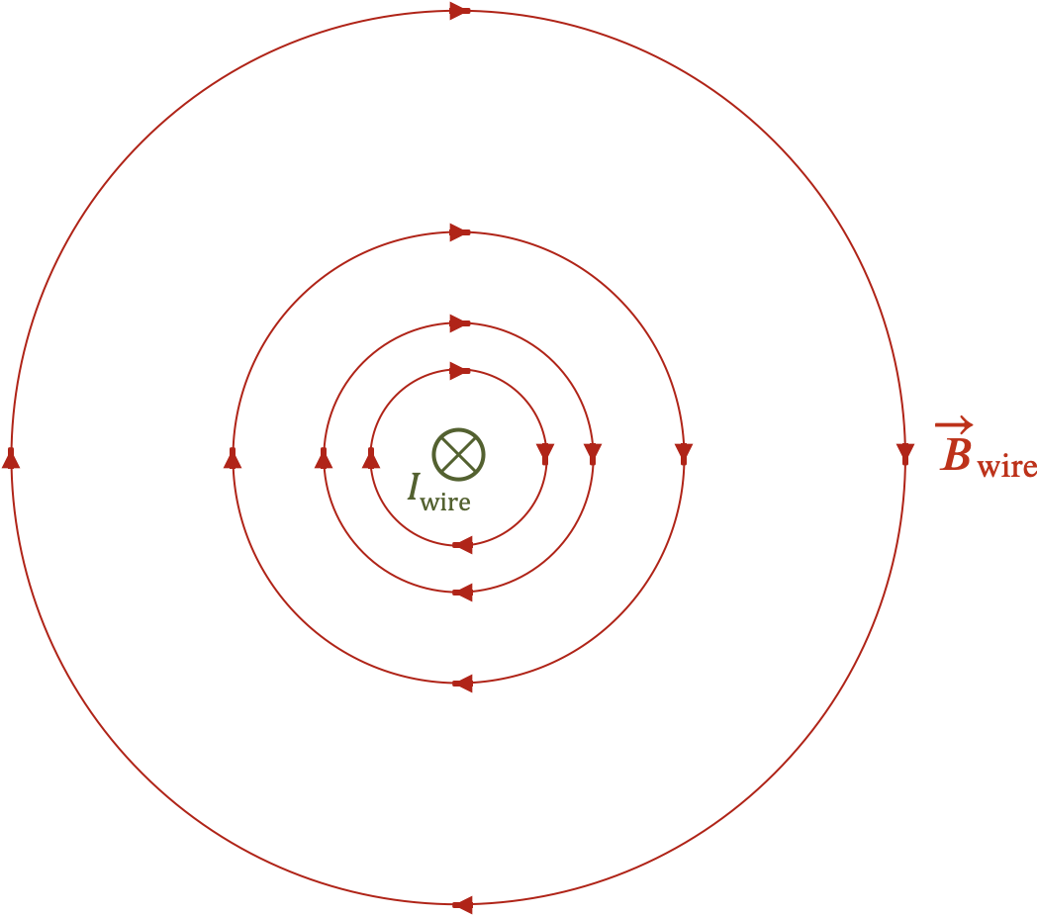

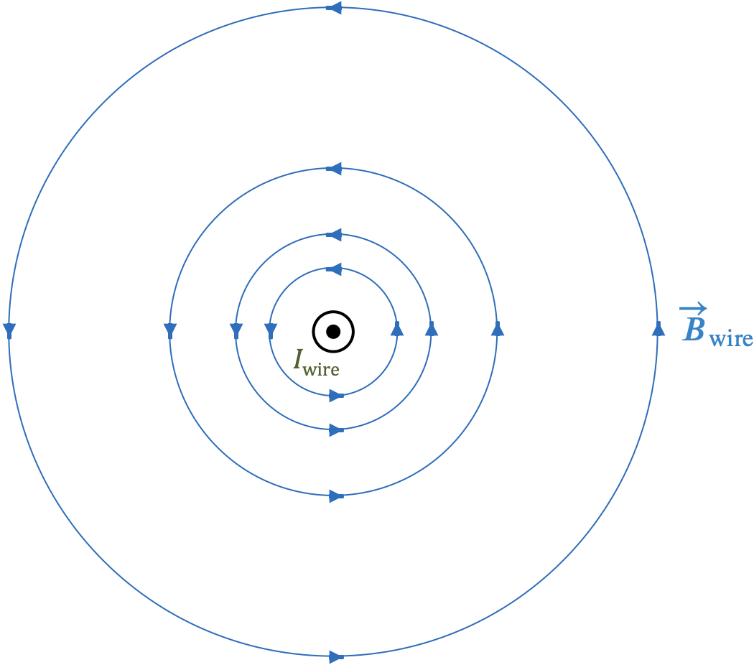

Data provided by the International Real-time Magnetic Observatory Network, www.intermagnet.org

