Lecture Tutorial: Habitable Zone Planets

Student Handout

Description:

This tutorial introduces you to various factors that influence the (average) surface temperature of a planet. First, you will consider a crude model based on principles from blackbody radiation, deducing how the equilibrium surface temperature of a planet is related to the intensity of the solar radiation that is incident upon it. You will then consider the effects of albedo and greenhouse gases as factors in elevating the average surface temperature of a planet like Earth (although a detailed treatment of greenhouse effects falls outside the scope of the tutorial). Finally, you will be introduced to the “faint young Sun paradox”: how could liquid water have been present on an early Earth while the luminosity of the Sun was significantly less than it is currently? You will be asked to suggest a possible resolution of that paradox by invoking greenhouse effects. Along the way, you will be shown data collected on Earth-like exoplanets surveyed by the Kepler project, view illustrations of nuclear fusion in the Sun’s core, and perform relevant calculations throughout the activity.

Prerequisite ideas:

- Blackbody radiation: An ideal blackbody is characterized by perfect absorption of all radiation incident upon it.
- Blackbody radiation: Total radiative intensity of an ideal blackbody (in W/m²) is proportional to equilibrium temperature to the fourth power (R = σ T ⁴, where the Stefan-Boltzmann constant is
σ = 5.67 × 10⁻⁸ W/(m²K⁴)).
- Intensity of radiation (W/m²) from a point source (or spherically symmetric body) varies with distance from the source as 1/r².
- Albedo: The albedo (“α”) of a planet (or moon, or asteroid) is a number between 0 and 1 that represents the average fraction of radiation that is reflected from its surface.
- Greenhouse effect, nuclear mass and mass-energy equivalence (familiarity)

A habitable planet is often treated as one for which liquid water can exist somewhere on its surface. A critical feature of a planet to make it habitable is its average surface temperature. This tutorial will introduce you to several factors that affect the average surface temperature of a planet.

A crude approximation: Planets as blackbodies
Let’s first start simple, which means treating a planet as a spherical blackbody. The figure below shows two such spheres, each receiving incident radiation (from our Sun, for instance) of intensity I_{o}. Note that the radii of sphere 2 is twice that of sphere 1.
In answering the questions below, treat both objects as blackbodies in thermal equilibrium. (Note: Ignore any interactions between the spheres themselves.)
A. Let P_{sphere1} represent the total power absorbed (energy absorbed per unit time) by sphere 1.

1. Calculate the total power absorbed by sphere 2 (P_{sphere2}) in terms of P_{sphere1}. Discuss your reasoning with your partners.

2. For each sphere, how does the total power that it radiates (re-emits) compare to the total power that that sphere absorbs? Explain your reasoning.

3. Let R _{sphere1} represents the power radiated per unit area by sphere 1. Calculate the power radiated per unit area by sphere 2 (R _{sphere2}) in terms of R_{sphere1}. Discuss your reasoning with your partners.

4. Use your knowledge of blackbody radiation to explain why the equilibrium temperature of either sphere does not depend upon its radius.

Please STOP here to have an instructor visit your group and check your results thus far.

B. Our results for the two spheres from part A can be used to help us obtain crude estimates for the average (surface) temperatures on Mars and Earth (since r_{Earth} ≈ 2r_{Mars}).
The intensity of solar radiation is approximately 1,370 W/m² at the location of Earth (1.00 AU from the Sun). Treating Earth and Mars right now as ideal blackbodies, calculate the following quantities. (Note: For reference, the value of the Stefan-Boltzmann constant is σ = 5.67 × 10⁻⁸ W/(m²K⁴).)

      - the equilibrium temperature of Earth

      - the equilibrium temperature of Mars, which is (on average) 1.524 AU from the Sun

Hint: How can the ratio 1.00/1.524 (≈ 0.656) help you quantify the intensity of incident solar radiation at Mars?

The surface temperature on a planet varies, obviously, according to location (from equator to poles). Our results thus far are just crude estimates for average surface temperatures. Enough variation exists, though—as much as 50 K or 60 K from average—that both Earth and Mars fall within the boundaries of the so-called “Habitable Zone” for a star like our Sun. (See Fig. 1 below.)

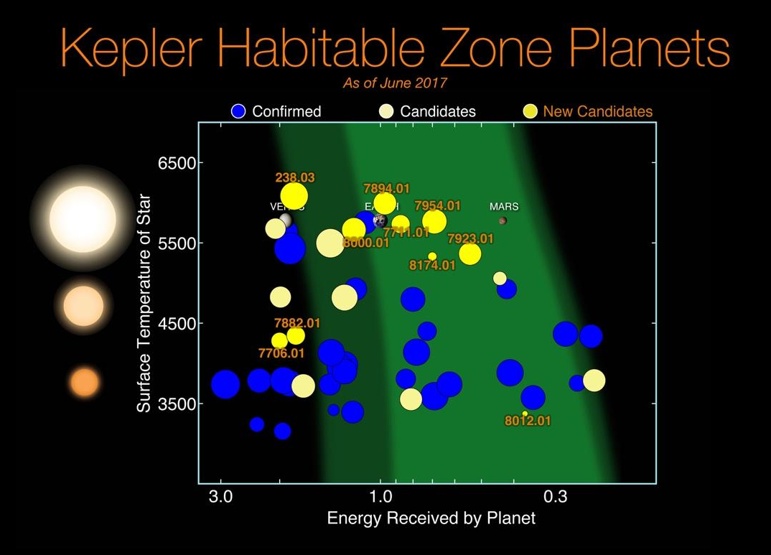

Fig. 1: Exoplanets (and candidates) detected by the now-retired Kepler space telescope. The vertical axis corresponds to the surface temperature of the star that the exoplanet orbits. The brighter, light green region of the graph represents a conservative estimate of the “habitable zones” for different stars. Earth and Mars fall within this zone but not Venus. (Image credit: NASA/Ames Research Center/Wendy Stenzel)

C. The horizontal axis of the plot, labeled “Energy received by planet,” is normalized so that Earth has a value of “1.”

Using your work from part B on the preceding page—and knowing that the average orbital distance for Venus (also shown on the plot) is 0.72 AU—show that the horizontal axis can be more precisely labeled as “solar irradiance,” measured in the usual SI units for intensity (W/m²).”

D. Assuming that exoplanet “7954.01,” shown in the plot between Earth and Mars, orbits a star that has the same size and surface temperature of our Sun, estimate (in AU) its orbital distance.

Refinements to our model
A. Albedo. One important factor that makes actual planets different from blackbodies (upon which our crude model has been based thus far) is that planets can reflect some of the radiation incident upon it. The albedo (“α”) of a planet (or moon, or asteroid) is a number between 0 and 1 that represents the average fraction of radiation that is reflected from its surface.
1. Would a planet having non-zero albedo have an average temperature that is warmer or cooler than that predicted by modeling the planet as a blackbody? Discuss your reasoning with your partners.

2. Let’s now extend our thinking quantitatively by repeating the average temperature calculations from part I.B (on p. 2 of this tutorial). That is, with your partners, using albedo values of α_{Earth} = 0.33 and α_{Mars} = 0.15, find new estimates for:

      - the equilibrium temperature of Earth

      - the equilibrium temperature of Mars

3. The estimate you should obtain here for the average surface temperature of Mars is not far off. However, the observed result for Earth is closer to 288 K (15°C), which is more than 35 K (more than 35C°) warmer than the result predicted here using blackbody ideas and albedo.

With your partners, identify what phenomenon could account for the discrepancy between our model and the observations about Earth’s average temperature--and explain why this phenomenon has little effect in the case of Mars.

This Photo by Unknown Author is licensed under CC BY-NC-ND

(Note: A hint is provided in the photo at right! However, a meaningful treatment of this topic is outside the scope of this tutorial.)

B. Early history of the Sun and the “faint young Sun problem.” Throughout this tutorial we have treated the luminosity of the Sun as isotropic and constant in time. However, well-accepted solar models suggest that the energy output of the Sun has not been constant but rather continually increasing over time. In this section we briefly explore a significant (and also rather intuitive) cause for this behavior.
To visualize what’s happening in the core of Earth’s sun, see Fig. 2, Fig. 3, and Fig. 4 illustrating the three full steps of the Proton-Proton Chain, the process in which hydrogen nuclei are ultimately fused to form one single helium nucleus.
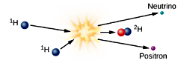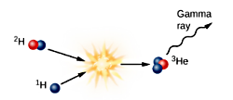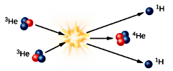
Fig. 2: Initial Step Proton-Proton Chain Fig 3: Step Two Proton-Proton Chain Fig. 4: Step Three Proton-Proton Chain
Step 1: The process starts with two hydrogen nuclei (protons shown in blue) overcome electrical repulsion to combine, forming a hydrogen nucleus with a proton (blue) and neutron (red). Note that hydrogen containing one proton and one neutron is given its own name: deuterium (combined red & blue in Fig 1). Also produced in this reaction are a positron (an antielectron) and a neutrino. Very high temperatures are required to sustain the reaction.
Step 2: One hydrogen nucleus (shown in blue, Fig. 3) combines with the deuterium nucleus from Step 1 (shown as a red and blue particle). The product of this is an isotope of helium with two protons (blue) and one neutron (red), called helium-3. As antimatter, the positron from Fig. 2 quickly collides with a nearby electron, annihilating both and releasing energy in the form of gamma-ray photons.
Step 3: Two helium-3 nuclei (the product from Fig. 3) must combine to form helium-4 in the sun. In this step, two energetic protons are left over. These leftover protons have the energy to collide with other protons in the sun and start the chain reaction again.
Image and Caption Credit: Fraknoi, Andrew., Morrison, David. Wolff, Sidney, OpenStax: Astronomy, October 13, 2016, OpenStax Astronomy: Chapter 16.2-Mass, Energy, and the Theory of Relativity
In the core of main sequence stars like our Sun, fusion of hydrogen (H) to helium (He) occurs in processes including (but not limited to) the one represented here:
$$4H→He+{2e}^{+}+2υ_{e}$$
m_{H} = m_{proton} = 1.6726 × 10⁻²⁷ kg; m_{He} = 6.6448 × 10⁻²⁷ kg; m_{e+} = 9.11 × 10⁻³¹ kg; m_{ν} ≅ 0
1. With your partners, discuss how this fusion reaction arises as a sequence of the three steps of the Proton-Proton Chain, shown above in Fig. 2, 3, and 4. (Hint: It may be more straightforward to start at the final step and “work backwards;” to form one He nucleus, Step Three must be carried out once, but how many times must Step Two be carried out? What about the Initial Step?)

2. Using the mass values given above for the H nucleus (proton), the He nucleus, and the positron, determine what percentage of the total mass of the four H nuclei is converted to energy.
Would you expect raising the temperature (i.e., the average kinetic energy) of the H nuclei to increase or decrease the rate at which fusion (and hence the energy conversion) occurs? Why?

3. As a result of these processes unfolding, describe in a sentence or two how each of the following properties will change. (Note: Your intuitions will probably serve you well here!)
        - the particle density (number of particles per unit volume) in the Sun’s core
        - the thermal pressure within the core

4. In response to this change in pressure within the core, the outer plasma layers of the star gravitationally compress more and more upon the core, in order to keep (hydrostatic) equilibrium between the core and the outer layers. This compression causes a gradual increase in core temperature, where H fusion is occurring. As a result of this process, what must happen to:
        - the rate of energy conversion within the core?

        - the overall luminosity of the star?

We have just now reasoned out why, during the very gradual (billions-of-years long) process of hydrogen fusion in our Sun’s lifetime, its luminosity must have increased during that process.
A serious “paradox” occurs, however. Extensive evidence exists for the presence of liquid water on Earth as far back as 3.0 – 3.5 billion years ago. Yet, that long ago, the energy output of our Sun must have been significantly less—20% to 30% smaller—compared to the current level. How could liquid water have formed, then? This “faint young Sun paradox” has not yet been definitively resolved, although the most widely accepted idea thought to resolve this paradox is, perhaps not surprisingly, greenhouse effects occurring in the atmosphere of early Earth.

Extension exercises (may be assigned as homework)
The model introduced in this tutorial—based on principles from blackbody radiation and albedo—can be extended so as to take into account explicitly the size and surface temperature of the star whose “habitable zone” we want to describe. It will be useful to denote the following variables:
Radius and surface temperature of star: R_{star}, T_{star} Orbital distance of planet from star: D_{orbit}
Radius and surface temperature of planet: R_{planet}, T_{planet} Albedo of planet: α

A. Using your knowledge of blackbody radiation and basic geometry of spheres, write algebraic expressions for the following quantities:
- The total power emitted by the star—in terms of R_{star}, T_{star}, and appropriate constants

- The intensity of the radiation from the star incident upon the planet—in terms of R_{star}, T_{star}, D_{orbit}, and appropriate constants

- The power absorbed by the planet—in terms of R_{planet}, α, R_{star}, T_{star}, D_{orbit}, and appropriate constants

- The power emitted by the planet (radiating as a blackbody)—in terms of R_{planet}, T_{planet}, and appropriate constants

B. Now take into account the fact that the planet must be in thermal equilibrium by setting equal to each other the two relevant expressions from part A. Solve the resulting equation for the equilibrium surface temperature of the planet (T_{planet}). Hint: Your result should depend upon R_{star}, T_{star}, D_{orbit}, α, and numerical constants (but not R_{planet}, and also not the Stefan-Boltzmann constant, σ!).
C. i. Verify your final expression for T_{planet} (in the preceding part) by redoing your calculations in part II.A of the tutorial (in which you found estimates for the equilibrium temperatures of Earth and Mars).
ii. Consider a star whose mass is 0.80 solar masses and whose surface temperature is 4,500 K. Using our quantitative model for average planetary surface temperature (developed in parts A and B above), find the orbital distances (in AU) for planets that would have the same average temperatures as Earth and Mars.

