Lecture Tutorial: Modeling Hydrogen Spectra from the Sun

Description: This guided inquiry tutorial introduces students to the basic quantum models of the atom (such as the Bohr model of hydrogen) and quantum energy levels, using the early observations of the Sun’s spectrum as a context.

Prerequisite ideas:
● Understand how visible white light can be thought of as a continuous spectrum.
● Understand that each element is characterized by unique emission and absorption spectral lines.
● Be familiar with the idea that light can be treated as being made up of discrete “packets” of energy, or photons, and that the energy of a photon is expressed in terms of Planck’s constant (“h”) and the frequency of the light (or alternatively, c/λ, where λ is the wavelength of the light and c is the speed of light in vacuum).

Lecture Tutorial: Modeling Hydrogen Spectra from the Sun

Atomic spectra
Unlike light sources that display a continuous spectrum, such as incandescent light bulbs, lamps that operate by sending electrical currents through elemental gases emit light of only specific wavelengths. Their spectra consist of sharp, discrete lines. Examples of these emission spectra for sodium, nitrogen, hydrogen, and oxygen are illustrated below. The corresponding absorption spectrum for each element illustrates how atoms of that particular element absorb only specific wavelengths of light.

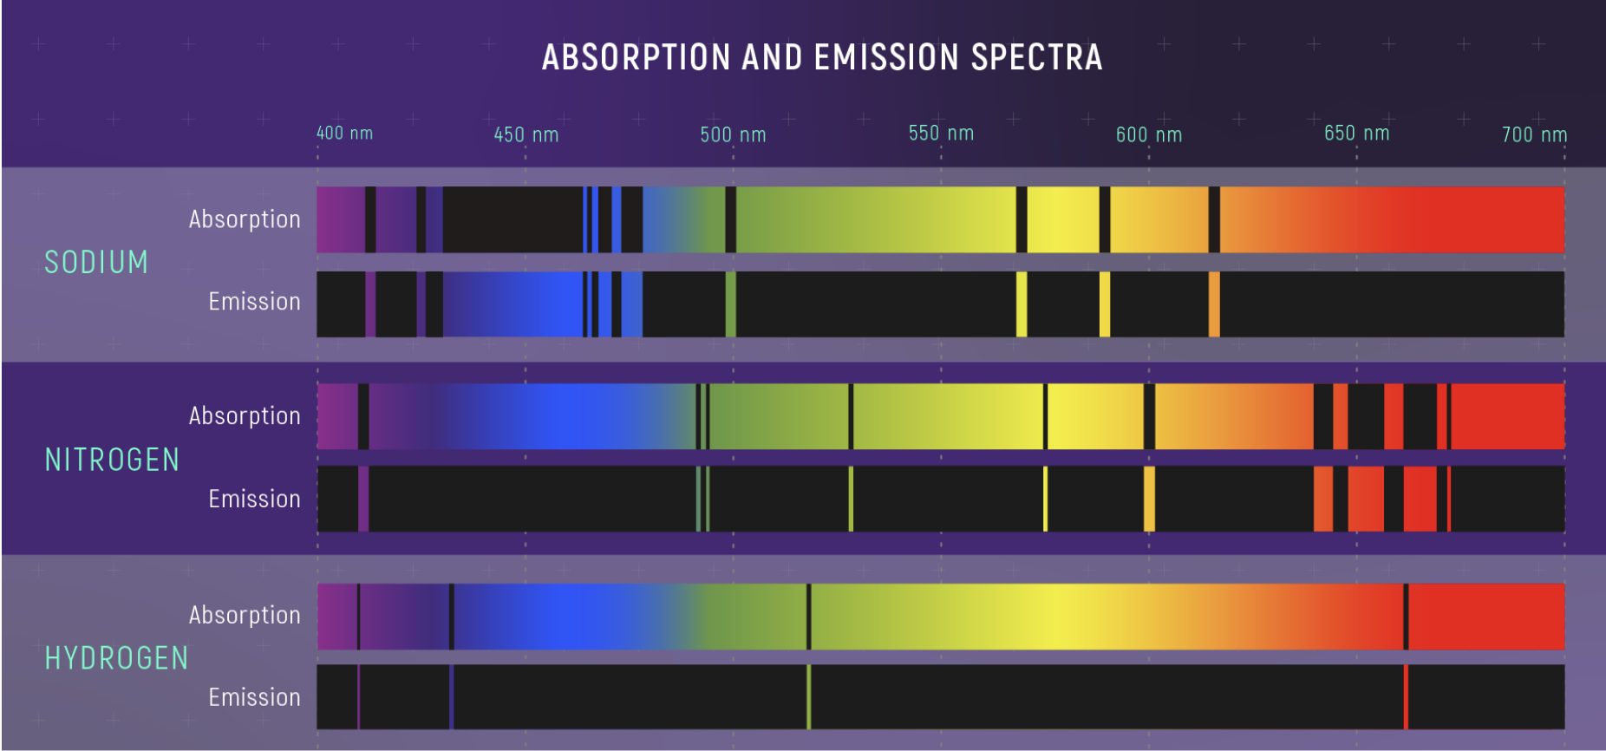
Credit: NASA

- Physicists often refer to absorption and emission spectra as “fingerprints” that can be used to detect the presence of certain elements or molecules (for instance, in stars, interstellar clouds, or the atmospheres of exoplanets). Justify this notion on the basis of the figure above.

Attempts to explain atomic spectra were unsuccessful until a breakthrough in the early 20th century. Max Planck has proposed that light can deliver energy in “chunks” that he called “quanta”. The amount of energy in quanta was not arbitrary; it was directly proportional to the frequency of light. This idea, that light came in discrete particles we now call photons, was revolutionary. Niels Bohr applied the quantum idea—indeed, at the atomic scale, everything comes in tiny “chunks”—to develop a model that explained basic characteristics of the emission spectrum of hydrogen.

You will now conduct simulated experiments with different atomic discharge lamps using the PhET simulation Neon Lights & Other Discharge Lamps (https://phet.colorado.edu/en/simulations/legacy/discharge-lamps). Open and run the CheerpJ browser-compatible version of simulation.

A. Take about five minutes to explore the simulation. List three things you notice or wonder.

For the remainder of your time using this simulation, use the following settings:
- Select the “Multiple Atoms” tab in the upper left.
- Move the battery/power supply to 30.0 V.
- Select “Electron production” to “continuous” and move the “Electron production” slider to 100%.
- Finally, in the bottom right corner of the screen, select the “Spectrometer” option.

- After adjusting the simulation settings as above, select the “Atom Type” to Hydrogen. Let the simulation run long enough so that the spectrometer records four (4) visible emission lines.

1. In the space below, record the approximate locations and colors of the hydrogen emission lines.

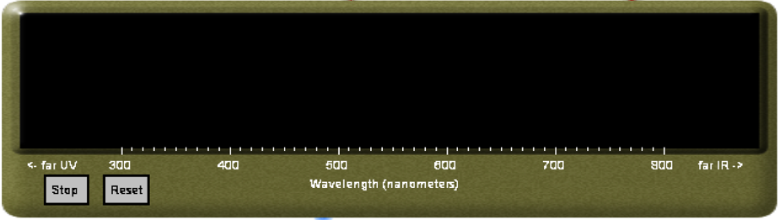

2. Compare the emission lines from the simulation to those shown for the hydrogen emission spectrum in Fig. 1(b). Do the results from the simulation agree with what the figure shows?

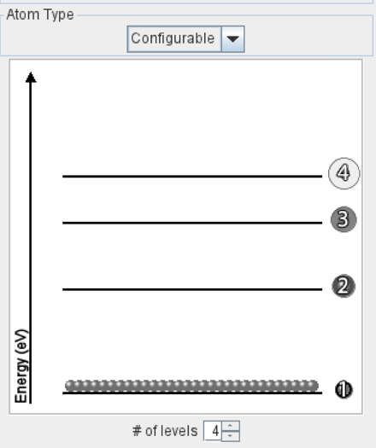

C. Now reduce “Electron Production” to 0%, and switch “Atom Type” from “Hydrogen” to “Configurable.” Here you and your partners will configure your own “hypothetical” atom. Create an energy level configuration with four (4) energy levels that matches as best you can the configuration shown at right. As you do so, notice that the difference in energies between levels 2 and 3 is smaller than the difference between levels 1 and 2. Similarly, the difference in energies between levels 3 and 4 is smaller than that between 2 and 3.

Once you have configured the energy levels of your “hypothetical” atom, do NOT run the simulation yet! 😊
1. BEFORE running the simulation, first predict how many emission lines will appear in your spectrometer. Discuss your prediction with your partners.
Before checking your prediction, consider the following conversation between two students:

Student #1: “There will be four emission lines, one for each energy level, right?

Student #2: “I think instead there will be only three emission lines, one for the transition from level 2 to level 1, another for level 3 to level 2, and one more for level 4 to level 3.”

Do you agree with Student #1, Student #2, or neither? Explain.

2. Now you may check your prediction: Move the slider for “Electron Production” from 0% to 100% and observe the spectrometer as the simulation runs. Sketch the resulting spectrum of emission lines in the space below.

Do you observe the predicted number of emission lines in the new emission spectrum? If so, well done! If not, that’s OK! However, with your partners, resolve the discrepancy between your prediction and your observations from the simulation.

Atomic energy states and spectra
The idea of quantization—used to describe energy as discrete “chunks”—revolutionized early 20th century physics. This idea was applied toward the idea of photons of light, and it was soon brought to bear on the behavior of electrons in atoms. Niels Bohr developed a model for the hydrogen atom in that the electron exists only at specified energy levels, “jumping” from one level to another. Each transition requires only a single photon of exactly the correct energy corresponding to the difference in energy levels, meaning only specific frequencies or wavelengths of light could be absorbed or emitted. Calculations made with this model fit the basic hydrogen spectra, earning Bohr the Nobel Prize in 1922.

A. How do discrete energy levels work?

In the atom, the positive nuclear charge and the negative electron charge interact by means of the electromagnetic force. Let’s look at an analogue using gravity.

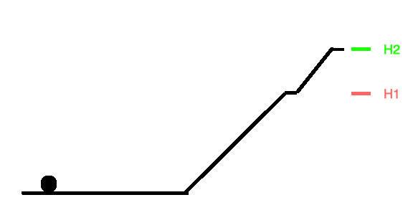
Consider the situation in the side view diagram in Fig. 1. A small hockey puck sits on a ramp with no friction. At two different heights, H₁ and H₂, there is a very narrow ledge whose width is exactly the same as the width of the puck. We can deliver a single jolt of energy to the puck in the form of kinetic energy. The mass of the puck is m and the acceleration due to gravity is g. Therefore, to reach a given height y the puck must start with kinetic energy mgy. Assume that if the puck slides to a lower state, like moving to the ground or moving from H₂ to H₁, it releases its remaining kinetic energy as a photon.

Fig. 1: Gravitational analogue showing a small puck at the
base of a ramp with two allowed “steps” at heights, H₁ and H₂.

1. We start the puck at the ground level and give it a jolt of energy. What happens to the puck if it receives an energy amount mgy for which:
- y is less than H₁? • y is between H₁ and H₂?

- y is exactly equal to H₁? • y is exactly equal to H₂?

Now imagine that the energy to push the puck is delivered by light, and that furthermore we have a large number of identical pucks and ramps in a darkened room. (We can assume that each puck is very small, as are H₁ and H₂.) The light source will provide a continuous spectrum, and we can assume that at every frequency there is one photon. If a puck absorbs a photon, it gets that energy and moves up the ramp.

Recall that the energy of a photon may be expressed as E_{γ} = hf, where h is Planck’s constant and f is the frequency of the light, or alternatively as E_{γ} = hc/λ, where c is the speed of light in vacuum and λ is the wavelength of the light.

2. The diagram below shows what happens to the spectrum of light hitting our large number of pucks: Two specific frequencies of light are absorbed, one corresponding to a different transition.


How can you account for the fact that the dark line for the H₂-to-ground transition is in the green part of the spectrum while the H₁-to-ground is in the red? Use your knowledge of photon energies and the wavelengths of light to explain.

3. In our thought experiment we can also imagine that a photon is released by the puck (and detected by a spectrometer) when the puck transitions from a higher energy level to a lower one. These photons would serve to form an emission spectrum of our system of pucks.

Consider three students who discuss the emission line that would occur when a puck transitions from H₂ to H₁:

Student 1: The photon frequency will be to the blue side of the H₂ line because it is the sum of H₁ and H₂.
Student 2: The photon frequency should be somewhere between the H₁ and H₂ lines because the transition is between those two states.
Student 3: I think that the photon should be to the red side of the H₁ line because the difference in energies between H₁ and H₂ is less than that between H₁ and the ground level.

With which student do you agree? Discuss your reasoning with your partners.

Please STOP here to have an instructor visit your group and check your results thus far.

B. Exploring the emission spectrum of hydrogen

In this section we will simulate measuring the emission spectrum of hydrogen using the PhET simulation Models of the Hydrogen Atom (https://phet.colorado.edu/en/simulations/models-of-the-hydrogen-atom/about).

- Open the simulation and engage with it for about five minutes. List three things that you notice or wonder.

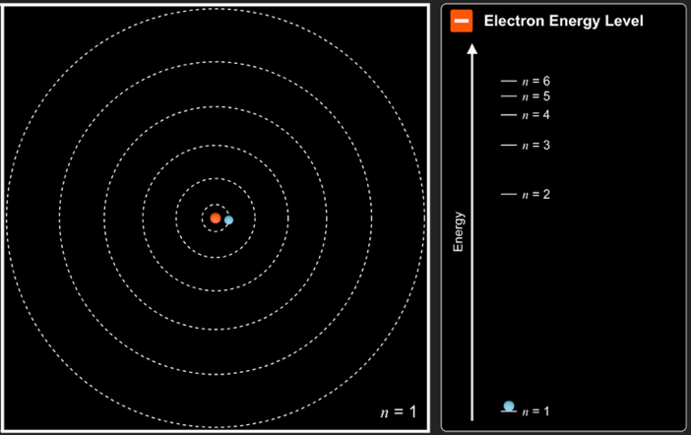

Fig. 2: Allowed electron orbits and energy levels in the Bohr model for hydrogen (PhET “Models of the Hydrogen Atom.”).

To set up the next part of this activity, select “Energy Levels.” On the right side of the window, select the “Bohr” model. On the left side of the window select the “white” light source and turn it on. At the bottom of the screen open the “spectrometer” to record photons emitted by the hydrogen atom.

- Explain how the simulation illustrates how the white light source emits light of all wavelengths, not just visible light.

A determining feature of the “fingerprints” that indicate the presence of hydrogen gas (for example, in the Sun) is the separation between consecutive energy levels. For the remainder of this tutorial we will deduce this information using the PhET simulation.

- With the “spectrometer” displayed on the screen, let the simulation run for a while so that the spectrometer records five (5) emission lines in the ultraviolet (UV) spectrum and four (4) emission lines in the visible spectrum. In the space below, record the wavelengths (in nm) that you observe, listed from shortest wavelength to longest wavelength in each group.

UV wavelengths:

Visible wavelengths:

- Let’s first examine the UV emission line data. Each of these emission lines corresponds to an electron transition from a higher energy state to the ground level (n = 1) energy state.
  - For each of the five (5) UV wavelengths that you recorded, calculate the photon energy (in electron-volts, eV) associated with that emission line. (Pro tip: A handy mathematical shortcut involving Planck’s constant and the speed of light is: hc = 1240 eV-nm.)

  - In the table below, tabulate the wavelength and photon energy values for each emission line. Make sure that you and your partners agree which values belong in which row of the table. (For instance, should the n = 6 to n = 1 transition correspond to the largest or smallest photon energy? The shortest or longest wavelength?)
Hint: For extra guidance, you can run this simulation in “Slow” mode, so that you can more easily match each electron transition to the corresponding photon that arrives at the spectrometer.

 | Emission line wavelength (nm) | Associated  photon energy (eV) | Associated  transition
Ultraviolet  emission  lines |  |  | n = 6 to n = 1
Ultraviolet  emission  lines |  |  | n = 5 to n = 1
Ultraviolet  emission  lines |  |  | n = 4 to n = 1
Ultraviolet  emission  lines |  |  | n = 3 to n = 1
Ultraviolet  emission  lines |  |  | n = 2 to n = 1

- With your partners, apply the same logic to your data for the four (4) visible emission lines. Each of these lines corresponds to an electron transition from a higher state to the n = 2 energy state.

For each of the four (4) visible wavelengths that you recorded, calculate the photon energy (in electron-volts, eV) associated with that emission line. Enter the wavelength and photon energy values for each emission line in the appropriate row of the table below.

 | Emission line wavelength (nm) | Associated  photon energy (eV) | Associated  transition
Visible  emission  lines |  |  | n = 6 to n = 2
Visible  emission  lines |  |  | n = 5 to n = 2
Visible  emission  lines |  |  | n = 4 to n = 2
Visible  emission  lines |  |  | n = 3 to n = 2

- Finally, consolidate your results from parts 4 and 5 above by deducing the difference in energy (in eV) between consecutive energy levels. Discuss your reasoning with your partners and enter your answers in the diagram at right.

n = 6
n = 5
n = 4
n = 3
n = 2
n = 1
? eV
? eV
? eV
? eV
? eV

For extra guidance—or to check your thinking—here are some helpful questions:

- Which of the unknown (“? eV”) energy differences in the diagram are equal to actual photon energy values that you calculated, and why?

- Consider the difference in energies between the n = 5 and n = 6 states. How can your photon energy data from the UV emission lines be used to deduce this difference? How can your data from the visible emission lines be used to corroborate your answer?

Please STOP here to have an instructor visit your group and check your results thus far.

While the basic Bohr model was the first to explain atomic spectra, many unanswered questions remained. Often, spectra showed fine structure, with additional spectral lines very close to the main spectral line. Also, the Bohr model was only successful for atoms with a single electron, such a hydrogen or single ionized helium. These issues were resolved when the Schrodinger Equation provided a full quantum mechanical description of atoms, and molecules too (molecules have their own unique spectra).

