Lecture Tutorial: Tracking Solar Energetic Particles
from Coronal Mass Ejections

Intended audience: Students in college/university course in modern physics or relativity (sophomore level) or an honors level college/university course in introductory physics.

Description: This guided inquiry tutorial gives students the opportunity to apply their knowledge of kinematics and dynamics to determine when particles were accelerated by an interplanetary shock wave from a coronal mass ejection (CME). Students analyze (1) coronagraph images taken by the NASA’s SOHO (Solar and Heliospheric Observatory) and (2) proton flux graphs recorded by a Geostationary Operational Environmental Satellites (GOES) detector during a CME event that sent high-energy protons toward Earth. Students discover that the CME shock waves that accelerated the protons did so at a point near the Sun. This resource is designed to supplement a standard university level mechanics course at either the introductory or advanced level. A follow-up companion activity (provided separately) guides students to both apply knowledge of relativistic kinematics and to use linear interpolation skills.

Prerequisite ideas:

- The emission of a signal (e.g., a light flash) and the reception of that signal must be treated as two distinct events, with different times as well as different locations.
- Students will need to apply kinematics concepts of constant speed motion as well as relate non-relativistic kinetic energy to mass and speed (K = ½mv²).
- Students may need a refresher on the meaning of flux – the rate of flow of a fluid, radiant energy, or particles across a given area.

Some instructor notes:

● This tutorial has an accompanying pre-tutorial homework activity with background information about CMEs, including examples of coronagraph images that the students will interpret in the tutorial. The students also can view videos produced by NASA Goddard Space Center highlighting examples of severe CME events recorded in 2012 and 2015.

● Although the explanatory text in the tutorial handout should be fairly straightforward, the overall procedure through which the students are guided in the course of the tutorial is as follows:
- Section I (Interpreting coronagraph images): Students inspect images with and without “streaks” caused by incident particles. They recognize that the arrival of these particles occur at the location of SOHO at the times indicated by the printed time stamp. Students also recognize that any events recorded on a coronagraph image that occur near the Sun must have happened approximately eight (8) minutes before the time indicated on the coronagraph itself.
- Section II (Analyzing graphs representing proton flux from a CME): Students estimate when—to within ± 1 minute—solar protons with kinetic energy 165 MeV first arrive at a GOES detector.
- Section III (Tracking the acceleration event of solar protons): Students use a non-relativistic treatment (i) to calculate speed and travel time of these protons, and (ii) to approximate, relative to the outer edge of the Sun, where the protons started to be accelerated by the CME shock wave.

● To check students’ work throughout the activity, section by section:
- Section I.D (on p. 2): The “checkpoint” at the end of Section I is critical for checking that students can properly relate the clock reading on a coronagraph image to the time of an event (near the Sun) that is recorded on that image.
- Section II.B (on p. 3-4): Students should recognize that the 165-MeV protons first arrive at GOES at approximately 16:23 UT, with the proton flux generally increasing as time progresses.
- Section III.A (on p. 4): Students are expected to use (non-relativistic) kinetic energy ideas to find that the 165-MeV protons have a speed of 0.593c, or 1.78 ⋅ 10⁸ m/s.
(Note: Treating the protons as non-relativistic is fine for the purposes for this tutorial. A relativistic treatment yields 0.526c, from which the non-relativistic result differs by less than 15%.)
- Section III.B and III.C (pp. 4–5): Continuing with the non-relativistic treatment of the 165-MeV protons, students should find:
- Part B.1: The protons take (just under) 14.0 minutes (13 min 57 sec) to travel the 149 million km from the Sun to SOHO.
- Part B.2: The CME shock wave began to accelerate the protons at about 16:09 UT, or 14 minutes earlier than 16:23 UT.
- Part B.3: The acceleration event at 16:09 UT would have been recorded on a SOHO image with time stamp of “16:17 UT” (taking into account the ~8 minute travel time for light).
- Part C: Our image set includes a coronagraph with time stamp of “16:18 UT,” just 1 minute off from 16:17 UT. From this image the shock wave, assumed to be at the farthest extent of the CME, is just over 3 solar diameters (about 3.2d◉) away from the Sun. That result indicates where (approximately) the solar protons began to be accelerated by the shock wave.
- Section III.D (p. 6): As time allows, encourage students to reflect on their work and to identify any assumptions they may have made along the way. For instance:
- Students may recognize that they needed to assume that a clock near the Sun’s location must at rest relative to clock onboard SOHO in order to have those clocks be synchronized, despite the orbital motion of Earth (and hence SOHO) about the Sun.
- Students should recognize that they treated the velocity of the protons as purely radial in direction (from the Sun to Earth) and constant in magnitude. (The protons actually follow a more helical path following the field lines of the interplanetary magnetic field, causing the actual travel time for the protons to be longer than the value approximated by the students.)

Tutorial: Tracking Solar Energetic Particles from Coronal Mass Ejections
Coronal Mass Ejections (CMEs) and solar flares, collectively known as Solar Energetic Particle (SEP) Events, can propel intense flows of radiation made up of protons and other charged particles. The leading edge of a CME can contain such strong electric fields that it serves as a shock wave to propel solar protons with sudden accelerations. These particles can damage satellites above Earth and cause aurorae in the upper atmosphere.
In this activity, you will analyze real NASA data to track the acceleration of SEPs resulting from a CME. One source of data you will analyze will be a set of coronagraph images captured by the NASA’s SOHO (Solar and Heliospheric Observatory), a camera that takes images of the Sun. The images by SOHO are shown in the far ultraviolet light wavelength, which allows astronomers to view CMEs more clearly.

Interpreting coronagraph images
Obtain from an instructor a series of coronagraph images taken during a “Severe” category CME event that began between 16:00 UT and 17:00 UT on September 2017. The images, labeled “1” through “10” and taken at 12-minute time intervals, show the CME as a bright region that rapidly expands.

A. The opaque disk at the center of each frame—which blocks direct light from Sun—contains a white circle that indicates the diameter of the Sun’s photosphere (that is, the visible surface of the Sun). With your partners, verify that the opaque disk at the center of each image would correspond to a spherical region (centered around the Sun) that would be approximately 5 solar diameters across.

Turn your attention now to images “3” through “6,” which show the progression of the CME. With your partners, analyze these images by carrying out the following steps with each image:

- On each image use a pencil or black ink pen to trace the entire leading edge of the CME (that is, the farthest extent of the CME in all directions that it is traveling). We will treat this traced curve as indicating the (approximate) location and shape of the CME shock wave.

- On each image measure the (approximate) distance from the center of the Sun to the point on the shock wave that is farthest from the Sun. (It is fine to express this distance as a number of solar diameters, e.g., “6.5d◉”).

The time stamps on the SOHO images are given in Universal Time (UT), which is defined to be the time in Greenwich, England (along the prime meridian, zero degrees longitude). For the coronagraphs in our image set, the SOHO time stamps range from 15:54 UT to 17:42 UT. These images, though, record events occurring very near the Sun, millions of km away.
- Imagine a clock located very near the Sun—perfectly synchronized at every instant with the clock on SOHO—and that this clock was visible on each SOHO image. For each SOHO image, how (if at all) would the reading on this clock differ from the SOHO time stamp for that image?

Hint: SOHO is about 1 million km away from Earth and 1 AU is about 150 million km, so the distance between the Sun and SOHO is about 149 million kilometers.

C. To help you check your work in part B above, consider the following dialogue between the following students who are discussing their ideas about a hypothetical clock located at the Sun:

Arturo: “We obviously cannot put a clock on the Sun and expect it to stay intact! But if we could place a clock very near the Sun, and, if we could actually see this clock in these SOHO images, wouldn’t it show the same time as that on SOHO time stamp?”

Cristiana: “Well, doesn’t light need time to travel from the Sun to SOHO in order to be recorded on these SOHO images? That would mean each SOHO image is recording what’s happening at the Sun several minutes before the time shown on the SOHO time stamp.”

Do you agree more with Arturo’s or Cristiana’s ideas? Discuss your reasoning with your partners.

Are your results in part B consistent with your group’s discussion about the student dialogue (above)? If not, resolve any inconsistencies.

D. Apply your findings from parts B and C above: On each SOHO coronagraph image is a space labeled “Clock at Sun.” In each of these spaces, write down the clock reading (in UT) that would appear on a clock very near the Sun, if it were visible in that image. Discuss your results with your partners.
Please STOP here for an instructor to visit your group and check your work thus far in
analyzing the coronagraph images.

Analyzing graphs representing proton flux from a CME
As described earlier, a shock wave at the leading edge of a CME can propel solar protons with sudden accelerations. Each proton can acquire hundreds of MeV of kinetic energy. Satellite instruments, such as those onboard Geostationary Operational Environmental Satellites (GOES), measure the flux of protons arriving near Earth from a solar particle event.

A. The graph at right illustrates how the flux of solar particles near Earth can vary during a typical SEP event, such as a CME. Peak flux values may be two to five orders of magnitude greater than the background.

Graph illustrating particle flux vs. time for a typical solar particle event. (Image credit: Walter Schimmerling, PhD, NASA Johnson Space Center.)

- If particle flux is defined as the measure of the number of particles passing through a given surface area per unit time, then discuss with your partners why the units of particle flux would be:
(# particles) / (cm²)(sec).

- As shown in the graph, a “propagation delay” elapses from the onset of the SEP event and the first arrival of particles from the event. Would you expect this delay to be greater than, less than, or equal to eight (8) minutes? Discuss your reasoning with your partners.

B. The graph below shows the proton flux measured by a GOES detector during the same severe CME event from September 10, 2017, depicted in the coronagraphs from Section I of this tutorial. The graph shows the proton flux recorded from 16:00 UT to 17:00 UT and depicts both the background level of flux that day as well as the initial increase in flux of 165-MeV protons from the CME.

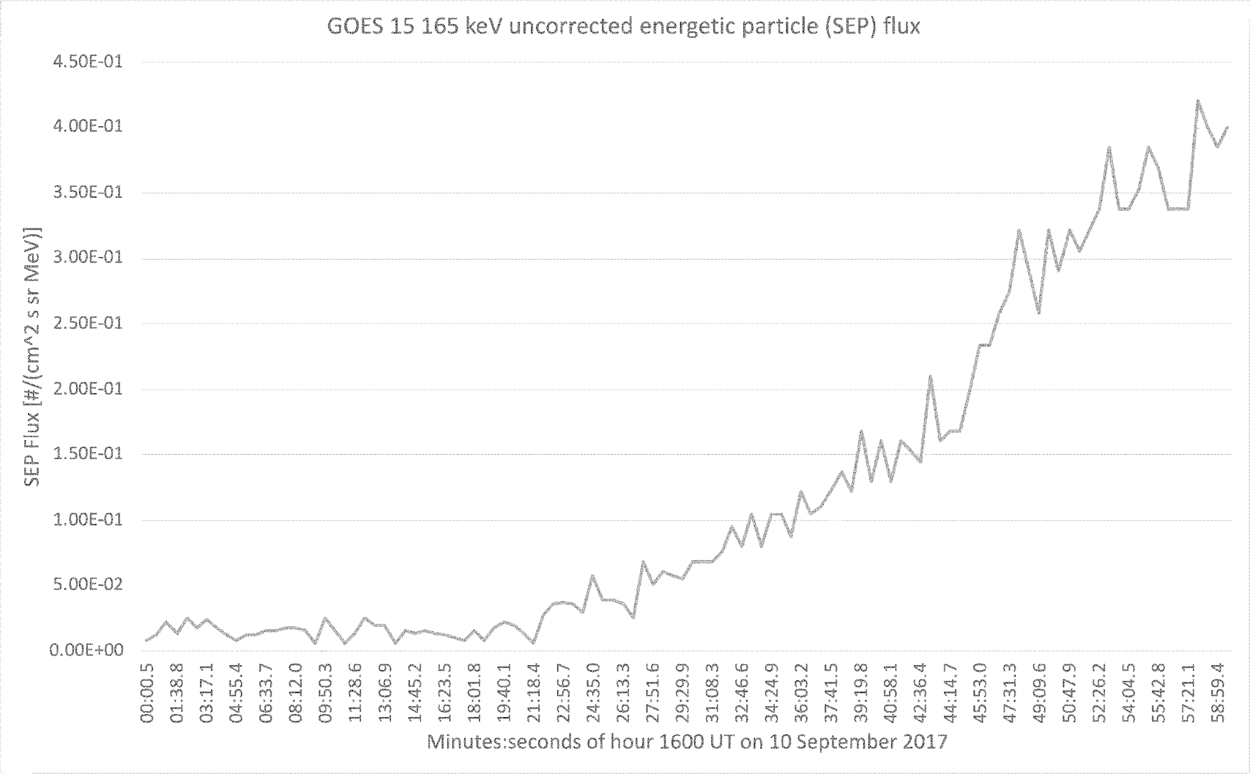

With your partners, follow the steps listed below in order to deduce—to within ± 1 minute—the earliest arrival of the 165-MeV protons at GOES:
- Estimate the background level of proton flux from the graph, and sketch a horizontal line on the graph to indicate this level.
- Sketch a smooth best-fit curve that you think best represents the proton flux recorded during the latter half of the hour between 16:00 UT and 17:00 UT.
- Identify where the best-fit curve intersects the line representing the background level of proton flux, and hence estimate at what time (± 1 minute UT) the 165-MeV protons arrived at GOES.

B. With your partners, discuss how the SOHO coronagraphs for this same time interval—images #2 through #6, specifically—corroborate the data shown in the graph.

(Hint: Although the CME itself first appears in image #3, what differences do you notice between images #3 and #4 that suggest that protons have already started to arrive at SOHO by image #4?)

Tracking the acceleration event of solar protons
For the rest of this tutorial, we will estimate where—that is, how many solar diameters from the Sun—the 165-MeV protons began to be accelerated by the CME shock wave.

A. With your partners, use (non-relativistic) kinetic energy ideas to determine the speed (relative to the Sun and Earth) of the 165-MeV protons. Express your answer in two ways, both (i) as a multiple of the speed of light, c, and (ii) in m/s.

NOTE: Use m_{p} = 938 MeV/c² as the mass of a proton, and c = 3.00 × 10⁸ m/s.

(i) as multiple of c:

(ii) in m/s:

B. We can assume to a good approximation that the CME shock started to accelerate these protons when the protons were very near the Sun (that is, only a few solar diameters away from the Sun).
Use your results above and the evidence shown in the SOHO coronagraph images to determine the following quantities. By doing so, you and your partners will estimate how far from the Sun the high-energy protons were suddenly accelerated by the CME shock wave.

- Determine the approximate time interval for the 165-MeV protons to travel from the Sun to the Earth (and hence from the Sun to SOHO).

- Deduce the approximate time, in UT, at which the shock wave from the CME began to accelerate the solar protons.

- What would have been the (approximate) time stamp on a SOHO image (in UT) that would have captured the event of the solar protons being accelerated?
(Hint: The answer here is not the same as that from question 2 above…. Apply your findings from Sections I.B and I.C here.)

- You and your partners should find that one of the SOHO images in the image set has a time stamp that agrees to within 1 or 2 minutes of your result in question B.3 (on the preceding page).

Identify this image and use it to estimate the farthest extent of the CME shock wave at the time you determined in question #2 above. This result, expressed as a multiple of solar diameters away from the Sun, will describe approximate where the solar protons started to be accelerated by the CME shock wave. Fortunately for us, this Severe Scale CME did not erupt on a direct trajectory with Earth.

Note: You should find that the shock wave accelerated the protons at a distance less than 4.0d◉ from the (surface of the) Sun. The protons therefore traveled the vast majority of the distance between the Sun and Earth after having been accelerated by the shock wave!

D. As time allows, reflect upon your work in this section (Section III) of the tutorial. In particular, identify any assumptions that you made along the way: What were those assumptions, and how did you make use of those assumptions in determining your results?

