Lecture Tutorial: Zeeman Effect

Description: The tutorial helps students understand the Zeeman Effect and how this effect is the basis for NASA’s EZIE mission, for which the aim is to make local measurements of the Earth’s magnetic field, especially during times of active space weather leading to aurora.

Prerequisite ideas:
- Magnetism basics: magnetic dipoles and the magnetic moment vector, magnetic field as a vector, and the right-hand rule linking current to field.
- Energy and mechanics: conservation of energy with kinetic (translational + rotational) and potential energy, stable vs. unstable equilibrium, and the dot product (for U = –μ·B).
- Atomic/quantum ideas: quantized atomic energy levels, angular momentum producing a magnetic moment, and the photon relation E = hf with spectral lines as energy differences. (Note: We strongly recommend that students previously complete the “Lecture Tutorial: Hydrogen Spectra on the Sun” activity.)

Lecture Tutorial: Zeeman Effect

In this tutorial we learn about the nature of magnetic interactions between atomic electrons and external magnetic fields as described by a phenomenon called the Zeeman Effect. Such interactions form the basis for NASA’s EZIE mission, for which the aim is to make local measurements of the Earth’s magnetic field, especially during times of active space weather leading to aurora.

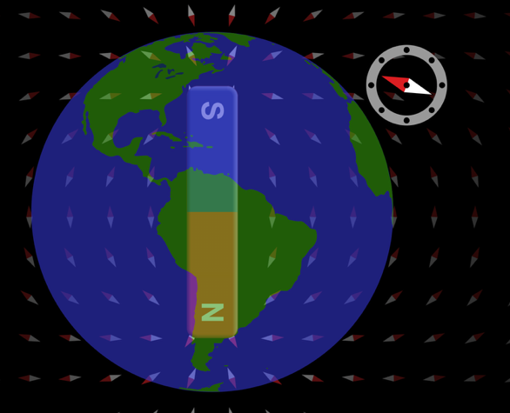
Magnetic energy and magnetic dipoles

Fig. 4: Screenshot from PhET “Magnet and Compass.” Overlaid on the screenshot is a vector (drawn in red) representing the magnetic moment of the compass.
The simplest magnetic field is that of a dipole, which we can represent as a single bar magnet with a north pole and a south pole. If we place a small magnetic dipole in a region in which an external magnetic field is already present—for example, Earth’s magnetic field—then the small dipole will tend to orient itself with its magnetic north pole directed the same way as the external field. This is how a magnetic compass works.

For example, in Fig. 4 at right, a magnetic compass aligns itself with its north pole (the red end) pointing in the direction of the Earth’s magnetic field. The figure includes a vector, labeled “$\vec{μ}$,” that points in the direction that the north end of the needle points. We define this vector $\vec{μ}$ to be the magnetic moment of the magnetic compass needle.

(Fig. 4 includes a screenshot from the PhET simulation Magnet and Compass (https://phet.colorado.edu/en/simulations/magnet-and-compass). Alternatively, a brief video demonstration using a magnetic needle and bar magnet can be viewed here: https://www.youtube.com/watch?v=KN6blM1AwpA.)

A. Magnetic potential energy

Magnetic field

Consider the following thought experiment: Imagine suspending two identical magnetic needles (1 and 2) from the ceiling the same height above the floor. (Ignore the effects of Earth’s magnetic field as well as any interactions between the needles themselves.) Imagine turning on a strong magnetic field, so that both needles rotate to align their magnetic moments with that field. (See figure at right.)

Magnetic field

Now imagine that we carefully push needle 1 to rotate it exactly 180 degrees, to make its magnetic moment point exactly opposite the magnetic field. (See figure at right.) If we have just the right touch—think of this process as creating an unstable equilibrium! The needle will remain in this orientation until something disturbs it, like a ball on top of an inverted dome. The smallest nudge and the system will move to the lower energy state.

Finally, let’s imagine we take pairs of scissors and simultaneously cut the strings holding up our needles. Our needles would fall to the floor, and surely cutting the string for needle 1 would disturb it from its unstable equilibrium! With your partners, discuss what our thought experiment reveals:

1. Just before reaching the floor, which needle would have greater total kinetic energy (translational plus rotational): needle 1, needle 2, or would they be equal? Explain.

2. Before the strings were cut, which needle must have started with the greater total potential energy (gravitational plus magnetic): needle 1, needle 2, or were they equal? Explain.

Our thought experiment should motivate the idea that there is a magnetic potential energy between the magnetic moment of each needle and the external field. We can express this potential energy in terms of the dot product between the magnetic moment vector and the vector representing the external field:
$U^{(B)}=-\vec{μ}∙\vec{B}$

3. With your partners, explain how the above expression for U^{(B)} makes sense. In particular, explain why the overall “–” sign is necessary in order to be consistent with our thought experiment.

4. For the needle in our thought experiment that had greater total energy (was it 1 or 2?), where did the additional energy acquired by that needle come from?

Please STOP here to have an instructor visit your group and check your results thus far.

B. Interactions between atomic electrons and external magnetic fields

The presence of a magnetic field can slightly shift the energy levels of electron states in an atom. Some electron states in atoms carry angular momentum, and that angular momentum would produce a magnetic moment, almost as if an electric current were running through a loop of wire. Electron states with angular momentum therefore exhibit properties like tiny compass needles, making interactions possible with background magnetic fields.

Electrons exist in atoms in quantum states that have a specific energy and angular momentum. Without an external magnetic field, multiple states—even those that have non-zero angular momentum—can have the same energy. As soon as there is magnetic field present, the quantum states separate in energy by a small amount, which are whole number multiples of a quantum quantity:
$\left(\frac{eh}{4πm_{e}}\right)B$

This expression includes constants (Planck’s constant, electron mass and charge) and is proportional to the size of the magnetic field. The quantity $\frac{eh}{4πm}$ = $5.8×{10}^{-5}$ eV/T is called the “Bohr magneton.”

1. What similarities do you notice between the above expression and the relationship on the preceding page, between magnetic potential energy U^{(B)} and magnetic field?

When Zeeman discovered in 1896 that the fine structure of spectral lines depended on the magnitude of the magnetic field, it was a huge and mysterious discovery (remember that this was well before the Bohr model of the so there was no explanation for atomic spectra) for which Zeeman won the Nobel Prize.

Below is an example of the Zeeman effect in the sun. On the left is an image showing a sunspot. The vertical line is the track of the spectrometer from top to bottom in the image, with the spectrum from the track appearing on the right. The sunspot contains a strong magnetic field, resulting in the splitting of spectral lines. The center line splits into three equally-spaced lines: The middle line is at the original frequency, while those on either side are at slightly lower or higher frequencies. (In the spectrometer image, the frequency increases in value from left to right.) The line to the far left does not split so it must have zero angular momentum, while the line to the right has even more, thus more spectral lines that in the resolution of this instrument they blur together.

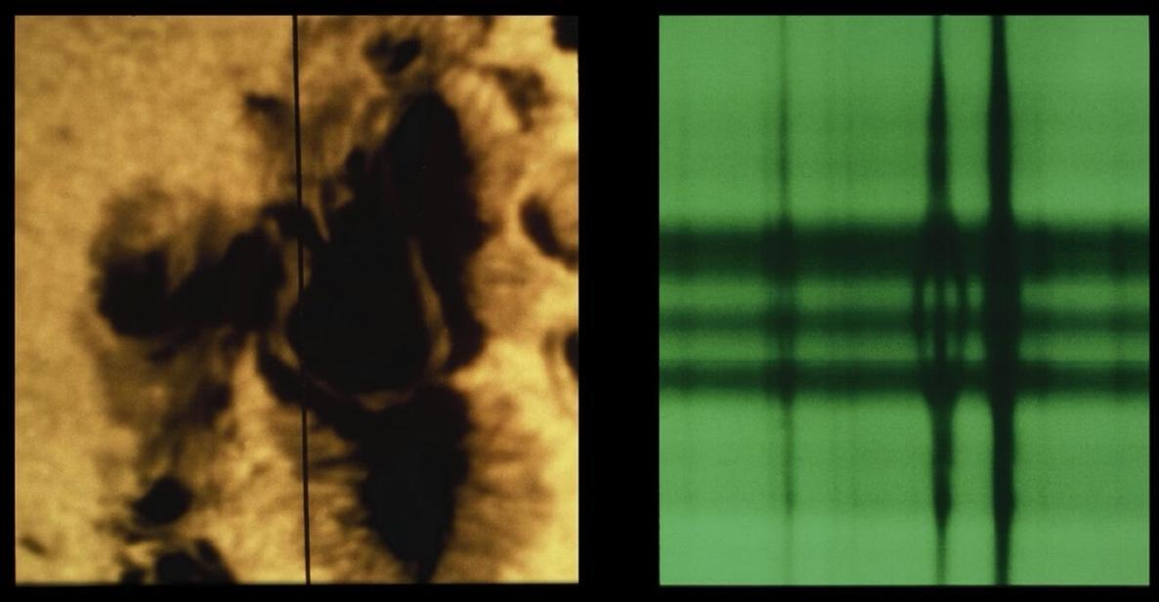
Credit: NSO/AURA/NSF

2. Consider the line that has been split into three equally-spaced lines. If the difference in frequency between neighboring spectral lines were measured to be ∆f = 2.0 × 10¹⁰ Hz:

- Use the photon energy equation E_{γ} = hf and Planck’s constant (h = 6.58 ⋅ 10⁻¹⁶ eV-s) to calculate the difference in energies between neighboring lines.

- Deduce the order of magnitude of the magnetic field in the sunspot. (Note: Typical magnetic fields can range from 1,500 to 3,500 Gauss, or 0.15 to 0.35 T.)

One of the first uses of the Zeeman effect was by astronomer Gregory Hale in 1908 to show that sunspots had strong magnetic fields, and to use the amount of splitting of the state to determine the magnitude of the magnetic field. We also use the Zeeman effect to measure the magnetic fields of distant stars.

II. Using the Zeeman effect to measure ionospheric electrojets
As the solar wind flows past Earth, some of the kinetic energy from the flow is transmitted to the Earth system. This flow of energy can power magnetic storms and other space weather phenomena that can negatively affect our technology. The energy from the solar wind is delivered through enormous electrical currents that flow along Earth’s magnetic field. These currents flow horizontally at altitudes of approximately 100 km through Earth’s ionosphere, the electrically conducting upper layer of the atmosphere), and are called ionospheric electrojets.

The magnitude of the electrojet current is a measure of the energy flow from the solar wind, while its fine-scale structure indicates what kind of localized extreme conditions could occur. In order to predict space weather we therefore need to understand the total current as well as the extreme local variations.

- The magnitude of the electrojet current measures the total energy flow from the solar wind, while its fine-scale structure reveals localized extremes. In your own words, why do scientists need both pieces of information rather than just the total current?

On Earth’s surface, the magnetic effect of electrojets is easily seen in magnetometer observations. There are some problems, however, with using ground magnetometers to characterize the electrojets. First, the changing magnetic field produced by the variable electrojet current induces currents in the ground and other conductors. The induced current in power transmission lines can damage those systems and this is a major space weather concern. But induced currents flow everywhere, and those currents produce their own magnetic fields. The magnetometers on the ground measure the sum of all magnetic fields at a given spot, making it difficult to isolate the effect of just the electrojet current. A second problem is that small-scale structures, tens of km in size, get washed out when observed from hundreds of km away. These effects present challenges to measuring small, high current bursts in the electrojet.

2. A ground magnetometer measures “the sum of all magnetic fields at a given spot.” With your partners, explain why this makes it hard to isolate the effect of the electrojet itself. What other sources are contributing to that sum?

3. The changing electrojet current induces currents in the ground and in power lines. Connect this to what you know about magnetism: why does a changing magnetic field drive these induced currents, and why are they a space-weather concern?

4. Small-scale structures “get washed out when observed from hundreds of km away.” Propose a simple everyday analogy (visual, audio, etc.) for why getting closer to a source lets you resolve finer detail.

What was needed was a way to measure the magnetic field right next to the electrojets to be able to accurately calculate the magnitude and the maximum variations of the electrojets. You can’t fly a satellite next to the electrojet because the air is too thick (even at 100 km) and the satellite will burn up, but it is way too thin to support airplanes or even balloons. A team of scientists at the Johns Hopkins University Applied Physics Laboratory (JHU/APL) proposed a mission to use the Zeeman effect to directly measure the local magnetic field remotely, just as was first done for the sun more than a century ago.

5. The electrojets flow at about 100 km altitude. Why does the text describe this height as a region where neither satellites nor airplanes/balloons can operate? What makes it too high for one kind of vehicle and too low for another?
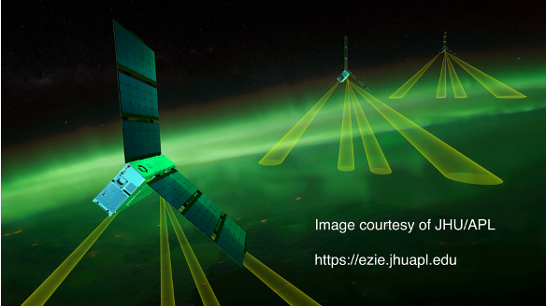
The Electrojet Zeeman Imaging Explorer (EZIE) mission is funded by NASA and it comprises a fleet of three identical spacecraft, flying in coordinated orbits, each with four imaging beams to look for very specific spectral lines to calculate the magnetic field from the Zeeman effect. You can read more about the mission at the EZIE website. https://ezie.jhuapl.edu

6. EZIE measures the magnetic field remotely using the Zeeman effect, rather than flying a probe through the electrojet. Referring back to Part I.B, what specifically does the Zeeman splitting let EZIE determine, and how does that address the problems raised for ground magnetometers?

7. Why might the mission use a fleet of three spacecraft with four imaging beams each, rather than a single instrument? What advantage does measuring from several positions at once provide?

Here is an example of the reconstructed magnetic field distribution from EZIE for one small space weather storm called a substorm. The colors indicate the value of the positive down component of the magnetic field from the electrojet. In the more southern region there is blue, indicating magnetic field pointing upward, while to the north, there is a region of red, indicating magnetic field pointing downward.

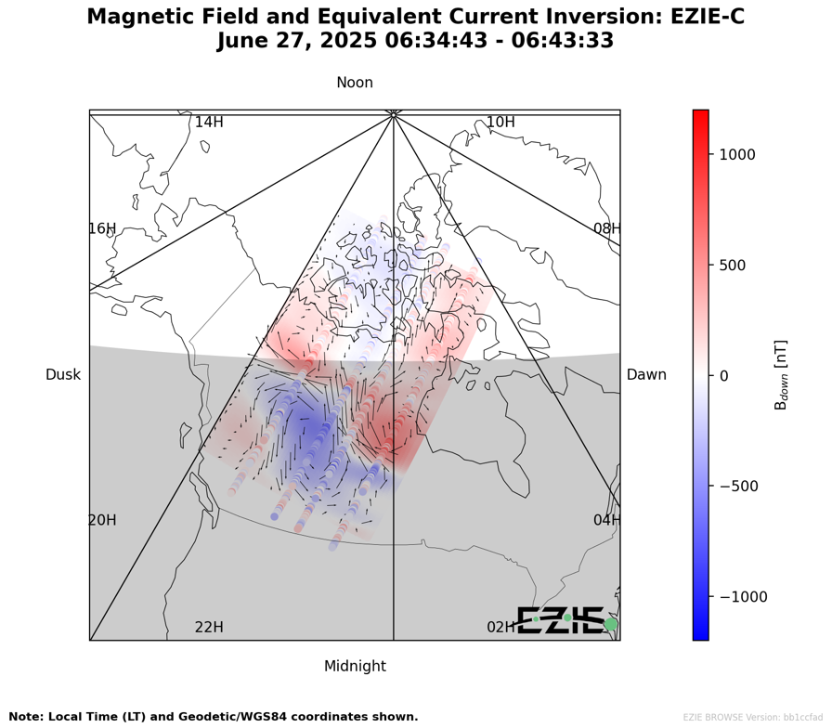
8. Using the appropriate right-hand rule, work out the direction of the current between these regions. Does your answer agree with the black arrows?

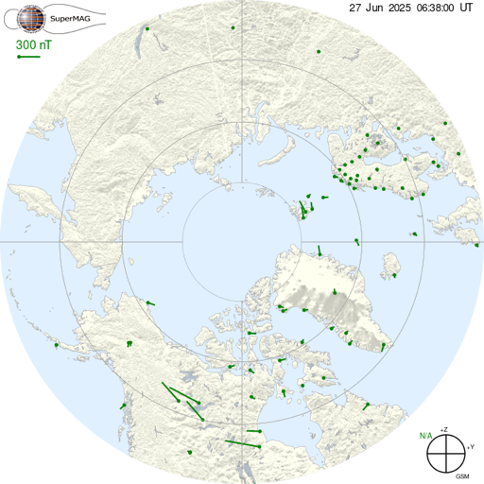

We can compare this image to the ground magnetometers in the Canadian sector (data from https://supermag.jhuapl.edu). The image to the right shows the equivalent current vectors in green as calculated from the magnetometer observations. The correspondence is actually quite good. NASA’s next steps will be to compare the data from magnetometers to the EZIE observations.

9. The EZIE reconstruction and the ground-magnetometer “equivalent current vectors” show good correspondence. Why is it scientifically valuable to confirm that two independent methods agree, even when we expect them to?

