Lecture Tutorial: Determining the Atmospheric Composition of Exoplanets

Description: This tutorial presents students to the idea of how spectral patterns observed through planetary atmospheres can provide information about atmospheric composition, as well as what other variables scientists consider when looking for planets that might support life.
Typical astronomy classes cover the nature of light, as well as graph reading skills.

Prerequisite:
- Be familiar with black-body diagrams
- Be familiar with the transit method
- Understand absorption and emission lines (for elements)

Instructions:
In this activity, "In this activity, you will explore one of the ways exoplanets are detected by astronomers. You'll build an understanding of how the chemical composition of an exoplanet's atmosphere can influence the light that comes to us from its star. To apply your knowledge, you then will select from among a number of possible exoplanets to explore, and provide a rationale for why you would choose it as a priority for exploration.

Pre-Reading
In advance of completing this activity in class, please review what you know about spectroscopy by reading Stellar Spectroscopy: The Message of Starlight, accessible from https://www.noao.edu/education/astrobits/files/Stellar-Spectroscopy-Abits.pdf

Part 1: Understanding the Transit Method
Below is a schematic of the transit method for discovering exoplanets orbiting other stars in the Milky Way. On the y-axis of the graph is the flux, or total output of the star’s light that is measured.

- Describe in words why the flux on the y-axis is not constant as time goes by on the x-axis.

- How would this solar system need to be oriented with respect to Earth for us to do this type of measurement? Include a diagram with your explanation.

- Notice that the light transit curves do not look the same for each star and its exoplanet. Provide at least four factors that might influence the shape of the curve.
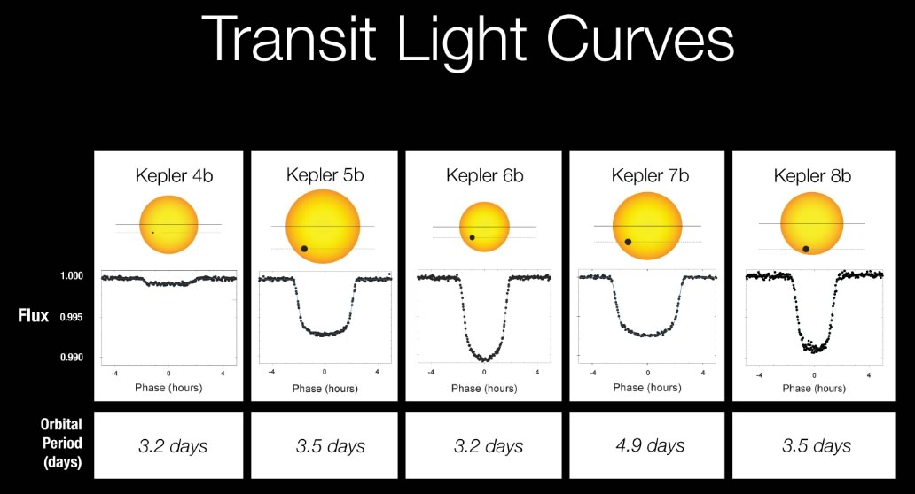

Source: NASA
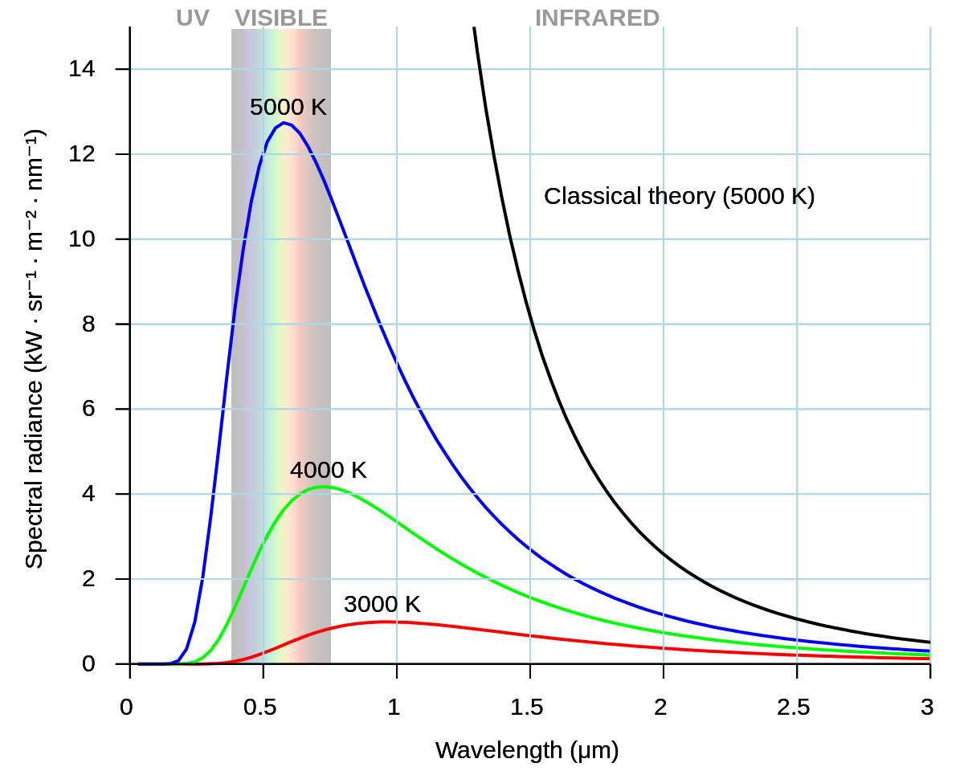
Part 2:Review of black body spectra
Stars are similar to “black bodies”—they are objects that can nearly perfectly emit and absorb radiation. The light they emit is similar to a blackbody curve, with color and spectral radiance (flux at each wavelength) determined only by their temperatures.

- Using the graph to the right, compare the characteristics of the black body spectrum of a red (3000 K) versus a blue (5000 K) star.

Source: Darth Kule (public domain)

- Although a star might appear red, white, or blue, how many visible colors do these stars actually produce?

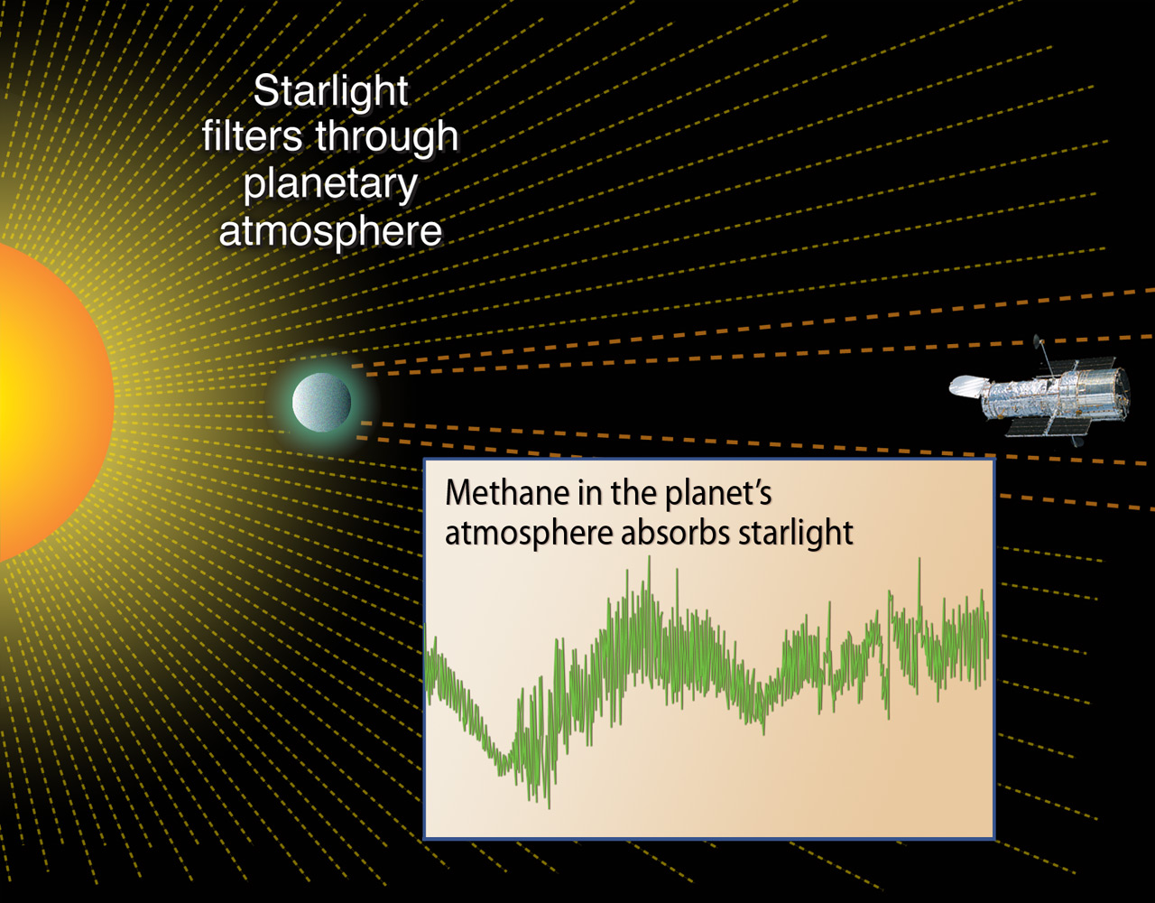
Part 3: Review of absorption spectra
When an exoplanet passes in front of its star, the planet blocks a small bit of the star's light (see Part 1). An even smaller amount of the star's light passes through the edge of the planet's atmosphere, and chemical elements and molecules in that atmosphere can absorb star light at some wavelengths. Rather than seeing a uniform spectrum, we see a spectrum in which certain frequencies (spectral lines) are removed or much dimmer than usual, showing a “dip” in the intensity graph. The frequency of these spectral lines corresponds to the unique chemical indicator of components in the planet’s atmosphere.
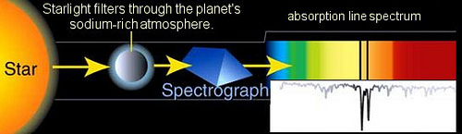
Source: NASA

Source: NASA
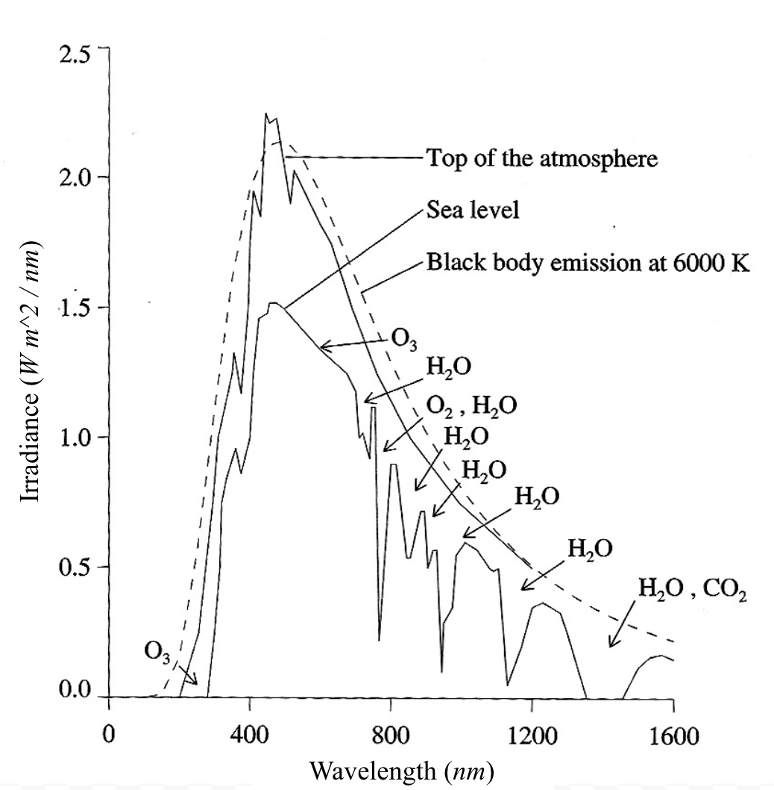

The graph to the right shows a blackbody curve of the light that has passed through the Earth’s atmosphere at the top of the atmosphere and at sea level.

1. Explain why the graph to the right shows more absorption dips in the sea level spectrum versus the top of the atmosphere spectrum.

2. Draw the general shape of a flux graph for an Earth-like planet, but whose atmosphere is composed of pure carbon dioxide (CO₂). | 3. Draw the general shape of a flux graph for an Earth-like planet, but whose atmosphere is composed of pure ozone (O₃).
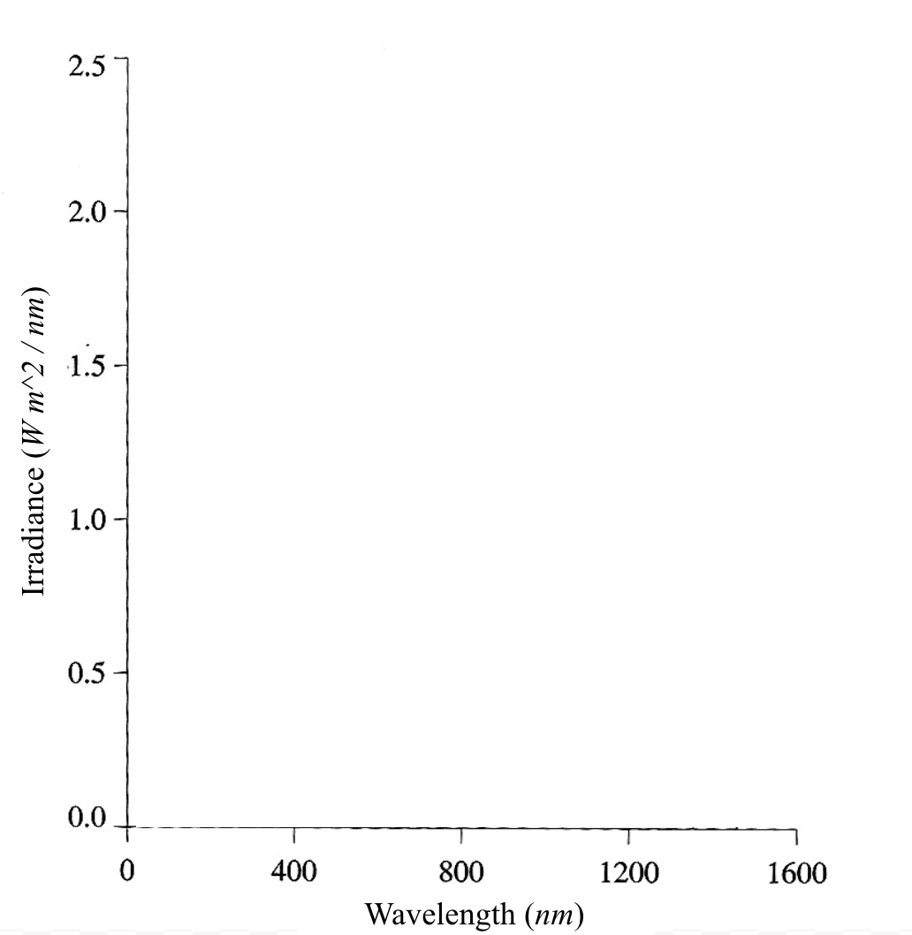

Post-Work (Complete after coming to class).

Read the following article by Dr. Sara Seager about the search for life on planets beyond the solar system:

Seager, S. (September 2014). Prospects for life detection on exoplanets. Proceedings of the National Academy of Sciences, 111(35), 12634-12640. Retrieved from https://www.pnas.org/content/111/35/12634
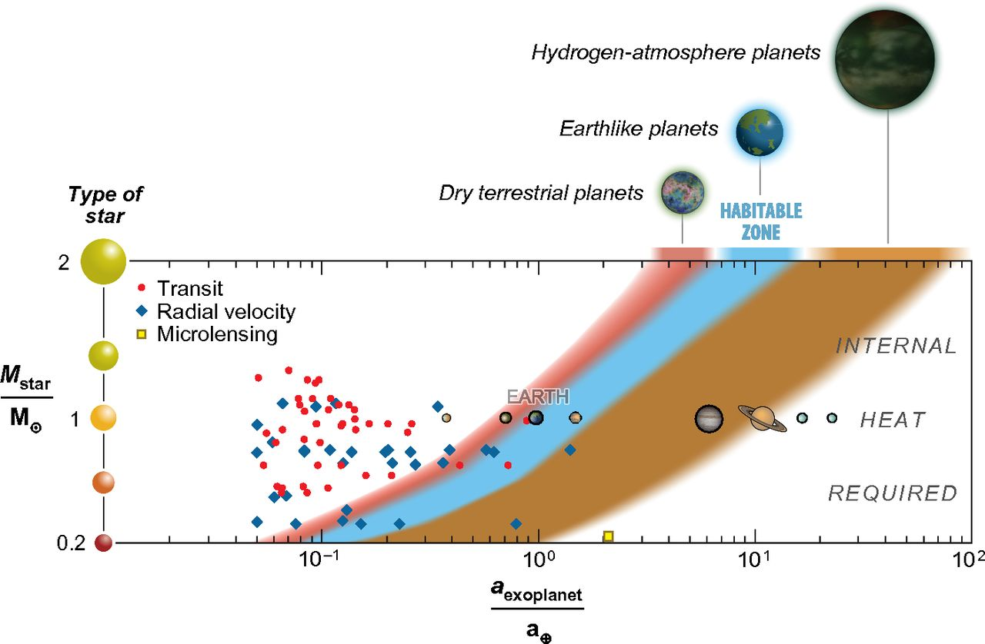
- In her article, Dr. Seager describes the various conditions that are necessary for a planet to be in the “habitable zone” of its star. In a well-constructed paragraph, describe what planetary traits are necessary to sustain life like that found on Earth.

- Dr. Seager describes three lessons that have been learned in the past two decades about detecting the atmospheric composition of exoplanets. What do these lessons suggest are the biggest challenges scientists encounter when trying to look at the atmospheric spectra of exoplanets?

- When scientists can get a good spectrograph, how do scientists determine if the exoplanet has the potential to harbor life? Explain the difficulties or ambiguities that scientists might encounter.

Extension
Consider deepening your understanding of exoplanet atmospheric spectra by reading the following article.
Burrows, A. S. (January 2014). Spectra and windows into exoplanet atmospheres. Proceedings of the National Academy of Sciences, 111(35), 12601-12609. Retrieved from https://www.pnas.org/content/111/35/12601

Next Generation Science Standards (NGSS) Alignments

Performance Expectations: Grades 9-12

Physical Science - Waves & Their Applications in Technologies for Information Transfer
- HS-PS4-4: Evaluate the validity and reliability of claims in published materials of the effects that different frequencies of electromagnetic radiation have when absorbed by matter.
- HS-PS4-5: Communicate technical information about how some technological devices use the principles of wave behavior and wave interactions with matter to transmit and capture information and energy.

Disciplinary Core Ideas (DCI’s): Grades 9-12

Earth and Space Science - Electromagnetic Radiation
- ESS4.B.1: Atoms of each element emit and absorb characteristic frequencies of light. These characteristics allow identification of the presence of an element, even in microscopic quantities.
Earth and Space Science - The Universe and Its Stars
- ESS1.A.2: The study of stars’ light spectra and brightness is used to identify compositional elements of stars, their movements, and their distances from Earth.

Science and Engineering Practices: Grades 9-12

Analyzing and Interpreting Data
- Analyze data using tools, technologies, and/or models in order to make valid and reliable scientific claims or determine an optimal design solution.
- Consider limitations of data analysis when analyzing and interpreting data.

Using Mathematics and Computational Thinking
- Use mathematical representations of phenomena to describe and/or support claims and/or explanations.

Constructing Explanations
- Apply scientific reasoning, theory, and/or models to link evidence to the claims to assess the extent to which the reasoning and data support the explanation or conclusion.

Obtaining, Evaluating, and Communicating Information
- Critically read scientific literature to determine the central ideas or conclusions and/or to obtain scientific and/or technical information to summarize complex evidence, concepts, process, or information presented in a text by paraphrasing them in simpler but still accurate terms.

Crosscutting Concepts: Grades 9-12

Patterns
- Empirical evidence is needed to identify patterns.

Scale, Proportion, and Quantity
- Algebraic thinking is used to examine scientific data and predict the effect of a change in one variable on another.

Nature of Science: Grades 9-12

Scientific Knowledge Assumes an Order and Consistency in Natural Systems
- Science assumes the universe is a vast single system in which basic laws are consistent.

Scientific Investigations Use a Variety of Methods
- Science investigations use diverse methods and do not always use the same set of procedures to obtain data.

Scientific Knowledge is Based on Empirical Evidence
- Science disciplines share common rules of evidence used to evaluate explanations about natural systems.

Science is a Human Endeavor
- Science is a result of human endeavors, imagination, and creativity.
- Technological advances have influenced the progress of science and science has influenced advances in technology.

