Lecture Tutorial: Habitable Zone Planets

Description: This guided inquiry tutorial—along with follow-up exercises that can be done as homework—introduces students to various factors that influence the (average) surface temperature of a planet. Students first consider a crude model based principles from blackbody radiation, deducing how the equilibrium surface temperature of a planet is related to the intensity of the solar radiation that is incident upon it. Students then introduce albedo into their conceptual model. They conclude the in-class tutorial by recognizing the importance of greenhouse gases (the effect of which falls outside the scope of the tutorial) in elevating the average surface temperature of a planet like Earth. Along the way, students are shown data collected on Earth-like exoplanets surveyed by the Kepler project. This resource is designed to supplement Lecture-Tutorials for Introductory Astronomy for lecture-style classrooms as well as for use in recitation or tutorial classrooms.

Prerequisite ideas:
● Blackbody radiation: An ideal blackbody is characterized by perfect absorption of all radiation incident upon it.
● Blackbody radiation: Total radiative intensity of an ideal blackbody (in W/m²) is proportional to equilibrium temperature to the fourth power (R = σT⁴).
● Intensity of radiation from a point source (or spherically symmetric body) varies as 1/r².

Some instructor notes:
● The instructor “checkpoint” on p. 2 of the tutorial is critical for checking that students can properly explain that the power radiated per unit area by each sphere is exactly one-fourth the intensity of the incident radiation bathing both spheres, and that that result is independent of the radius. Even if students obtain this final result by the checkpoint, it is worthwhile checking their reasoning on the following questions:
- For question in A.1 of part I students should invoke the idea that blackbodies are perfect absorbers and that the cross-sectional area of each sphere is important. (Some students might say that the power absorbed by a sphere is equal to “I_{o}(2πr²)”, not I_{o}πr²), thinking that the entire hemisphere facing the incident radiation absorbs the same amount per unit area.)
- For question in A.2 students should invoke the idea that each sphere is in thermal equilibrium (the idea that each sphere is a blackbody is irrelevant here).

● In parts I.B and II.A of the tutorial (p. 2 and p. 4, respectively), you should check students’ answers for the surface temperatures of Earth and Mars. Taking into account only blackbody considerations (part I.B), T_{Earth} ≈ 279.6 K (5.5°C) and T_{Mars} ≈ 225.7 K (-47.5°C). Taking into account albedo as well (part II.A), T_{Earth} ≈ 252.1 K (-21.0°C) and T_{Mars} ≈ 216.8 K (-56.4°C).

A habitable planet is often treated as one for which liquid water can exist somewhere on its surface. A critical feature of a planet to make it habitable is its average surface temperature. This tutorial will introduce you to several factors that affect the average surface temperature of a planet.

Crude approximation: Planets as blackbodies
Let’s first start simple, which means treating a planet as a spherical blackbody. The figure below shows two such spheres, each receiving incident radiation (from our Sun, for instance) of intensity I_{o}. Note that the radii of sphere 2 is twice that of sphere 1.
In answering the questions below, treat both objects as blackbodies in thermal equilibrium. (Note: Ignore any interactions between the spheres themselves.)
A. Let P_{sphere1} represent the total power absorbed (energy absorbed per unit time) by sphere 1.

1. Calculate the total power absorbed by sphere 2 (P_{sphere2}) in terms of P_{sphere1}. Discuss your reasoning with your partners.

2. For each sphere, how does the total power that it radiates (re-emits) compare to the total power that that sphere absorbs? Explain your reasoning.

3. Let R _{sphere1} represents the power radiated per unit area by sphere 1. Calculate the power radiated per unit area by sphere 2 (R _{sphere2}) in terms of R_{sphere1}. Discuss your reasoning with your partners.

4. Use your knowledge of blackbody radiation to explain why the equilibrium temperature of either sphere does not depend upon its radius.

Please STOP here to have an instructor visit your group and check your results thus far.

B. Our results for the two spheres from part A can be used to help us obtain crude estimates for the average (surface) temperatures on Mars and Earth (since r_{Earth} ≈ 2r_{Mars}).
The intensity of solar radiation is approximately 1,370 W/m² at the location of Earth (1.00 AU from the Sun). Treating Earth and Mars right now as ideal blackbodies, calculate:

      - the equilibrium temperature of Earth

      - the equilibrium temperature of Mars, which is (on average) 1.524 AU from the Sun

Hint: How can the ratio 1.00/1.524 (≈ 0.656) help you quantify the intensity of incident solar radiation at Mars?

The surface temperature on a planet varies, obviously, according to location (from equator to poles). Our results thus far are just crude estimates for average surface temperatures. Enough variation exists, though—as much as 50 K or 60 K from average—that both Earth and Mars fall within the boundaries of the so-called “Habitable Zone” for a star like our Sun. (See Fig. 1 below.)

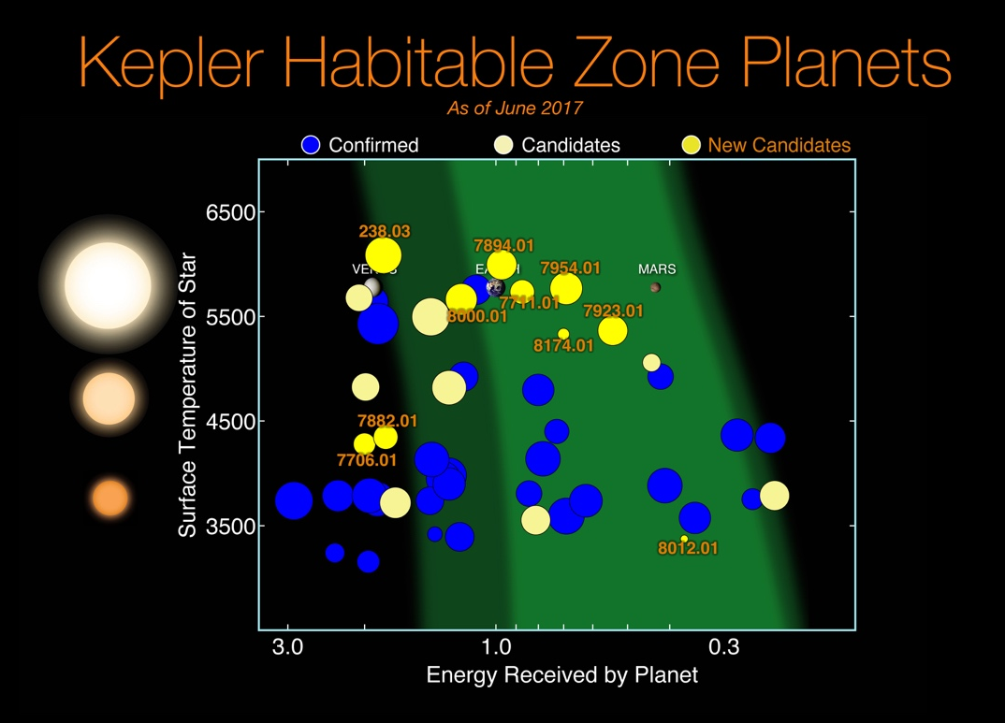

Fig. 1: Exoplanets (and candidates) detected by the now-retired Kepler space telescope. The vertical axis corresponds to the surface temperature of the star that the exoplanet orbits. The brighter, light green region of the graph represent a conservative estimate of the “habitable zones” for different stars. Earth and Mars fall within this zone but not Venus. (Image credit: NASA/Ames Research Center/Wendy Stenzel)

C. The horizontal axis of the plot, labeled “Energy received by planet,” is normalized so that Earth has a value of “1.”

Using your work from part B on the preceding page—and knowing that the average orbital distance for Venus (also shown on the plot) is 0.72 AU—show that the horizontal axis can be more precisely labeled as “intensity of incident radiation.”

D. Assuming that exoplanet “7954.01,” shown in the plot between Earth and Mars, orbits a star that has the same size and surface temperature of our Sun, estimate (in AU) its orbital distance.

Refinements to our model
A. Albedo. One important factor that makes actual planets different from blackbodies (upon which our crude model has been based thus far) is that planets can reflect some of the radiation incident upon it. The albedo (“α”) of a planet (or moon, or asteroid) is a number between 0 and 1 that represents the average fraction of radiation that is reflected from its surface.
Would a planet having non-zero albedo have an average temperature that is warmer or cooler than that predicted by modeling the planet as a blackbody? Discuss your reasoning with your partners.

Let’s now extend our thinking quantitatively by repeating the average temperature calculations from part I.B (on p. 2 of this tutorial). That is, with your partners, using albedo values of α_{Earth} = 0.33 and α_{Mars} = 0.15, find new estimates for:

      - the equilibrium temperature of Earth

      - the equilibrium temperature of Mars

B. Other refinements to our model. The estimate you obtain here for the average surface temperature of Mars is not far off. However, the observed result for Earth is closer to 288 K (15°C), which is more than 35 K (more than 35C°) warmer than what would be predicted by blackbody ideas and albedo.
With your partners, identify what phenomenon could account for the discrepancy between our model and the observations about Earth’s average temperature (and explain why this phenomenon has little effect in the case of Mars). Note: A proper treatment of this phenomenon is, unfortunately, beyond the scope of this tutorial.

Extension exercises (may be assigned as homework)
The model introduced in this tutorial—based on principles from blackbody radiation and albedo—can be extended so as to take into account explicitly the size and surface temperature of the star whose “habitable zone” we want to describe. It will be useful to denote the following variables:
Radius and surface temperature of star: R_{star}, T_{star} Orbital distance of planet from star: D_{orbit}
Radius and surface temperature of planet: R_{planet}, T_{planet} Albedo of planet: α

A. Using your knowledge of blackbody radiation and basic geometry of spheres, write algebraic expressions for the following quantities:
- The total power emitted by the star—in terms of R_{star}, T_{star}, and appropriate constants

- The intensity of the radiation from the star incident upon the planet—in terms of R_{star}, T_{star}, D_{orbit}, and appropriate constants

- The power absorbed by the planet—in terms of R_{planet}, α, R_{star}, T_{star}, D_{orbit}, and appropriate constants

- The power emitted by the planet (radiating as a blackbody)—in terms of R_{planet}, T_{planet}, and appropriate constants

B. Now take into account the fact that the planet must be in thermal equilibrium by setting equal to each other the two relevant expressions from part A. Solve the resulting equation for the equilibrium surface temperature of the planet (T_{planet}). Hint: Your result should depend upon R_{star}, T_{star}, D_{orbit}, α, and numerical constants (but not R_{planet}, and also not the Stefan-Boltzmann constant, σ!).

C. i. Verify your final expression for T_{planet} (in the preceding part) by redoing your calculations in part II.A of the tutorial (in which you found estimates for the equilibrium temperatures of Earth and Mars).
ii. Consider a star whose mass is 0.80 solar masses and whose surface temperature is 4,500 K. Using our quantitative model for average planetary surface temperature (developed in parts A and B above), find the orbital distances (in AU) for planets that would have the same average temperatures as Earth and Mars.

