Lab: Modeling Planetary Magnetism

Description: This hands-on, guided-inquiry activity helps students to understand the features of Earth’s and a Mars-like planet’s planetary magnetic fields using a smartphone sensor and easily-constructed planetary models. Students will visualize the magnetic fields around a planet model with a planetary dipole field (representing Earth) and a Planet X with a disordered planetary field comprised of localized regions of magnetization in the crust (which is the situation on Mars). They will compare these magnetic fields and explain how field vectors vary based upon location on the surface of the planet. This resource is designed to supplement Physics by Inquiry for physics teacher preparation and includes elements similar to those found in Ranking Tasks for Introductory Astronomy.

Purpose: This lesson was developed to promote understanding of:
- Characteristics of planetary magnetic fields
- Visualization of three-dimensional vectors, especially with respect to planetary geography

Prerequisite:
- Have a general conceptual understanding of magnetic field lines and magnetic field vectors.
- Basic understanding of magnetic dipole (“bar magnet”) field.

- If you will be using your own AR-compatible smartphone or tablet for this activity, you will need to download one of the following apps from Google Play or the Apple App Store:
  - Physics Toolbox Sensor Suite (AR mode, selected from the internal menu to the left of the screen)

  - Physics Toolbox AR (stand-alone)

Part 1. Modeling Earth’s Magnetic Field

- Using the app and the Earth model provided to you by your teacher, perform enough explorations with the smartphone app to determine what the field looks like around the globe. Using vectors (with attention to magnitude and direction), sketch the approximate field, and provide a narrative description of it. Assume that the seam of the ball represents the equator, and note the location of the north geographic pole.

Sketch | Description
North Geographic Pole

- Consider Earth from various perspectives. Draw arrows that show Earth’s approximate magnetic field direction on each map below.
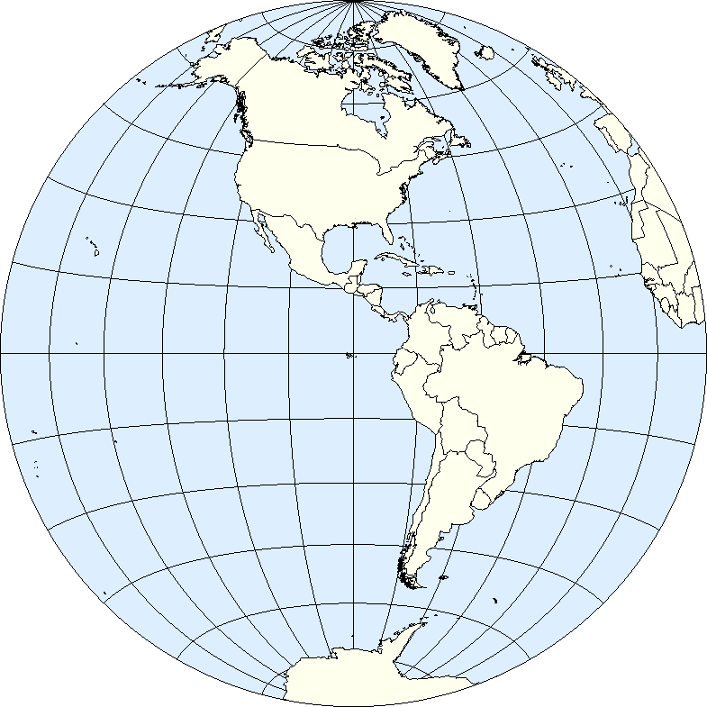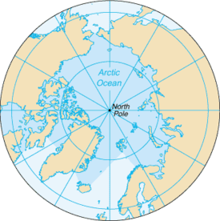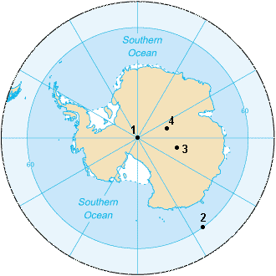
Source: Sean Baker Source: CIA Source: CIA

- Imagine you were visualizing Earth’s magnetic field standing on the surface of the planet while looking East and West off the coast of California. Which way would the magnetic field point? Drawn in at least five arrows on the screen, and provide an explanation.

Visualization | Explanation
Looking East
Looking West

North Geographic Pole
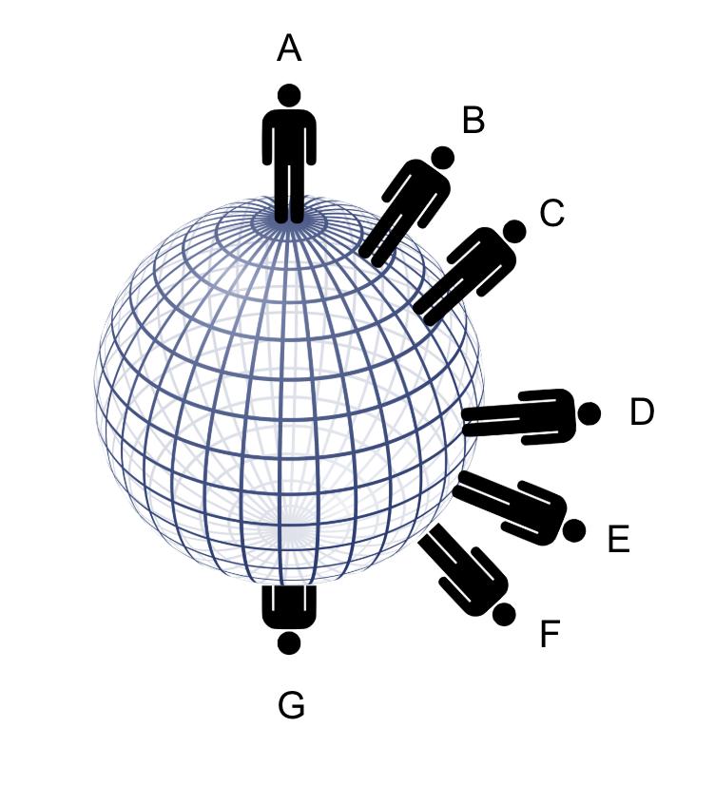
- Two individuals at different points of the globe took screenshots of visualized magnetic fields around them. Consider the locations on Earth represented on the globe as you answer the questions in the table below.

Visualization | - At which point (A-G) must the viewer have taken the picture?  - Which direction (N, S, E, W) must the viewer have been facing?  - Provide a rationale for your answers.
Source: Arturo Martí
Source: Rebecca Vieyra

Part 2. Modeling Planet X’s Magnetic Field
- Using the app and the Planet X model provided to your by your teacher, perform enough explorations with the smartphone app to determine what the field looks like around the globe. Using vectors (with attention to magnitude and direction), sketch the approximate field, and provide a narrative description of it. Assume that the seam of the ball represents the equator, and note the location of the north geographic pole.

Sketch | Description
North Geographic Pole

- Compare Planet X’s field with Earth’s magnetic field. How are they similar/different?

- Imagine that NASA sent a rover to two locations on Planet X. Based on the magnetic field vectors within the images, mark the possible locations of Rover #1 and Rover #2 on your sketch in question A, above.
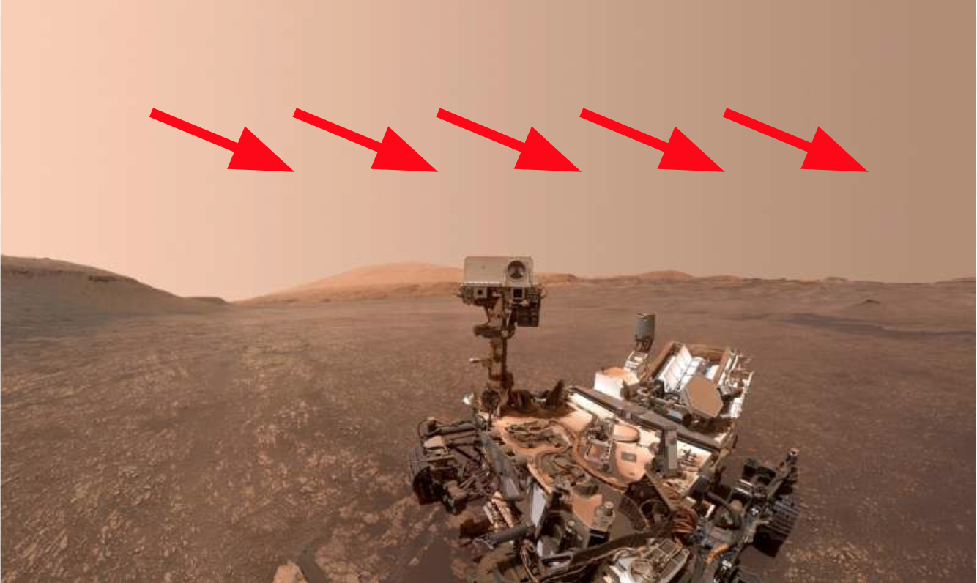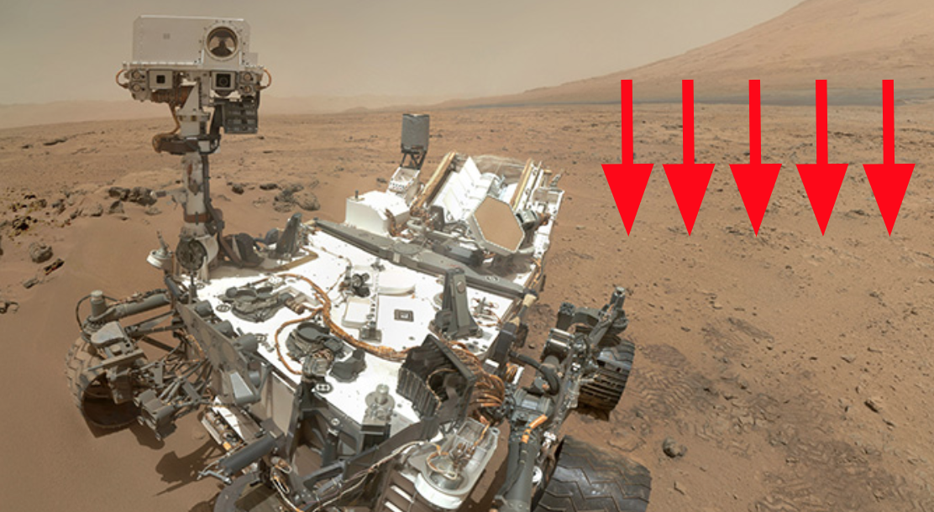Credit: NASA

Part 3. Understanding the Source and Impact of Planetary Magnetic Fields
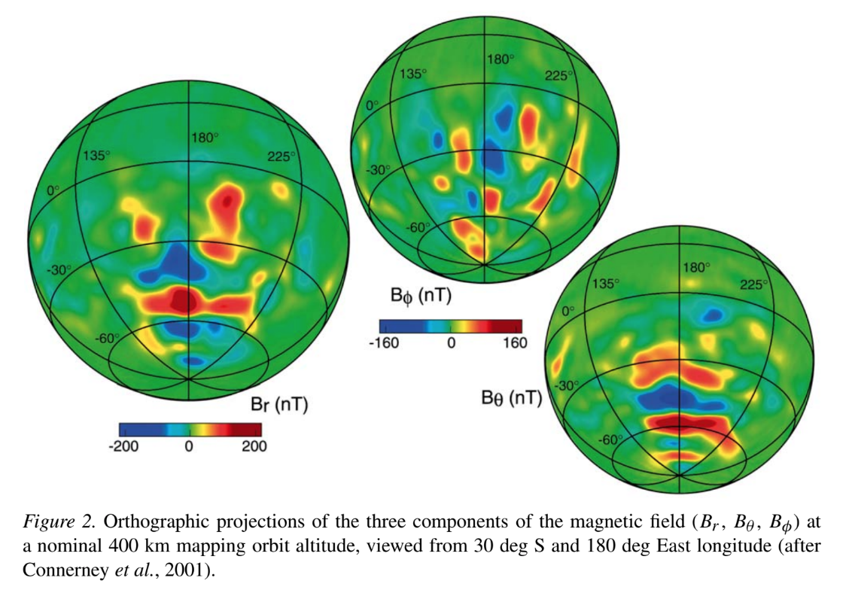
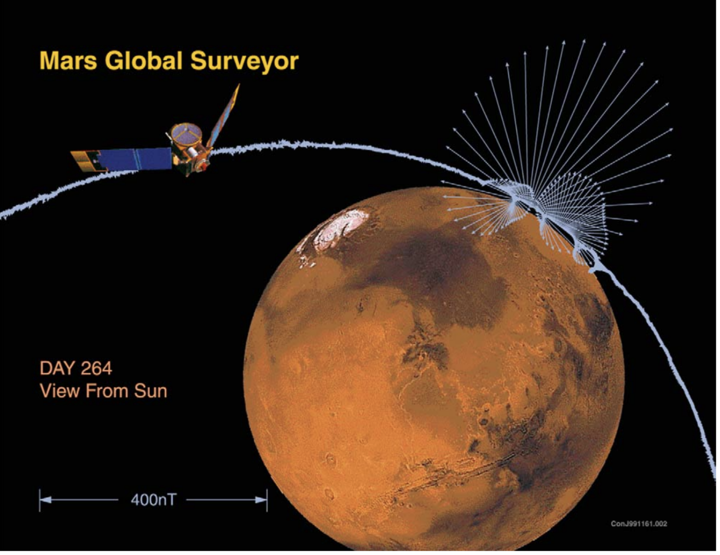
Planet X’s magnetic field is similar to that of Mars. Unlike Earth, Mars does not have an organized dipole field. Magnetism on Mars is restricted to regions of the crust where there are magnetic minerals. Scientists speculate Earth’s magnetic field might arise from convection currents of fluid metal under the crust. In contrast, Mars has no such active fluid flow. Mars’ field is caused by magnetic minerals, somewhat akin to having randomly-organized permanent magnets buried in the crust.

The diagram to the upper right shows the components of Mars’ magnetic field, with red showing an outward magnetic field (a north pole near the surface) and blue showing inward magnetic field (a south pole near the surface). The diagram to the right shows the complex arrangement of magnetic vectors measured by Mars Global Surveyor as it passed close to the Martian surface during its mission.

What does the lack of a substantial planetary magnetic field mean for humans on Mars?

The lack of a substantial planetary magnetic field means that the Martian surface has essentially no shield from particles in space. The Martian atmosphere is quite thin as well, so Mars is essentially exposed to all of the cosmic rays—high-energy particles—flying around in interplanetary space. While the magnetic field in the solar wind protects the inner solar system to some degree by pushing cosmic rays away, cosmic radiation in space is still at a level that is quite dangerous for human life. In addition, the Sun produces occasional blasts of material and magnetic field called coronal mass ejections (CMEs). These fast-moving clouds pile up the solar wind in front of them and produce shock waves, which in turn produce high energy particles called Solar Energetic Particles (SEPs), some of which are travelling almost the speed of light. Even when there are no blasts of CMEs from the Sun, the solar wind from different parts of the Sun can have different speeds. Fast wind catches up to slow wind, compressing it, eventually producing a shock wave, which yields more SEPs. All of this means that interplanetary space is full of high energy particles that are dangerous for humans. On Earth we are protected by our atmosphere and magnetic field. Mars provides no such protection.

Astronauts on the way to Mars will have to be shielded, probably by living inside the center of the water tank or other dense material since only a thick blanket of matter can stop the high energy particles. Once on Mars, humans will have to dig a shelter or find a cave, and do it quickly before they get a lethal dose of radiation. Once they have shelter, they will still need to limit the time they spend on the surface. Space weather prediction will provide critical information about when the Martians can expect a radiation storm. They will want to stay sheltered at all costs during those times. In the distant future, if we terraform Mars to provide it with a thick, breathable atmosphere, that atmosphere will be an effective shield against space radiation, but Martians will still get a significantly bigger dose of cosmic rays compared to Earthlings because of the lack of a magnetic field.

- Envision that NASA is one day able to collect and transmit data about magnetic fields for various planets outside of the solar system to look for inhabited or inhabitable planets. Using the information above, what kind of information might scientists be able to glean about the planet in general, as well as the planet’s inhabitability from magnetic field readings?

