Lecture Tutorial: Measuring the Frequency and Period of Sunspots

Description: This data analysis activity requires students to analyze sunspots on NASA’s SOHO coronagraph images to make meaning of cyclical patterns using the terms period and frequency. This resource is designed to supplement Lecture-Tutorials for Introductory Astronomy for lecture-style classrooms.

Prerequisite:
● None

Instructions:
In this activity, you will analyze a various types of data associated with the periodic cycle of sunspots. Some of the data you will analyze was collected by scientists nearly 300 years ago!

Part 1: Define Frequency and Period

To better understand frequency and period, imagine the following scenario:

Envision yourself along with a classmate in a boat away from the beach. One of you is counting the wave crests that pass your boat during the span of a 10 minute period. The other is timing how long it takes between the crest of one wave to the next.

- In a brief paragraph, describe what is different about the measurements each of you are taking while in the boat.

- Scientists describe these two ways of measuring cyclical patterns in terms of the following:
Period: The length of time for a cyclical pattern to repeat itself.
Frequency: The number of cyclical repetitions in a pattern per unit of time.

Based on the above definitions, which person in the boat is measuring the period? the frequency?

- While in the boat, a storm picks up, and the wave crests come more often. How will the measurements made by each of you change?

The terms period and frequency can be used for any kind of cyclical or “periodic” phenomenon.
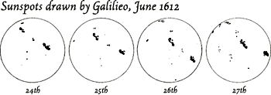

Galileo Galilei observed a recording sunspots in the 1600’s and noticed that the appearance of these dark splotches on the Sun came and went in a regular pattern.

Nowadays, sunspots can be observed by anyone through a telescope using an approved solar filter, and images are professional captured by NASA’s SOHO (Solar and Heliophysics Observatory), which is a camera that has been placed in space. Dark spots on the Sun are produced by strong localized magnetic fields that cause a the area to be cooler and appear darker.

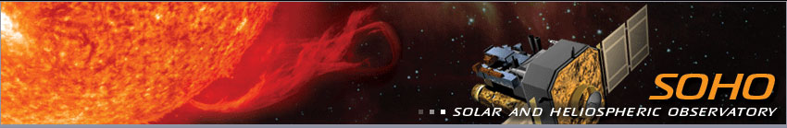
Credit: NASA
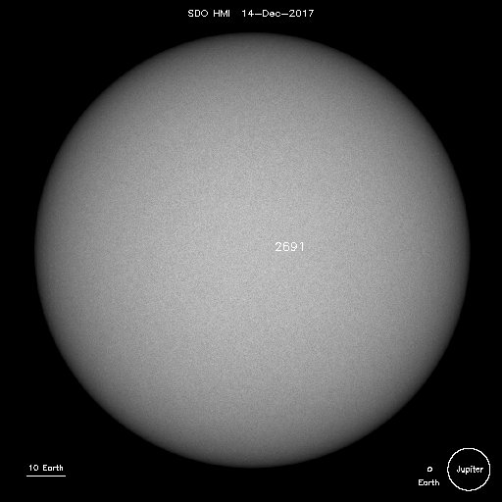
Part 2: Single Observation

- Look at an image of the Sun today on SOHO’s site: https://sohowww.nascom.nasa.gov/sunspots/

a) Sketch any sunspots on the image to the right. If there are no sunspots, click on “List of all available daily images” and find a day with clearly visible sunspots. Include the date below the image.

b) How big are these sunspots? (Estimated based on the diameter of Earth and/or Jupiter).

- Watch a video of a sunspot time lapse shown by your instructor. (Or, see a variety of sunspot time lapses from SOHO here: https://sohowww.nascom.nasa.gov/bestofsoho/Movies/sunspots.html)

Would it be appropriate to use the terms period and/or frequency when describing these images?
Why or why not?

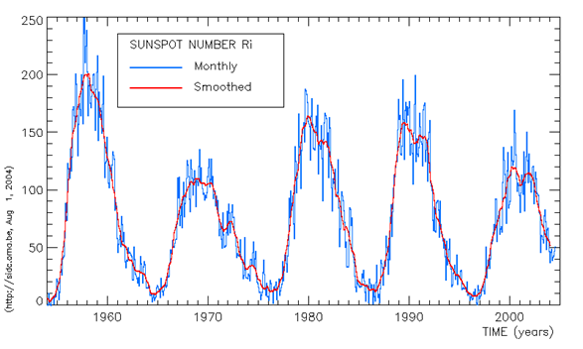
Part 3: Describe Sunspot Cycles in Terms of Period and Frequency (Long Period)

People have been making these observations of the Sun for a really long time. When you plot the number of sunspots produced each month, an interesting pattern results. Two graphs below display data across the past 50 years and the past three centuries.

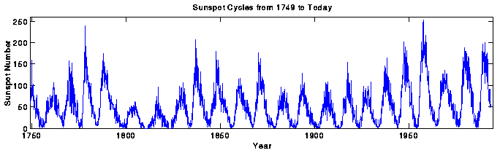
- What is similar and what is different about the two graphs above?

- What do you notice about the number of sunspots produced each month as years go by?

- Describe these changes based upon the terms period and frequency:

- What is the period of sunspot cycles? (Explain how you calculated this).

- What is the frequency of sunspot cycles? (Explain how you calculated this).

Part 4: Amplitude
- Using the 1950-2005 graph, in what years do you see a solar maximum?

- Using the 1950-2005 graph, in what years do you see a solar minimum?

- The difference between max and min is called amplitude. Is the amplitude the same from cycle to cycle? Explain how you know.

Part 5: Extending the Sunspot Model
- Predict: When do you expect the next solar maximum to be? Extend the graph into the gray area with a sketch.
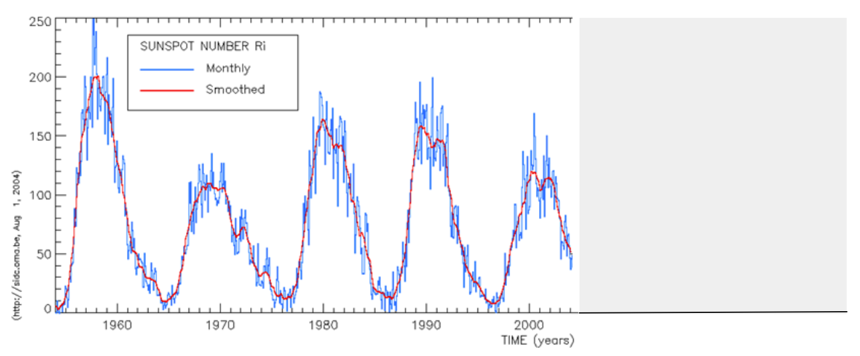
- Predict: What would the graph above look like if it was to have a higher frequency?

- Predict: What would the graph above look like if it was to have a greater period?

Section 6: Additional Cycles
- The Sun has cycles other than the number of sunspots. Look at the images below of the location of sunspots. What kinds of cycles do you notice? How might you measure or quantify these changes?
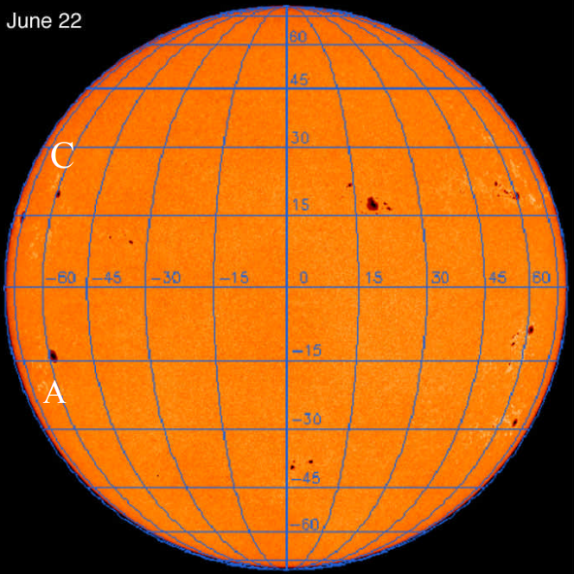 | 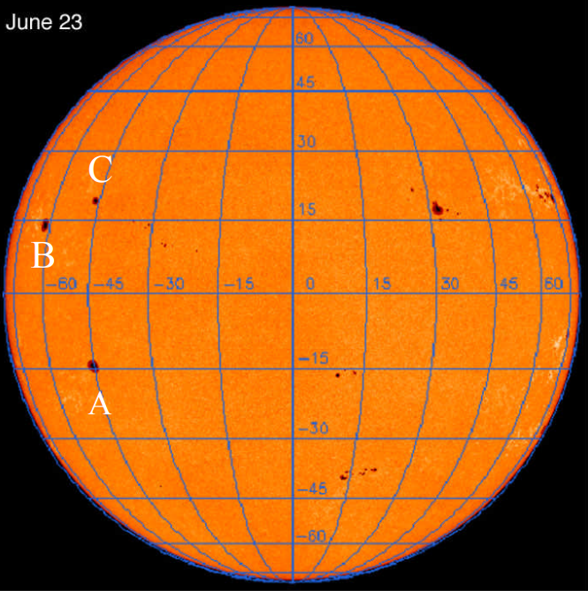
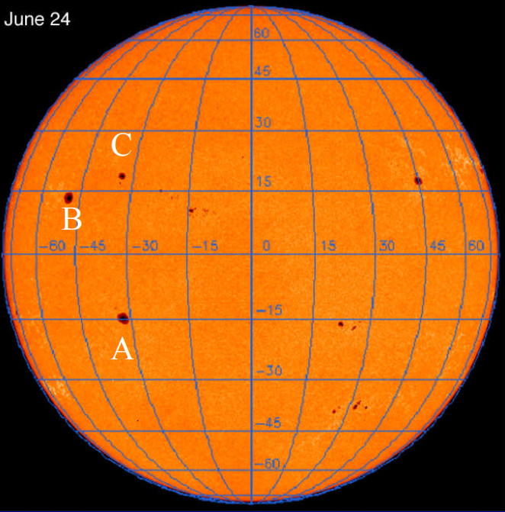 | 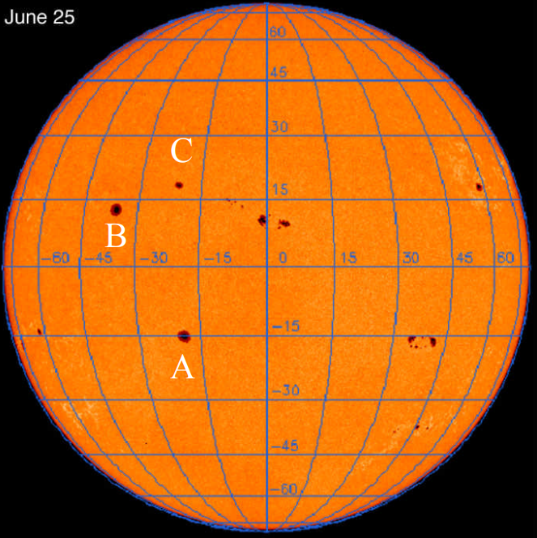

- The following are two additional graphs that demonstrate the surface area and location of sunspots over time. What patterns do you notice in each of the graphs below? Use the words period and frequency in your descriptions.

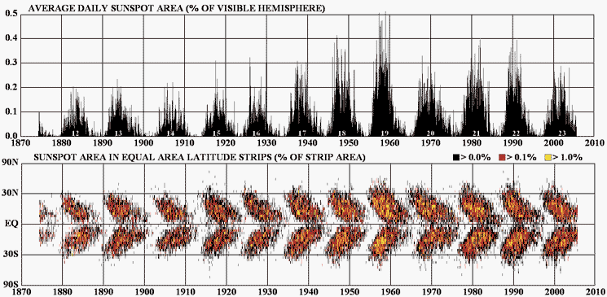

- Think about coherence and continuity of patterns throughout scientific data. Where else in this class have we talked about periodic cycles in the physical world?

