Lecture Tutorial: Reading Solar Eclipse Maps

Description:
This tutorial guides students to interpret information displayed on a solar eclipse map like that produced by NASA for the April 8, 2024, total solar eclipse. This tutorial also utilizes an interactive 3D visualization of this eclipse available on NASA’s website. Both of these resources may be accessed by clickable links (if using electronic copies of this tutorial) and QR codes (if using hardcopies).

Learning objectives:

Examine the path of the Moon’s shadow (umbra) across the Earth’s surface.

Identify locations and duration of totality at various locations during a solar eclipse.
- Determine the differences in observation in locations of total versus partial obscuration.

Prerequisite ideas:

● In solar eclipses, the Sun casts a shadow of the Moon onto the surface of the Earth.
● For locations on Earth that experience totality, the umbra of the shadow falls upon those locations. A partial eclipse is observed at locations upon which the penumbra of the shadow is falling.

Equipment:

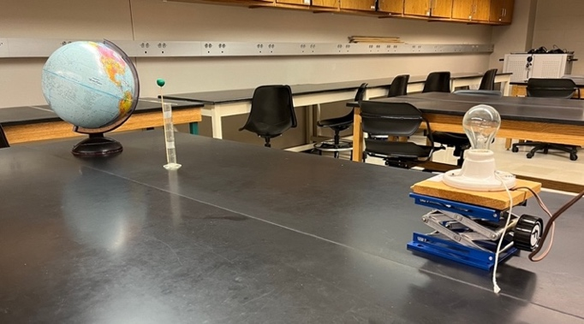
● Earth globe
● Clay ball (1.5 – 2.0 cm diameter) and stand
● Household light bulb, socket, and stand
(In the photo at right, a skewer and plastic graduated cylinder are used as a stand for the clay ball. We recommend a clear bulb, not frosted, for ease of viewing the shadow as it falls on different parts of the globe.)

Equipment (cont.)

● NASA eclipse map. Varying sizes of this map are available on https://svs.gsfc.nasa.gov/5123/. We strongly recommend a high resolution to clearly read important details printed on the map. Navigate to https://svs.gsfc.nasa.gov/vis/a000000/a005100/a005123/eclipse_map_2024_QR_5400.png for a map of resolution 10800 x 5400 (~77 MB) or use the QR code below.
NASA eclipse map
NASA 3-D eclipse visualization
● NASA interactive 3-D visualization. Access the simulation at https://science.nasa.gov/eclipses/future-eclipses/eclipse-2024/ or by using the QR code at right.

Instructor note:

● After students conduct their explorations using the physical model in Section I (the Earth globe, clay ball, and bulb), they are prompted for one or more diagrams that show the shape of the Moon’s shadow (as it falls upon the Earth) is affected by the curvature of the Earth’s surface. Make sure that their diagrams show that shadow becomes more elongated in shape where the light rays forming the shadow strike the Earth’s surface more obliquely. Shown below are two examples of ray diagrams that would be considered acceptable.
(Note: Neither the physical model nor the students’ diagrams are intended to account for the formation of the umbra and penumbra of the Moon’s shadow. That is, for the purposes of this part of the tutorial the bulb representing the Sun may be treated as a point source of light rather than an extended source.)
Earth globe
To bulb
Positions of clay ball
Earth globe
To bulb
Positions of clay ball
Example ray diagrams that correctly illustrate the effect of Earth’s curvature on the appearance of the Moon’s shadow: treating bulb-globe distance as either (i) infinitely large (above left) or (ii) finite (above right).

Lecture Tutorial: Reading Solar Eclipse Maps

This tutorial focuses on how to interpret solar eclipse maps. Access NASA’s map for the April 8, 2024, eclipse here: https://svs.gsfc.nasa.gov/vis/a000000/a005100/a005123/eclipse_map_2024_QR_5400.png. You can also access this map using QR code below right.
NASA eclipse map
NASA 3-D eclipse visualization
During this tutorial you will also utilize NASA’s interactive 3-D visualization of the eclipse. You can access the simulation here: https://science.nasa.gov/eclipses/future-eclipses/eclipse-2024/. You can also reach the simulation using the QR code at far right.

Examining the path of the Moon’s shadow across the Earth’s surface
During a solar eclipse the Moon passes directly between the Sun and the Earth. For observers on Earth who experience totality the Moon blocks the entire disk of the Sun. Wherever totality is occurring, the darkest part of the Moon’s shadow, the umbra, is falling on the surface of the Earth at their location.
View the NASA eclipse map, zooming in as you work. Notice that the umbra of the Moon’s shadow is plotted at 5-minute intervals. Each plot of the umbra is indicated by a purple oval and labeled with a time expressed in terms of the local time zone.
City experiencing totality | Time of day (local time)
A. Identify at least 3 cities (including your city, if applicable!) that will experience totality. For each city list an approximate time of day when the umbra of the Moon’s shadow will envelop that city.

B. Notice that the shape of each umbra on the map is not a perfect circle (even though the Moon is nearly a perfect sphere!). Furthermore, notice that as the day progresses, the umbra sweeps across North America at varying rates. (That is, if someone were to try to fly a plane and keep their plane inside the umbra, the speed of the plane would not be constant as the day goes on.)

      - During which times throughout the day is the umbra (i) more circular in shape? (ii) more elongated in shape?

2. During which times throughout the day does the umbra sweep (i) more quickly across the Earth’s surface? (ii) more slowly across the Earth’s surface?

3. With your partners, propose one or more reasons that might account for these patterns you have just noticed about the umbra of the Moon during the eclipse.

C. Test your ideas from part B.3 above by having your instructor show you a physical model that includes a light bulb (representing the Sun), an Earth globe, and clay ball (representing the Moon). Although not to scale, this setup (see photo below for an example) can be used to model what you have already observed on the eclipse map about the path and shape of the Moon’s umbra.

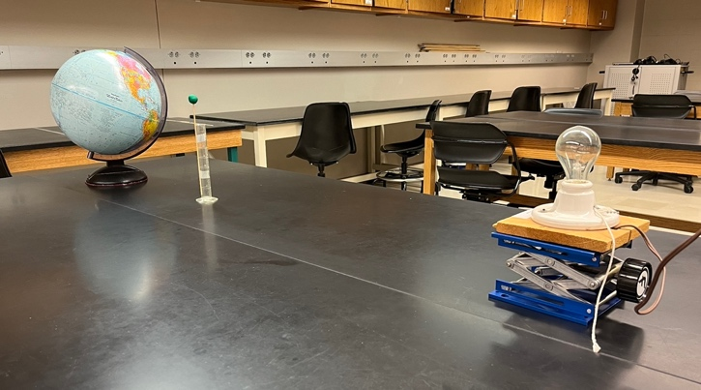
Darken the room and turn on the light bulb. Manipulate the clay ball and the Earth globe so that the shadow of the clay follows the same patterns you have observed from the eclipse map. With your partners, answer the following questions as you explore:
Earth globe
Light bulb, socket, and stand
Clay ball

            - In which direction (clockwise or counterclockwise, as viewed from above) should you move the clay ball (Moon) as it revolves around the Earth?

      - In which direction (clockwise or counterclockwise, as viewed from above) would you need to rotate the globe in order to model the Earth’s rotation during the eclipse day?

      - How should the globe’s rotation axis be oriented with respect to the Sun so that the shadow of the clay ball sweeps a path from Texas to Maine (that is, from southwest to northeast), as shown on the eclipse map?

4. STOP here to check your reasoning with an instructor. Then, record the results from your explorations with one or more diagrams (including the top view diagram below).

Earth globe
To bulb
Positions of clay ball

Where and when observers will see totality during the solar eclipse
For locations within the path of the umbra of the Moon’s shadow, the eclipse map indicates how long observers at that location will experience totality. The light-colored contours drawn along the length of the umbra’s path are labeled according to the duration (in minutes) of totality.
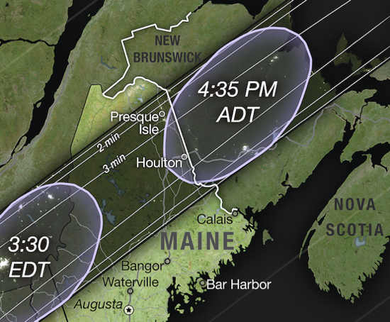
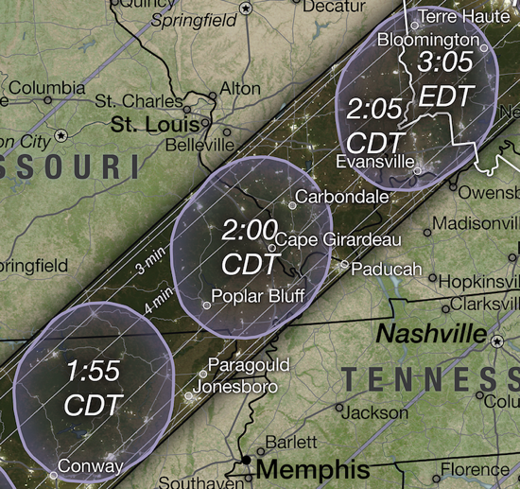
A. For example, in the inset map shown at right, locate:
- Poplar Bluff, Missouri
- Paducah, Kentucky
- Evansville, Indiana

Although geographically near each other, observers in which of these cities will experience totality for:

(i) more than 4 minutes?

(ii) about 3 minutes?

(iii) about 2 minutes?

B. How long (approximately) will totality last in Houlton, Maine, in the Eastern Daylight Time zone? (See inset map at right.)

C. Now compare your results for Poplar Bluff, Missouri, and Houlton, Maine. Both cities lie very near the exact center of the path swept out by the umbra of the Moon. However:

1. Which city experiences totality for the longer duration of time?

2. With your partners, propose a reason to account for the different durations of totality in Poplar Bluff and Houlton.

D. Summarize your results in this section: For an observer who experiences totality during a solar eclipse, how does the duration of totality depend upon the following two factors?

- The location of that observer within the path of the umbra

- The rate at which the umbra sweeps across their region on the Earth’s surface

Totality vs. partial obscuration
We now turn to cities that fall outside the band of totality. For observers for whom the Moon only partially blocks the Sun, only the lighter part of the Moon’s shadow, the penumbra, falls upon the Earth at their location. The degree of partial obscuration varies with location and time of day during the eclipse.
For cities outside the path of totality the eclipse map shows contour lines, stretching diagonally across the map, that indicate the largest percentage of the Sun’s disk that will be blocked at some point during the day. The contour lines are labeled along the map’s edge by this percent of maximum partial obscuration.

- On the eclipse map locate the two cities listed below as well as a third (use your city, if applicable) that lies outside the path of totality. Use the contour lines to estimate the maximum obscuration experienced by observers in that city. Enter your results in column A in the table below.

⚠️ Caution! You will complete columns B and C on the following pages. ⚠️

City outside path of totality | A) Maximum partial obscuration (%) | B) Time of max partial obscuration | C) What observers  would see
Milwaukee, Wisconsin
Washington, D.C.

- The eclipse map can also be used to answer the important question: At what time of day will the largest fraction of the Sun’s disk will be blocked by the Moon? To help us do this, we will access an interactive 3-D visualization of the April 8, 2024, eclipse produced by NASA. (This simulation is referenced at the top of p. 1. The QR code to access this sim is also found on the next page.)

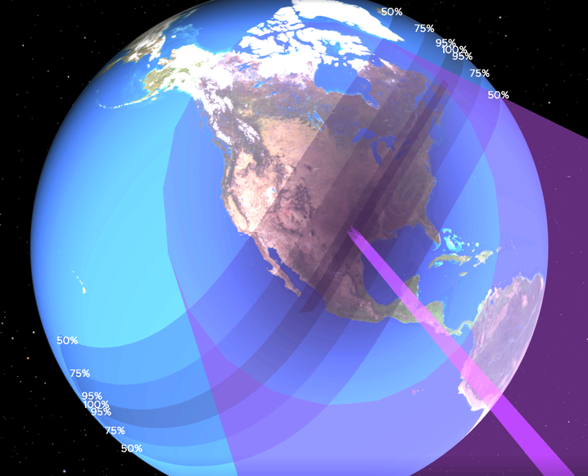
1. Shown below is an enhanced screenshot from the simulation (with colors adjusted for black and white photocopying) representing the time 2:40 pm EDT (1:40 pm CDT) on April 8, 2024.
On the screenshot, clearly label (for future reference):

- the path of totality

- the location of the umbra falling on the Earth’s surface (marked by the black dot)

- the extent of the penumbra falling upon the Earth’s surface (marked by the large, dashed oval encompassing almost all North America)

2. The screenshot also shows two locations (marked by white dots) that will experience their maximum obscuration of 50% at the exact time pictured (1:40 pm CDT). Sketch a single line that connects these two marked locations and the location of the umbra.
NASA 3-D eclipse visualization
  - What is the (approximate) orientation of this line in relation to the orientation of the path of totality? Suggest a reason why this relationship makes sense.

(Note: You may find it helpful to check out the interactive 3-D simulation! The QR code from p. 1 is repeated here for convenience.)

  - Use the line you have drawn in the above figure to mark two other locations at which observers experience their maximum obscuration of 75% at the time pictured.

3. Now we can apply the ideas used in the previous question to the eclipse map: With your partners, devise a method to estimate at what time of day maximum partial obscuration will occur for a particular city. Use your method to complete column B in the table under part III.A (on p. 4).

(Hint: To check your method, you should find that the city of Houston, TX, will experience its maximum obscuration of ~93% at 1:40 pm CDT.)
- Finally, we can predict which part of the Sun’s disk will be blocked during maximum partial obscuration. The diagrams (A – D) below roughly approximate different “observers’ views” (with appropriate eye protection!) as the Moon passes in front of the Sun. To help you decide which choice best describes what observers in different cities would see, answer the following questions:

1. Recall that on April 8, 2024, the umbra of the Moon sweeps a path from southwest to northeast (Texas to Maine). As a result, as the Moon passes in front of the Sun, will observers see the Moon appear to move:
A
B
C
D

- from left to right or from right to left across their field of view?

- gradually higher and higher or lower and lower in the sky?

2. Of the diagrams A – D above, which would better illustrate the observer’s view for someone located (i) north of the path of totality? (ii) south of the path of totality?

3. Test your ideas by using the physical model set up in the room (light bulb, globe, and clay ball) to imagine what observers at different cities might see. Alternatively, you can run the NASA 3-D simulation you used earlier; you “swivel” the Earth so that the simulation displays the Earth, the Sun, and the Moon simultaneously in the frame of the video.

4. STOP here to check your reasoning with an instructor. Then, record your results for each city in column C in the table under part III.A (on p. 4) by shading in the portion of the Sun’s disk that would be blocked by the Moon.

NASA 2017 eclipse sim
5. For additional practice, check out this NASA video simulation from the August 21, 2017, solar eclipse: https://www.youtube.com/watch?v=XX7AxZhPrqU. This video simulates images of the Sun’s disk during the course of that eclipse.

Important! During the 2017 eclipse the umbra swept along a path from Oregon to South Carolina—northwest to southeast—opposite from the April 2024 eclipse! Which diagram (among A – D, above) would show what observers saw in Chicago, IL (north of totality) or Dallas, TX (south of totality)?

