Star Spectra Science: Using Balloons and Buttons to Model Spectroscopy

Student Worksheet
Purpose: Interpret spectra of stars by sorting colored buttons.

Guiding questions:
Astronomers can learn an immense amount about stars from their spectra. In this activity, you will model how astronomers do this using colored buttons.
- In this activity, you will see colored buttons (violet, blue, green, yellow, orange, and red) that will represent photons. For each color, determine the corresponding wavelength (using a textbook or digital resource) and calculate the energy of a single photon of that color (show work).

Energy can be calculated using Planck’s equation.
$E_{photon}=\frac{hc}{λ_{photon}}=\frac{\left(6.6×{10}^{-34} J∙s\right)\left(2.9×{10}^{8} m/s\right)}{\left(λ_{nm}×{10}^{-9} m\right)}$
Then, convert from Joules to eV.
$1 J=6.242×{10}^{18} eV$

Color | Wavelength Range  (nm) | Average Wavelength (nm) | Energy  (J) | Energy (eV) | How energy was calculated
Violet

Blue

Green

Yellow

Orange

Red

- Look at the following energy-level diagrams for Model Atom #1 and Model Atom #2 below. For each energy transition (absorption or emission), label the color photon that corresponds. Are any of the energy transitions outside the visible spectrum (UV or IR)?

Model Atom #1 Model Atom #2
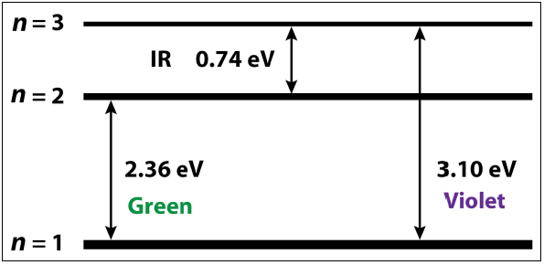
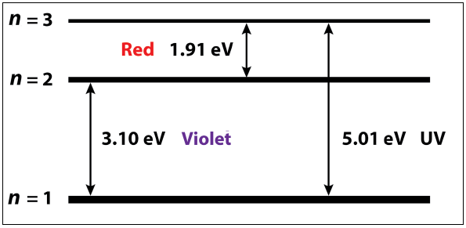

- Collect three “stars” (balloons) from your teacher. What similarities and differences do you notice about each “star”?

- Separately, you will now analyze the spectrum of each “star.” One at a time, separate the “photons” into their respective colors, and count them. Create a histogram of the colors for each star on the following page. If you have colored pencils, color the histogram bars with their respective color.

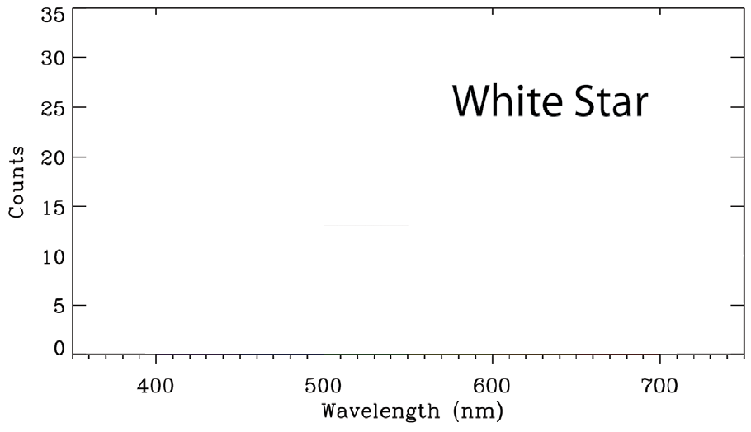
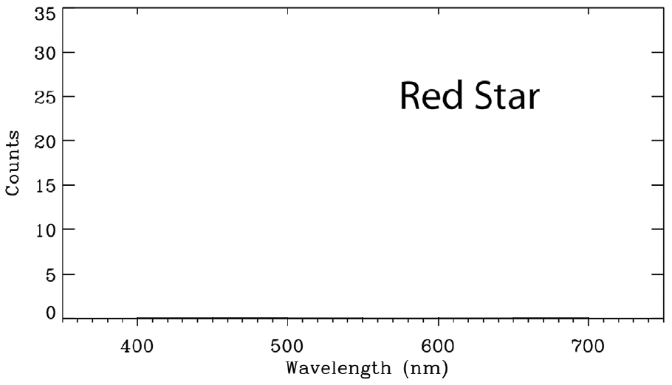
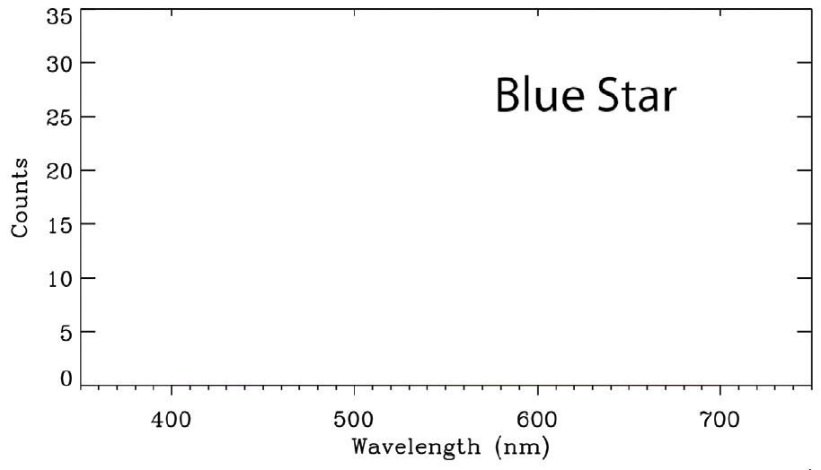

- On the previous page, label the approximate peak wavelength for each star.

- Do you see any correlation between the peak color and the perceived color of the star? Explain.

- Estimate the surface temperature of each star. Show your work.

Use Wein’s law to quantitatively determine the temperatures.

$T (K)=\frac{2,900,000 K∙nm}{λ_{nm}}$
 | Red | White | Blue
Temperature (K)

How temperature was calculated

- How does the luminosity of the three stars compare? Provide a justification for your answer.

- You will now be provided with three “mystery” astronomical objects and their absorption or emission spectra. For each of baggy “a,” “b,” and “c,” separate the “photons” into their respective colors, and count them. Create a histogram of the colors for each star on the following page. If you have colored pencils, color the histogram bars with their respective color.
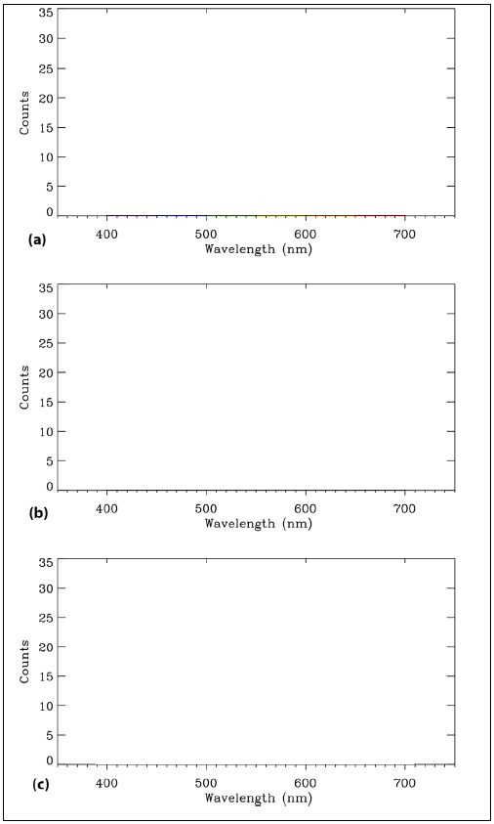

When astronomers observe spectra, they are likely to get a combination of light from various objects in their path. For example, when observing the light of a star, it is possible that the star’s light will have passed through combinations of:

Cool, diffuse gas that absorbs light

or

Warm, diffuse gas that emits light

These absorptions or emissions correspond to changes in the energy levels of electrons that are dependent upon the type of element involved.

- Create a histogram of the colors for the following example:
A red star emitted a spectrum, but violet and red were absorbed by a cool, diffuse Model Atom #2 gas before being observed by the astronomer.

If you have colored pencils, color the histogram bars with their respective color.

- Draw a diagram explaining why you observed the spectra for baggies “a,” “b,” and “c” based upon what you know about red, white, and blue stars, Model Atom #1 and #2, absorptions vs emissions, and how they must have been aligned in the astronomer’s line of sight

 | Diagram | Explanation
Example |  | A red star emitted a spectrum, but violet and red were absorbed by a cool, diffuse Model Atom #2 gas before being observed by the astronomer.
Baggie “a”

Baggie “b”

Baggie “c”

If possible, observe the atomic spectra of various elements directly with emission tubes and diffraction gratings.

- Based on this activity, summarize what information astronomers can gather from using atomic spectra.

- In modeling atomic spectra with balloons and buttons, what are the limitations to this activity? (How does it differ from what astronomers do?)

- Observe the spectral curves for stars of various temperatures below. How does the data you collected in this lab compare to the data on the curves below? Why is there a difference?

